Water-Flushing Register External Outlets

(Weekly)

Document 132

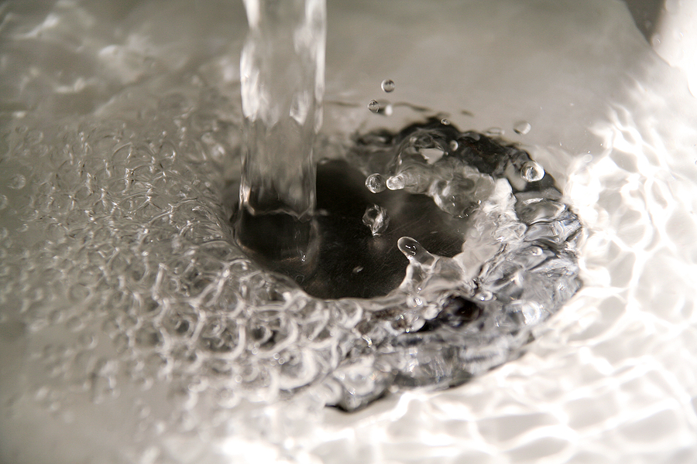

Water-Flushing Register External Outlets (Weekly)
- Flush at least weekly (Monday mornings and first day back from holidays)
- Flush 2 mins for cold water, 1 min for hot water

Weekly Water-Flushing External Outlets
Building | Location/Description | Date | Date | Date | Date | Date

Location and Item | Comment/Action | Date

Guidance Version Control

Name of Document | Version | Last Review date
Water-Flushing Register External Outlets (Weekly) | NASPM V1 | August 2025

Copyright © 2024 NASPM

All rights reserved.

No part of any NASPM document may be reproduced, distributed, or transmitted in any form or by any means, including photocopying, recording, or other electronic or mechanical methods, to any individual, school, or organisation outside of the school named in the school membership agreement.

Should membership terminate, no part of any NASPM document may be used, reproduced, distributed or transmitted by any individual, school, or organisation

