G

Premises

Management

Handbook

Document 69



Premises Management Handbook Contents

Section 1 Introduction
1.1 Key tasks
1.2 Summary of tasks and checks
1.3 Premises Checklist

Section 2 Health and Safety Arrangements
2.1 Premises Risk Assessments
2.2 Health and Safety Inspections
2.3 First Aid
2.4 Pedestrian and Vehicle Segregation
2.5 Bomb Threats and Suspicious Packages
2.6 Tree Hazards

Section 3 Access and Use of Premises
3.1 Security Arrangements
3.2 Control of Visiting Contractors
3.3 Event Safety

Section 4 Fire Safety
4.1 Fire Safety
4.2 Fire Detection and Alarm System
4.3 Fire Fighting Equipment
4.4 Means of Escape
4.5 Fire Safety Arrangements
4.6 Fire Safety Information Training

Section 5 Maintenance Arrangements
5.1 Requesting Maintenance Work
5.2 Safety during Construction Work
5.3 Cleaning Arrangements
5.4 Window Maintenance

Section 6 Plant and Equipment
6.1 Boilers
6.2 Kitchen Canopy Extract Systems
6.3 Local Exhaust Ventilation
6.4 Fall Arrest Anchors
6.5 Fuel and Oil Storage
6.6 Gas Safety
6.7 Lifts
6.8 Playground and Gymnasium Equipment

(Continued)

Premises Management Handbook Contents Continued

Section 7 Electricity
7.1 Fixed Electrical Installations
7.2 Portable Electrical Appliances

Section 8 Water Hygiene
8.1 Control of Legionella

Section 9 Asbestos
9.1 Asbestos Information
9.2 Asbestos Management
9.3 Asbestos Emergency Procedures



(Continued)

Premises Manager Handbook

1. Introduction and Background

The statutory framework for any school includes the legal compliance duties to ensure that the school is legally compliant. This also includes the setting of identified key staff and specifically those responsible for managing the estates.

Premises staff including premises managers have extensive requirements as detailed within their job descriptions to manage the school estate which also includes many premises duties including these examples:

- Building Statutory Compliance
- Selection and management of contractors
- Risk assessment for premises management
- Fire safety
- Condition management
- Security
- Traffic management
- Contractor management including cleaning, catering and local school contractor management
- Building and area inspection
- Electrical and Mechanical management
- Management of site deliveries
- Emergency management

This Premises Management Handbook has been produced by NASPM to assist the Premises Manager and Premises Staff in those duties and tasks associated with this role. The handbook has been developed to cover the most common range of property compliance tasks that will apply to the majority of school premises, however, due to the often unique nature of individual premises and facilities this handbook cannot be considered exhaustive.

Role of the Responsible Person

School management should ensure that the key premises staff are aware of their compliance duties and also have a ‘check the checker’ role which may include a senior member of staff involved in checking the roles and responsibilities are being managed and monitored.

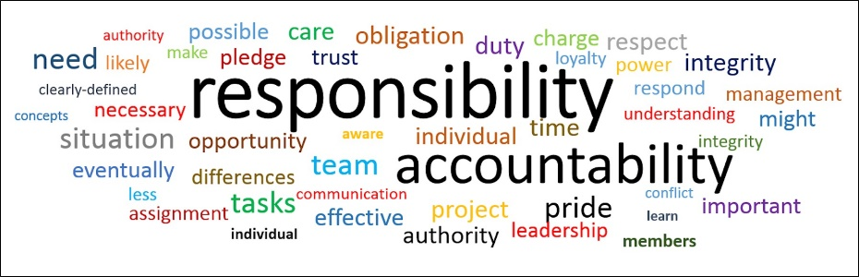

Section 1.1 Key Tasks



- Emergency arrangements (including bomb threats and suspicious packages)
- Pedestrian and vehicle movement
- First aid requirements and risk assessment
- Health and Safety tours, inspections
- Risk assessments
- Security Management
- Contractor management
- Event Management
- Temporary closure of premises
- Permanent closure of premises
- Requesting essential maintenance
- Safety during work within the premises
- Property/service-funded improvements
- Housekeeping
- Asbestos management and control
- Control of legionella
- Electrical safety
- Safety of plant, facilities and equipment
- Fire risk management
- Window Management
- Management of water
- Working at height equipment checks

(Continued)

Section 1.2 Summary of Tasks and Checks

On the following pages, there is a summary of tasks and duties for persons in charge of premises and the frequency at which they should be carried out. Actual tasks required at properties will vary.

Key for the table below is: I = Initially, D = Daily, W = Weekly, M = Monthly, Q = Quarterly, 6 = 6 Monthly, A = Annually, O = Ongoing

Subject | Task | I | D | W | M | Q | 6 | A | O
Premises Audit | Carry out a Premises Checklist of the Premises Management Handbook and action accordingly. |  | X
Premises Audit | Review the Premises Audit. |  |  |  |  |  | X
Layout Plans | Do you have a copy of the layout plans of the premises showing key components and hazard areas? | X
Layout Plans | Have these been updated to accurately reflect the property? |  |  |  |  |  |  | X
Trees | Have overhanging trees in high-use areas been checked?  Complete the section in the responsible person’s duties. | X
Trees | Have trees visually checked for obvious interference with the building etc. | X |  |  |  |  |  | X
Trees | Clear leaf fall or other tree debris if a trip hazard. |  |  |  |  |  |  |  | X
Trees | Check trees for obvious damage following extreme weather conditions. |  |  |  |  |  |  |  | X
Trees | Check other hazards including tree positioning near power lines and branches obscuring area lighting. |  |  |  |  |  |  |  | X
Security Arrangements | Carry out a security audit of the premises to identify the current provision of security systems and procedures. | X
Security Arrangements | Implement security management procedures/improvements to existing as identified by the audit. | X
Security Arrangements | Ensure staff and other relevant building users are aware of security procedures. |  |  |  |  |  |  |  | X
Security Arrangements | Maintain a list of key holders for the premises who can be contacted in an emergency. |  |  |  |  |  |  |  | X
Security Arrangements | Ensure procedures are in place to secure premises whenever they are left unoccupied. |  | X |  |  |  |  |  | X
Security Arrangements | Review security management arrangements and make changes when necessary. |  |  |  |  |  |  | X

Key for the table below is: I = Initially, D = Daily, W = Weekly, M = Monthly, Q = Quarterly, 6 = 6 Monthly, A = Annually, O = Ongoing

Subject | Tasks | I | D | W | M | Q | 6 | A | O
Maintenance requests | Are procedures in place to report faults found in building fabric, plant or facilities as you become aware of them? |  |  |  |  |  |  |  | X
Control of visiting contractors | Implement arrangements for the control of visiting contractors. | X
Control of visiting contractors | Ensure you liaise with visiting contractors when they arrive on-site before commencing any repair works. |  |  |  |  |  |  |  | X
Control of visiting contractors | Ensure contractors have been signed in and out of the premises each day they are on site. |  |  |  |  |  |  |  | X
Safety during construction work | Cooperate with contractors in the management of safety during construction work at the premises. |  | X
Smoking | Ensure smoking does not take place except in designated smoking areas. |  |  |  |  |  |  |  | X
Smoking | Check that no smoking signs are in place. |  |  |  |  |  |  | X
Cleaning | Identify and record cleaning arrangements and key contacts. | X
Control of Legionella | Identify little-used outlets, basins, baths, and showers. |  |  |  |  |  |  |  | X
Control of Legionella | Flush little-used outlets as identified |  |  | X
Control of Legionella | Check the Legionella contractor has visited. |  |  |  | X
Portable electrical appliance checks | Ensure procedures for the removal and reporting of faulty or suspected faulty electrical appliances are in place. |  |  |  |  |  |  |  | X
Boilers and heating plant | Ensure that boilers and heating systems are operating satisfactorily. |  | X
Boilers and heating plant | Ensure plant rooms are free from combustible materials. |  |  |  |  | X
Boilers and heating plant | Check that a contractor has visited to carry out routine maintenance of boilers and heating plant. |  |  |  |  |  | X
Boilers and heating plant | Check that a competent person has visited to carry out an annual inspection of boilers and heating plant. |  |  |  |  |  |  | X
Kitchen canopy air extraction systems | Check that a contractor has visited to clean kitchen air extraction systems. |  |  |  |  |  |  | X
Fuel and oil storage | Check fuel and oil storage vessels and systems for signs of leakage. |  |  | X

Key for the table below is: I = Initially, D = Daily, W = Weekly, M = Monthly, Q = Quarterly, 6 = 6 Monthly, A = Annually, O = Ongoing

Subject | Task | I | D | W | M | Q | 6 | A | O
Fuel and oil storage | Check that a contractor has visited to maintain fuel and oil storage vessels and systems. |  |  |  |  |  |  | X
Gas safety | Ensure procedures for the removal and reporting of faulty gas appliances are in place. |  |  |  |  |  |  |  | X
Gas safety | Ensure correct procedures are followed in the event of a suspected gas leak. |  |  |  |  |  |  |  | X
Gas safety | Check that a contractor has visited to carry out maintenance of gas-fired appliances. |  |  |  |  |  | X
Lifts | Check lifts visually for obvious faults. |  | X
Lifts | Check that a contractor has visited to carry out regular servicing of lifts. |  |  |  | X
Lifts | Check that a thorough examination of cargo-only lifts has been carried out. |  |  |  |  |  |  | X
Lifts | Check that a thorough examination of passenger-carrying lifts has been carried out. |  |  |  |  |  | X
Playground and gymnasium equipment | Create and implement a schedule of owner/user inspections. | X
Playground and gymnasium equipment | Ensure inspections are carried out in accordance with your schedule of inspection. |  |  |  |  |  |  |  | X
Playground and gymnasium equipment | Review the inspection schedule based on observations made. |  |  |  |  |  |  |  | X
Playground and gymnasium equipment | Arrange for a contractor to carry out operational inspections of equipment. |  |  |  |  | X
Playground and gymnasium equipment | Arrange for a competent contractor to carry out main inspections of equipment. |  |  |  |  |  |  | X
Fire risk assessment | Carry out an annual review of the premises fire risk assessment. |  |  |  |  |  |  | X
Portable firefighting equipment | Check and replace portable firefighting equipment that has been moved from its correct location. |  | X
Portable firefighting equipment | Check that equipment is not displaying faults and has not been discharged, including tags, pressure and signage. |  |  | X
Portable firefighting equipment | Check that a contractor has visited to service equipment. |  |  |  |  |  |  | X

Key for the table below is: I = Initially, D = Daily, W = Weekly, M = Monthly, Q = Quarterly, 6 = 6 Monthly, A = Annually, O = Ongoing

Subject | Task | I | D | W | M | Q | 6 | A | O
Fire detection and alarm system | Identify and record on a layout drawing the location of the fire alarm control panel.
Fire detection and alarm system | Check if the fire alarm control panel is displaying a fault indication and report as required. |  | X
Fire detection and alarm system | Test and activate the fire alarm using different call points. |  |  | X
Fire detection and alarm system | Check that a contractor has visited to carry out servicing of the fire alarm system. |  |  |  |  | X
Fire suppression systems: | Check fire suppression systems are operational. |  | X
Fire suppression systems: | Check that a contractor has visited to service fire suppression installations. |  |  | X
Fire safety management arrangements | Create and implement fire safety management arrangements. | X
Fire safety management arrangements | Review fire safety management arrangements following incidents and, at least, annually. |  |  |  |  |  |  | X | X
Fire safety management arrangements | Arrange for fire drills and practice evacuations of the premises. |  |  |  |  |  | X
Fire safety information and training | Provide relevant fire safety information to visitors. |  |  |  |  |  |  |  | X
Fire safety information and training | Maintain a centralised record of fire safety training delivered to employees in the workplace. |  |  |  |  |  |  |  | X
Fire safety assistance –  Fire Marshal/  Fire Wardens | Appoint persons to act as Fire Marshals/Fire Wardens. | X
Fire safety assistance –  Fire Marshal/  Fire Wardens | Provide initial training to Fire Marshals/Fire Wardens. | X
Fire safety assistance –  Fire Marshal/  Fire Wardens | Maintain a centralised list of Fire Marshals/Fire Wardens and post copies for staff information. |  |  |  |  |  |  | X | X
Fire safety assistance –  Fire Marshal/  Fire Wardens | Review the list of Fire Marshals/Fire Wardens and make new appointments as necessary. |  |  |  |  |  |  | X
Dangerous substances | Identify and record the location, type and quantity of dangerous or flammable substances in the premises. | X
Dangerous substances | Review the register of dangerous substances. |  |  |  |  |  |  | X

Key for the table below is: I = Initially, D = Daily, W = Weekly, M = Monthly, Q = Quarterly, 6 = 6 Monthly, A = Annually, O = Ongoing

Subject | Task | I | D | W | M | Q | 6 | A | O
Fire safety assistance for persons with a disability | Create Personal Emergency Egress Plans (PEEPS) for people with a disability (either permanent or temporary disability). |  |  |  |  |  |  |  | X
Fire safety assistance for persons with a disability | Ensure that alterations, facilities, equipment and personnel are provided to assist disabled persons. |  |  |  |  |  |  |  | X
Facilities for firefighters | Check and remove obstructions to access points for dry/wet risers. |  |  |  |  |  |  |  | X
Facilities for firefighters | Check and remove obstructions to access the fire hydrants on the premises. |  |  |  |  |  |  |  | X
Facilities for firefighters | Are fire hydrants installed at the premises maintained annually? |  |  |  |  |  |  | X
Facilities for firefighters | Check and remove obstructions to access and use of fire roads. |  |  |  |  |  |  |  | X
Facilities for firefighters | Check and remove combustible materials from protected staircases. |  |  |  |  |  |  |  | X
Means of escape | Identify escape routes, fire doors, emergency exits etc. | X
Means of escape | Check and remove obstructions or combustible materials from escape routes. |  | X
Means of escape | Check fire doors are not wedged or propped open. |  | X
Means of escape | Unlock or disable out-of-hour security devices on doors on escape routes and final exits. |  | X
Means of escape | Check general lighting on the escape route is operational. |  | X
Means of escape | Check emergency lighting units are not displaying fault indicators. |  | X
Means of escape | Check the operation of push bars/pads fitted to emergency exit doors. |  |  | X
Means of escape | Check the operation and condition of self-closing fire doors. |  |  | X
Means of escape | Check that the door holds open device releases when the fire alarm is activated for weekly testing. |  |  | X
Means of escape | Check that fire safety signs and notices are present and legible. |  |  | X
Means of escape | Check that communication systems in temporary waiting areas are operational. |  |  | X
Means of escape | Check fire doors for faults, damage, missing intumescent strips and signage, twisting or warping. |  |  |  | X
Means of escape | Check that a contractor has visited to service the emergency lighting system. |  |  |  | X

Key for the table below is: I = Initially, D = Daily, W = Weekly, M = Monthly, Q = Quarterly, 6 = 6 Monthly, A = Annually, O = Ongoing

Subject | Task | I | D | W | M | Q | 6 | A | O
Emergency incident response pack | Create an Emergency Incident Response Pack from the premises using the standard template and emergency shutdown document. |  |  |  |  |  |  |  | X
Emergency incident response pack | Review the Emergency Incident Response Pack annually or if there have been significant changes. |  |  |  |  |  |  | X



(Continued)

Section 1.3 Premises Checklist

Fill in the following table to identify fabric, installations, facilities and equipment at your premises to which compliance legislation applies and to check that appropriate procedures are being followed.

Ref | Description | Yes | No
1.0 | RESPONSIBLE PERSON DUTIES
1.1 | SUMMARY OF TASKS AND CHECKS  Have you read the summary of tasks and checks and understand what you are required to do as a responsible person?
2.0 | HEALTH AND SAFETY ARRANGEMENTS
2.1 | PREMISES RISK ASSESSMENTS  Have all relevant premises risk assessments been carried out?
2.2 | HEALTH AND SAFETY INSPECTIONS  Have arrangements been made for 6 monthly health and safety inspections of the premises?
2.3 | FIRST AID  Have an appropriate number of staff been appointed to carry out first aid duties?
 | Record the names of first aid personnel in the Premises Management Logbook. (Tick Yes when done)
2.4 | PEDESTRIAN AND VEHICLE SEGREGATION  Do your premises incorporate the movement of vehicles via car parking or roadways?
 | If ‘Yes’ have risk assessments and arrangements for pedestrian and vehicle segregation been carried out?
2.5 | BOMB THREATS AND SUSPICIOUS PACKAGES  Is there a possibility of bomb threats or suspicious packages?
 | If ‘Yes’, has the Bomb Threats and Suspicious Packages policy been implemented?
2.6 | TREE HAZARDS  Do trees overhang high-use areas at your premises?  If ‘Yes’ ensure that the condition and risks posed by trees have been assessed and action has been taken to avoid or reduce that risk.

Fill in the following table to identify fabric, installations and equipment at your premises to which compliance legislation applies and as a check that appropriate procedures are being followed.

Ref | Description: | Yes | No
3.0 | ACCESS AND USE OF PREMISES
3.1 | SECURITY ARRANGEMENTS  Has a security audit been carried out?
 | If ‘Yes’ have adequate security arrangements been made?
3.2 | CONTROL OF VISITING CONTRACTORS
 | Have arrangements been implemented to control visiting contractors?
3.3 | EVENTS SAFETY  Have all staff been made aware that they should not arrange events without notifying you in advance?
3.4 | PARTNERSHIP PREMISES  Does your premises include ‘partnership’ working?
3.5 | SMOKING  Has action been taken to control smoking on the premises, including posting signs and notices and designating  no-smoking and smoking-permitted areas?
3.6 | TEMPORARY CLOSURE OF PREMISES  Are arrangements in place to decide on the closure of the premises in the event of unforeseen circumstances such as severe weather?
3.7 | PERMANENT CLOSURE OF PREMISES  This will be on a risk-based approach – completion of risk assessment

(Continued)

Fill in the following table to identify fabric, installations and equipment at your premises to which compliance legislation applies and as a check that appropriate procedures are being followed.

Ref | Description | Yes | No
4.7 | DANGEROUS SUBSTANCES  Are dangerous substances used or stored on the premises?
 | If ‘Yes’ are sufficient arrangements in place to ensure the safe handling and use of dangerous substances?
4.8 | MAINTENANCE OF FIRE SYSTEMS  Have you checked that fire safety installations, facilities and equipment receive regular maintenance?
 | Is all maintenance being recorded appropriately?
4.9 | FIRE SAFETY ASSISTANCE  Have sufficient numbers of persons been appointed to act as Fire Marshals and Fire Wardens at the premises?
 | Have Fire Marshals and Fire Wardens been trained so that they are aware of their duties?
 | Do any disabled people work in or use the premises? (Bear in mind the temporarily disabled)
 | If ‘Yes’ have arrangements been made to create a ‘PEEP’ for each disabled person?
 | Have sufficient numbers of people been appointed to assist disabled people to escape from the building in an emergency?
 | Has appropriate equipment been provided for use by disabled people when escaping?
 | Have other reasonable adjustments been made to assist disabled persons to escape?
4.10 | FACILITIES FOR FIREFIGHTERS
 | Are checks made to ensure that access routes and roads used by fire services are clear and available for use?
 | Are private fire hydrants installed on the premises? Ensure they are maintained and tested annually
Are dry/wet risers installed at the premises?
If Yes are checks made to ensure they are maintained clear of obstruction?

(Continued)

Fill in the following table to identify fabric, installations and equipment at your premises to which compliance legislation applies and as a check that appropriate procedures are being followed.

Ref | Description | Yes | No
5.0 | MAINTENANCE ARRANGEMENTS
5.1 | REQUESTING MAINTENANCE WORK  Are arrangements in place to request maintenance work, including recording the request and follow-up checks to ensure the work has been actioned?
5.2 | SAFETY DURING CONSTRUCTION WORK  Are arrangements in place to safely manage building users during any construction or repair work that may take place?
5.3 | CLIENT INSTRUCTED WORKS  Have all arrangements been put in place to manage contractors before starting work? As per guidance
5.4 | CLEANING ARRANGEMENTS  Are you aware of the cleaning arrangements at your premises?
 | Is cleaning regularly carried out?
5.5 | WINDOW MAINTENANCE  Has a contractor been on site to maintain windows within the calendar year?

(Continued)

Fill in the following table to identify fabric, installations and equipment at your premises to which compliance legislation applies and as a check that appropriate procedures are being followed.

Ref | Description: | Yes | No
6.0 | PLANT AND EQUIPMENT
6.1 | BOILERS  Does a contractor visit to carry out boiler servicing every 6 months?
 | Are boilers inspected annually by a competent person?
6.2 | KITCHEN EXTRACT SYSTEMS  Are kitchen extract systems cleaned annually by a competent contractor?
6.3 | LOCAL EXHAUST VENTILATION  Are local exhaust ventilation systems thoroughly examined at least every 14 months?
6.4 | FALL ARREST ANCHORS  Are fall arrest anchors installed at the premises?  If ‘Yes’ ensure the system has been tested and certified safe for use before visiting contractors carry out any works that require use of the system.
6.5 | FUEL AND OIL STORAGE  Is fuel or oil stored on the premises?
 | If ‘Yes’ are weekly checks of storage facilities carried out to check for leaks?
 | Where quantities stored are more than 200 litres is annual servicing of storage tanks etc. carried out?
6.6 | GAS SAFETY  Is gas used on the premises, either mains or LPG?
 | If ‘Yes’ Is a gas safety health and safety plan available for the premises?
 | Does a registered contractor carry out servicing of gas appliances every 6 months?

(Continued)

Fill in the following table to identify fabric, installations and equipment at your premises to which compliance legislation applies and as a check that appropriate procedures are being followed.

Ref | Description: | Yes | No
6.7 | LIFTS  Are any lifts installed on the premises?
 | If ‘Yes’ are arrangements in place to check the lift every day – operating correctly/no obvious damage etc.?
 | Does a contractor visit to carry out lift servicing every month?
 | Are thorough examinations of lifts carried out at 6 or 12 months, as appropriate?
6.8 | PLAYGROUND AND GYMNASIUM EQUIPMENT  Is there any playground or gymnasium equipment installed at your premises?
 | If ‘Yes’ are regular checks of equipment made to check for damage or danger?
 | Are formal checks carried out every 3 months?
 | Does a competent contractor carry out annual inspections?

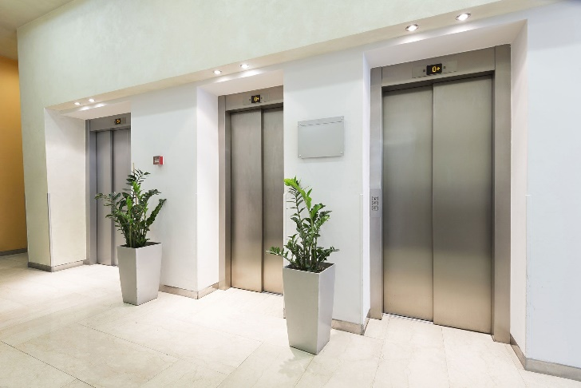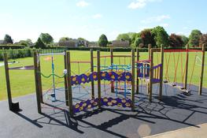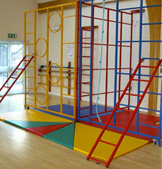

(Continued)

Fill in the following table to identify fabric, installations and equipment at your premises to which compliance legislation applies and as a check that appropriate procedures are being followed.

Ref | Description: | Yes | No
7.0 | ELECTRICITY
7.1 | FIXED ELECTRICAL INSTALLATIONS  Has an inspection of fixed electrical installations been carried out in the last 5 Years?
7.2 | PORTABLE ELECTRICAL APPLIANCES  Has portal electrical appliance testing been carried out in the last 12 months?
8.0 | WATER HYGIENE
8.1 | CONTROL OF LEGIONELLA  Is a water logbook present on the premises?
9.0 | ASBESTOS
9.1 | ASBESTOS INFORMATION
9.2 | ASBESTOS MANAGEMENT  Is an asbestos register and layout plan present on your premises?
9.3 | ASBESTOS EMERGENCY PROCEDURES  Is asbestos present on your premises?
 | If ‘Yes’ do you have arrangements in place to deal with an accidental disturbance of known asbestos materials?

(Continued)

Section 2 Health and Safety Arrangements

2.1 Premises Risk Assessments

There must be a risk assessment in place that covers the premises and estate management. Refer to the NASPM risk assessment document.

The law does not expect you to eliminate all risk, but you are required to protect people as far as is ‘reasonably practicable’.

What Is Risk Assessment?

A risk assessment is simply a careful examination of what, in the workplace, could cause harm to people, so that you can weigh up whether you have taken enough precautions or should do more to prevent harm. Staff, patients, pupils, clients, contractors and others have a right to be protected from harm caused by a failure to take reasonable control measures.

Five Steps to Risk Assessment

- Identify the hazards
- Decide who might be harmed and how
- Evaluate the risks and decide on precaution
- Record your findings and implement them
- Review your assessment and update it if necessary

This is not the only way to do a risk assessment, other methods work well, particularly for more complex risks and circumstances. However, this method is the most straightforward for most organisations.

How to Assess the Risks in Your Workplace

Follow the five steps to risk assessment.

Common examples of hazards in any premises that would need to be considered by the responsible person would be:

- Slips, Trips and Falls
- Manual Handling
- Workplace environment e.g. Temperature, light, welfare facilities
- Noise
- Legionella
- Management of Water
- Fire and bomb procedures, alerts including evacuation/maintenance etc.
- Security of premises (in and out of working hours)
- Traffic Management (parking, deliveries, pedestrian/vehicle segregation)
- Business Continuity Plans and Procedures
- Window Management
- Working at Height

Section 2.2 Health and Safety Inspections



What Is The Purpose Of A Health And Safety Inspection?

The purpose of these inspections is to ensure that staff and visitors are adhering to the safety measures put in place via the risk assessment process and that all work activities are being carried out safely, without endangering other building users. Refer to the NASPM document centre for all premises health and safety inspection forms, these should be made specific for the school.

These tours and inspections should be recorded with any findings being communicated and actioned accordingly.

What Do I Have To Do and When?

Frequency | Task
Initially | Carry out full premises inspection to ascertain overall compliance, this should be carried out with input from other persons such as Trade Union Representatives, Health and Safety Adviser and other building users as deemed necessary.
Ad hoc | Interim or ad hoc inspections should be carried out but may be within a specific area of the premises only or looking at particular hazard staff compliance throughout the building. Again input from those mentioned previously should be sought.
Incident | If following an incident or adverse event it is identified that procedures or controls were not being adhered to then random workplace activities, of a similar nature, should be observed to ensure compliance is being met.
Bi-Annually | A fully planned premises inspection is to be conducted on a bi-annual basis.

(Continued)

Section 2.3 First Aid

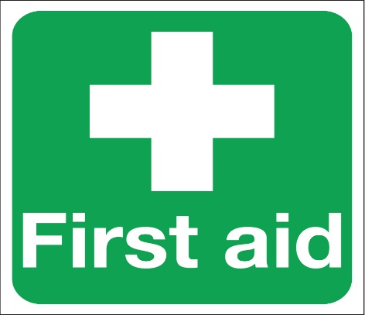

What Is The Purpose of First Aid?

Most low-risk workplaces need only a first aid box and a person appointed to take charge of first aid arrangements such as calling the emergency services and stocking the first aid box. The appointed person does not need specific first-aid training. You must provide all your employees with details of the first aid arrangements. If your workplace has more significant health and safety risks: For example, if you use machinery or hazardous materials then you are more likely to need a trained first aider.

What Do I Have To Do And When?

Frequency | Task
Initially | Carry out a First Aider Risk Assessment to establish the need for such within the premises to ensure adequate first aid measures are in place so that employees and visitors to the premises receive timely attention.
Initially | Ensure all necessary staff is appropriately trained for the First Aid roles identified through the Risk Assessment process with the necessary first aid kits and equipment purchased. That signage is in place identifying names and locations of both first aiders and first aid equipment.
On-Going | Ensure all refresher training is carried out timeously and that all first aid equipment and materials are maintained and in date. You may appoint another person to do this.

(Continued)

Section 2.4 Pedestrian and Vehicle Segregation



What Is The Purpose Of Pedestrian And Vehicle Segregation?

By law, pedestrians or vehicles must be able to use a traffic route without causing danger to the health or safety of people working near it.

A traffic management plan and risk assessment should be completed to ensure that all areas of traffic are assessed against the movement of pedestrians.

What Do I Have To Do And When?

Frequency | Task
Initially | Carry out a Risk Assessment covering the movement and segregation of pedestrians and vehicles to identify areas of risk and the necessary control measures to implement.
On-Going | Monitor movement and segregation of pedestrians and vehicles to ensure compliance with control measures.



(Continued)

Section 2.5 Bomb Threats and Suspicious Packages



What Do I Have To Do And When?

Frequency | Task
Initially | Ensure that staff receiving mail deliveries and incoming phone calls to the premises under their control are aware of the school policy and controls.
Initially | You need to ensure that all staff is aware of the Policy and Procedure that has to be adopted if a suspicious package or bomb threat is received within your premises.
On-Going | These initial actions should form part of the induction process for all new staff being employed within the premises.
On-Going | You should check staff knowledge and understanding of the Policy and Procedure by questioning them during inspections.



(Continued)

Section 2.6 Tree Hazards

What Is The Purpose Of Managing Tree Hazards?

Trees can represent a significant hazard to buildings and their users. This section covers the management of risk associated with trees.

What Do I Have To Do And When?

Frequency | Task
Initially | Identify trees overhanging high-use areas and carry out an initial annual condition check.
Annually | Check the condition of trees overhanging high-use areas and, where necessary, take action to remove risk. Also, check proximity to nearby power lines and for the obstruction of external lighting.
Ongoing | Ensure leaf fall and other tree debris are cleared away where it is likely to be a hazard.
Incidentally | Check trees for damage following extreme weather  E.g. high winds or very heavy snowfall.  Identify trees which overhang high-use areas on your premises.  - You should carry out an inspection to identify any trees which overhang high-use areas i.e. footpaths, roads, playgrounds and car parks etc.  Check the condition of trees that overhang high-use areas.  - If you have identified trees that overhang high-use areas you should carry out a brief visual inspection of the trees from ground level. Look for obvious signs of damage or disease, such as loose or hanging branches, dead limbs and rot.

How Do I Do It?

Task | Instruction
Take action to remove the risk | Where trees exhibit signs of damage, disease or rot they may require work to make them safe.
Check trees for damage | High winds or very heavy snowfall can cause damage to trees. Following extreme weather events, it is recommended that you visually inspect trees from ground level and look for obvious signs of damage. Do not attempt to inspect trees during extreme weather.

Section 3 Access and Use of Premises

Section 3.1 Security Arrangements



What Do I Have To Do And When?

You are responsible for ensuring that premises-specific security management procedures are in place.

Procedures for security management should include arrangements for:

- Normal day-to-day opening and closing of premises
- Control of access to premises, or specific areas within premises, for authorised personnel, visitors or visiting contractors
- Identification of key holders who can be contacted to open the building ‘out-of-hours’ if required
- Control and operation of security equipment and systems
- Employee awareness
- Unauthorised Visitors – Break-in

Frequency | Task
Initially | Carry out a security check of the premises.
Ongoing | Implement and operate security procedures.
Ongoing | Ensure staff and others are aware of security procedures.
Ongoing | Maintain a list of key holders for the premises.
Daily | Ensure premises are secure at the end of each day.
Annually | Review security audit and procedures.

Task | Instruction
Carry out a security audit | A security audit is intended to identify the current provision of security systems and procedures and any possible weaknesses in the arrangements.  There is no ‘one size fits all’ security audit as all premises, and the security risks they face, are different. As a Responsible Person in charge of premises, you will have to use your judgement and knowledge of the premises to help carry out an effective audit.  When carrying out the audit consider:  - Existing security policies, arrangements and equipment i.e. access control systems, fences, window bars, shutters, security locks, alarms, CCTV etc.  - If the building is permanently staffed or not  - What are the arrangements for access to the building?  - Who requires access and at what times?  - Is there a high crime rate in the local area (ask the police)  - Type and value of materials and equipment used in the premises  - Type and sensitivity of information held on the premises  - Arrangements for visitors and visiting contractors  - Specific areas of the premises where access should be closely controlled
Implement and operate security procedures | You should identify, implement or amend security management procedures based on the findings of your security audit.  Procedures should clearly identify who is responsible for the tasks required. In some premises, FMA staff will be on hand to open and close the property and arm/disarm alarm systems. In other premises, you may have to carry out these tasks yourself or appoint staff/deputies to assist you.  If necessary, write down your security procedures, listing each security precaution and who is responsible for carrying it out. These can be circulated to staff if desired. Make sure everyone who has a responsibility for security is aware of what they are supposed to do and when.

(Continued)

Task | Instruction
Implement and operate security procedures | Normal day-to-day opening and closing:  Decide on the arrangements to open the premises each day and to secure them when they close at the end of the day or when they are otherwise left empty. Nominate persons to carry out these tasks and ensure they are aware of what they have to do.  Control of visitors:  - Decide how visitor access to the premises shall be controlled and implement procedures  - Typically this will include  - Deciding which access route visitors shall use when arriving and departing  - Setting up or designating a ‘reception’ area where visitors will report when arriving and departing  - Making sure other access routes are secured against unauthorised entry  - Identifying areas of the premises where access is for authorised persons only and making sure these areas are adequately secured  - Using a means to record visitor arrival and departure e.g. a visitor’s book  - Using a means to identify visitors when they are on the premises e.g. visitor passes  - Ensuring visitors are escorted by whoever they are visiting  - Ensuring visitors have sufficient safety and security information e.g. if a fire alarm test is due
Ensure staff and others are aware of security procedures | Staff should be made aware of the security arrangements in place at the premises including basic security precautions they should follow whilst at work.  Visitors should be made aware of security arrangements, such as signing in and out of the premises, wearing visitor badges etc.
Maintain a list of key holders for the premises | Maintain a list of key holders who can be contacted to open the premises out of hours in an emergency or if the intruder/fire alarm is activated. There should be at least three names on the list (where possible) one of whom should be the Responsible Person.

(Continued)

Task | Instruction
Ensure premises are secure at the end of each day | External doors must be locked and any security bars or shutters fitted.  Gates in perimeter fences/walls, where provided, should be locked.  Fire Alarm/Intruder Alarms should be set at the end of each day using the appropriate code/swipe and disconnected by the same method on re-opening.
Review security audits and procedures | On an annual basis, following significant alterations to the layout or use of the premises; or following a serious security breach, a review of the security audit and arrangements should be carried out to check if they are still applicable and appropriate changes made.

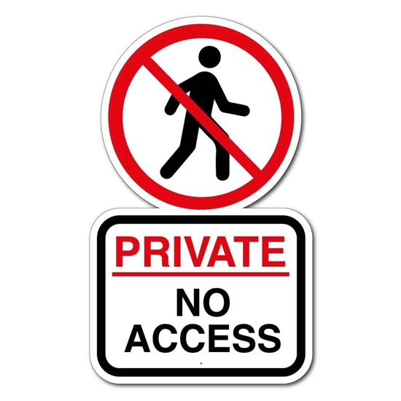

(Continued)

Section 3.2 Control of Visiting Contractors

What Is The Purpose Of Managing Contractors?

Having contractors on the premises that are unfamiliar with its function and layout, is a potential source of health and safety risk.

This section deals with the control of contractors visiting your premises to carry out essential, short-duration, maintenance or repairs to building fabric and services.

Short-duration work typically lasts minutes up to a few hours and is completed the same day, although some work may require follow-up visits on another day.

What Do I Have To Do And When?

You are responsible for ensuring that procedures are in place to control access to your premises by visiting contractors and for sharing information with contractors that will help ensure the safety of everyone at the premises.

Task | Action Required
Arrival of Contractor | The contractor’s arrival and departure times are recorded and there is an exchange of essential information between you at the premises and the contractor.
Arrival of Contractor | When the contractor first arrives on site and before they start work, run through the following points. If you are not satisfied that the contractor can work safely do not allow them to proceed.
Arrival of Contractor | Establish where the proposed work will be carried out so that you can give the contractor relevant information.
Asbestos | Provide the asbestos register for the contractor to check that their work will not disturb identified asbestos; and To check if the work requires disturbance of areas not recorded in the asbestos register (in which case the contractor should not proceed).

(Continued)

Task | Action Required
Arrival of Contractor | Provide the contractor with relevant information about the premises, including:  - Building manuals, risk assessments or logbooks  - Layout of buildings and facilities, location of services, access hatches etc.  - Basic housekeeping and fire procedures  - Significant fire risks that may affect the contractor  - Arrangements for accessing the premises and for security  - Health and safety arrangements that are in place  - Identity and location of other contractors working on the premises  - Any no-go areas (unless escorted by a local member of staff)  - Particular activities that must not be disrupted.  - Advising that anchor bolts or devices (where fitted) should have been tested and to check certificate and tags before use
Arrival of Contractor | Ask the contractor about any aspect of their work that may affect the normal running of the premises including:  - Hot work leading to increased fire risk  - Falls from height/protection from falling objects  - Noisy or dusty working or works causing smells  - Switching off power, water, heating or ventilation  - Switching off or testing alarms  - Temporary obstructions, particularly fire routes and exits  - Arrangements for parking and deliveries  - Segregation of works where appropriate (fencing etc.)  - Welfare arrangements  - Ensure all relevant information is communicated to all staff affected by any works, movement restrictions and changes to normal procedures including evacuation routes

(Continued)

Section 3.3 Event Safety

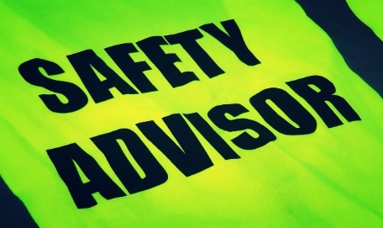

The Event Coordinator

Persons hosting an event are responsible for ensuring they are planned and managed, that there are arrangements for dealing with incidents and emergencies and that attendees are provided with event and safety information, facilities, access and welfare. (See the considerations outlined in the table below).

What to Do and When?

Liaise with the Event Coordinator | You should ensure that any events taking place at your premises are properly managed by the event coordinator. To do this it is recommended that you:  - Make all premises staff aware that they must not organise an event at the premises without seeking your prior approval  - Check that the event coordinator has risk assessed and made arrangements for the successful operation of the event (see the considerations outlined in the table below)  - Events are organised and managed in accordance with any applicable policy or procedure

Event Management, Information and Guidance

Consideration must be given to whether the existing procedures and facilities at the premises are adequate to cope with an event or if temporary additional arrangements must be made.

A framework of considerations is provided in the following table but this list is not exhaustive nor is every consideration applicable to every event. A degree of interpretation and judgment is necessary. The event coordinator should be able to demonstrate that arrangements are in place to address these considerations and where they apply.

(Continued)

Subject | Consideration
Planning and management | Events should be planned and a risk assessment must be carried out.
Venue | A venue for the event should be chosen and consideration given to suitability, capacity, accessibility, welfare facilities and so on.
Fire safety | Fire safety at events needs to be considered, particularly where a large number of people will be present who are unfamiliar with the premises.  Considerations should include:  - Means to detect and give warning of fire  - Means of escape  - Firefighting equipment.
Insurance | Outside companies organising or providing facilities for events should have adequate public liability insurance.
Communication | There should be communication and cooperation between parties involved in planning, organising and running an event.  If necessary there may need to be arrangements for communication between persons who will be managing an event in progress.
Attendance management | There may need to be arrangements to control the number of people allowed into an event so that facilities and safety provisions are not overwhelmed. Examples are ticketing of events and access control at entrance doors.
Transport management | Availability of parking at the premises may need to be considered.
Structures | If temporary structures are to be used there should be consideration of their safe operation, including:  - Location of temporary structures  - Arrangements for supply, erection and dismantling  - Safety arrangements for the operation of the temporary structure
Electrical installations and lighting | Consider arrangements for inspection and safety of temporary electrical installations and equipment.
Catering | Consideration should be given if catering is to be provided and suitable arrangements.

(Continued)

Subject | Consideration
Amusements, attractions. | Consideration should be given to hazards associated with amusements and attractions.
Sanitary facilities | There should be an assessment of whether existing sanitary facilities are adequate given attendee numbers and profile. Perhaps additional facilities need to be arranged.
Waste management | There should be arrangements for collection and disposal of waste.
Fireworks | There must be suitable safety arrangements if fireworks are to be used.
Facilities for persons with special needs | Any special needs of attendees should be taken into account.  Events open to the public should be reasonably accessible to disabled persons.
Medical, ambulance and first aid management | Arrangements should be made to handle medical emergencies including calling an ambulance, if one is needed. Persons should be nominated to take charge of emergencies.  Arrangements should be made for a trained first aider to be on hand.
Information and welfare | Arrangements should be made to provide information to attendees i.e. location of welfare and other facilities.
Children | If children are likely to attend the event arrangements need to be made for their welfare and safety.



(Continued)

Section 4 Fire Safety
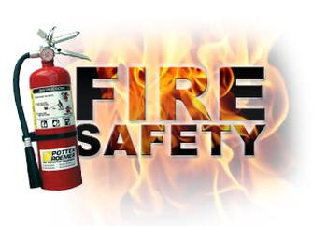
Section 4.1 Fire Safety

Background and Legislation

The Regulatory Reform (Fire Safety) Order 2005 is a statutory instrument applicable in England and Wales. The Order places the responsibility on individuals within an organisation to carry out risk assessments to identify, manage and reduce the risk of fire.

What Am I Responsible For?

As a Responsible Person in charge of the premises, you are responsible for:

- Ensuring that a fire safety risk assessment is carried out
- Cooperating with fire safety risk assessors when they are carrying out the fire safety risk assessment
- Implementing actions assigned to you in the fire safety risk assessment action plan
- Updating the recommended action plan
- Ensuring that actions assigned to others have been carried out and completed
- Ensuring that the fire safety risk assessment is regularly reviewed and kept up to date

What Do I Have To Do And When?

Frequency | Task
Initially | Ensure that a fire safety risk assessment has been carried out.
When a fire safety risk assessment is carried out | Cooperate with fire safety risk assessors carrying out fire safety risk assessments.
When a fire safety risk assessment is issued. | Implement recommended actions assigned to you.
When implementing recommended actions. | Update the action log to indicate progress and completion of recommended actions.
Annually (or following a ‘significant event’) | Review the fire safety risk assessment.

How Do I Do It?

Task | Instruction
Ensure that a fire safety risk assessment has been carried out | Check that a copy of the most recent fire safety risk assessment is available at the premises and that it is up to date. The frequency of fire safety risk assessments shall be indicated on the fire safety risk assessment document.
Cooperate with fire safety risk assessors | The frequency of fire safety risk assessments is determined by the priority rating of your premises
Implementing actions assigned to you | Several recommended actions are likely to be assigned to you to implement:  - Identify what actions are assigned to you and make arrangements to implement them  - Complete each recommended action in accordance with its priority and within the timescale indicated
Update to indicate progress and completion of recommended actions | When implementing the recommended actions assigned to you:  - Regularly update to indicate progress.
Ensuring actions assigned to others are carried out | - Regularly check that recommended actions are being completed within their timescale
Review the fire safety risk assessment | When to review:  A fire safety risk assessment must be reviewed every 12 months or following a significant event at the premises.  Examples of significant events are:  - A fire or a fire ‘near-miss’ occurs  - A proposal to move combustible storage or electrical equipment into a corridor, whether temporarily or permanently  - Changes in the use of the premises or rooms within e.g. a former storeroom being turned into an office  - New or increased levels of flammable substances are stored or used in the workplace  - Proposed or ongoing construction or repair work that prevents or restricts the use of an escape route  - Introduction of portable heaters for use at the premises

Task | Instruction
Review the fire safety risk assessment  (Continued) | - Changes of work practices – changes in opening times or occupation out with normal working hours; new plant or machinery introduced; new work processes introduced  - A deficiency letter is issued by the fire and rescue service  - A member of staff (or another person) raises concerns regarding a fire safety issue  - Someone now requires special assistance to exit the building e.g. disabled employee  - Employees who have an identified role within the evacuation procedure leave, or are unavailable, and cannot be replaced  - An evacuation drill has indicated that there are procedural problems or deficiencies in arrangements  It is up to you as the Responsible Person in charge of the premises to decide if a review is required following a significant event and to manage day-to-day changes that may impact fire safety but which do not necessarily warrant a full review of the fire safety risk assessment.

How Will I Know That My Duties Are Being Met?

An up-to-date fire safety risk assessment will be kept on-site in the compliance logbook.

All fire safety risk assessment recommended improvements will be complete by, or before, their due date shown in the action plan.

A completed review document will be kept on-site in the compliance logbook for each review carried out.

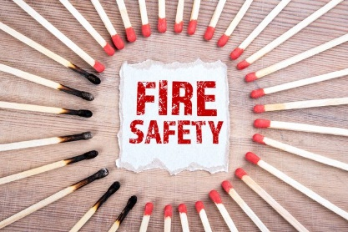

(Continued)

Section 4.2 Fire Detection and Alarm System

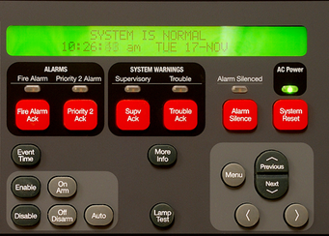

What Am I Responsible For?

As a Responsible Person in charge of the premises, you are responsible for checking that the alarm system is operational at all material times, reporting faults and implementing suitable alternative means to detect and give warning of fire in the event of an alarm failure.

What Do I Have To Do And When?

Frequency | Task
Initially | Identify and record the location of the fire alarm control panel.
Ongoing | Record fire alarm testing and maintenance.
Incidentally | Report any suspected faults in the alarm system
Daily | Check the fire alarm control panel for fault indicators.
Weekly | Tests activate the fire alarm using a break glass call point.
Quarterly | Check that fire alarm servicing has been carried out.

How Do I Do It?

Task | Instruction
Identify and record the location of the fire alarm control panel | Identify the location of the fire alarm control panel and mark this location on a plan of your premises to be placed in the Premises Management Logbook. Include a copy of the plan in the Emergency Incident Response Pack.

Task | Instruction
Record fire alarm testing and maintenance | When weekly test activations of the fire alarm system are carried out make a record of the test using the appropriate form in the compliance logbook. Information records should include the date and time of the test, the location of the call point used and what the results of the test were.
Record fire alarm testing and maintenance | Ensure that contractors visiting to carry out servicing of the fire alarm system record details of their visit in the compliance logbook.
Test activate the fire alarm using a break glass call point | Every week the fire alarm should be test activated using a break glass call point bypass key. A different call point on a different zone should be used for each successive test.
Check that fire alarm servicing has been carried out | Alarm servicing in the compliance logbook and confirm that the contractor has carried out servicing

How Will I Know That My Duties Are Being Met?

A layout drawing has been completed to indicate the location of alarm control panels and break glass points.

A test activation of the fire alarm is carried out every week and there is a complete record of tests carried out in the compliance logbook.

Fire alarm servicing is being carried out and there is a complete record of servicing in the compliance logbook.

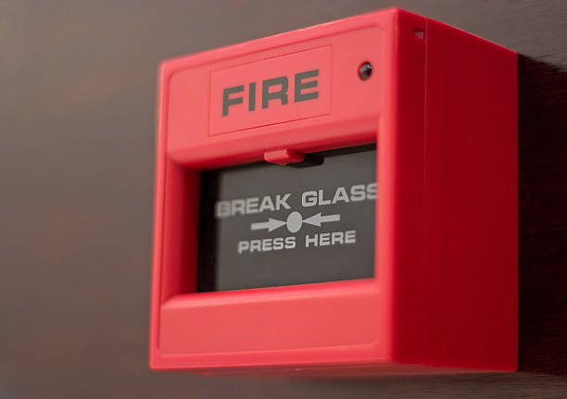

(Continued)

Section 4.3 Fire Fighting Equipment

What Am I Responsible For?

As a Responsible Person in charge of the premises, you are responsible for:

- Ensuring that firefighting equipment and installations are operational and available for use
- Checking that regular maintenance of firefighting equipment is being

What Do I Have To Do And When?

Frequency | Task
Daily | Check portable firefighting equipment is kept in its proper location.
Daily | Check fire suppression installations are operational.
Weekly | Check the condition of all portable firefighting equipment.
Weekly | Check that fixed fire suppression equipment has been tested by a competent contractor in the last 7 days.
Annually | Check that all portable firefighting equipment has been serviced by a competent contractor in the last 12 months.

How Do I Do It?

Task | Instruction
Ensure portable firefighting equipment is kept in its proper location | There are designated points throughout your premises where portable firefighting equipment is stored for use.  You should identify these points and mark them on a plan of the premises for future reference.  Extinguisher points may be indicated by signs. Equipment is generally stored at these points either in floor stands or hung on a wall bracket.  During day-to-day occupation of the building if it is noticed that an extinguisher is missing it should be located and returned to its designated location.  It is not uncommon for extinguishers to be misappropriated for other uses, such as holding doors open.  All staff in the premises should be made aware that if they find an extinguisher out of place then they should replace it in its correct location. All staff should also be made aware that it is not acceptable to use extinguishers for purposes other than their intended use.

Task | Instruction
Ensure that maintenance logs and test cards are correctly filled in by visiting contractors | Contractors shall periodically visit your premises to carry out servicing and checks of firefighting equipment or installations.  You must ensure that these contractors properly record their visit in the compliance logbook and, where appropriate, on the insurers test card.
Check fire suppression installations are operational | Where fixed fire suppression systems are installed they should be checked daily for obvious signs of fault or failure.  All suspected faults or failures should be promptly reported  As each system may differ in design it is not practical for this guidance to describe how these checks are to be carried out.
Check fire suppression installations are operational | Use a competent contractor who visits to service the system.
Check all portable firefighting equipment | Portable firefighting equipment should be checked weekly to ensure that it is present in its correct location and that it has not been tampered with or otherwise discharged.
Check that fixed fire suppression equipment has been tested by a competent contractor in the last 7 days | Fixed fire suppression equipment, where fitted, must be checked and serviced by a competent contractor
Check that all portable firefighting equipment has been serviced by a competent contractor in the last 12 months | Portable firefighting equipment must be maintained and ready for use.

How Will I Know That My Duties Are Being Met?

Record of checks carried out and actions taken.

An up-to-date record of portable firefighting equipment maintenance in the compliance logbook.

Up-to-date labels fitted to portable firefighting appliances.

Section 4.4 Means of Escape

Background and Legislation

The provision of escape routes should be assessed during the fire safety risk assessment process.

What Am I Responsible For?

As a Responsible your duties include ensuring that fire escape routes are provided and that these are available for use at all material times.

To do this you will have to carry out several checks and actions to ensure that:

- Internal and external escape routes are maintained free from obstruction
- Fire and smoke control doors are kept closed when not in use and that hold open devices, where installed, operate when the fire alarm sounds
- Escape routes are provided with adequate artificial lighting
- Alternative escape routes are identified whenever an existing escape route is unavoidably blocked
- Doors and fire doors on escape routes are not locked, free from serious damage, free to open on both sides and operate correctly
- Emergency exit doors and devices are free from serious damage and operate correctly

What Do I Have To Do And When?

Frequency | Task
Initially | Identify escape routes, fire doors, emergency exits and fire assembly points and mark these on a plan of the premises.
Ongoing | Keep records of checks, inspections and actions taken in the Premises Management Logbook.
Daily | Check all identified escape routes and emergency exit doors and remove any obstructions or combustible materials discovered.
Daily | Check and ensure that self-closing fire doors are not wedged or propped open.
Daily | Open, remove or disable any out-of-hours security devices fitted to emergency exit doors e.g. locks, bolts, shutters etc.
Daily | Check that lights on escape routes are operational and that emergency lights do not show obvious faults.

(Continued)

Frequency | Task
Weekly | Check the operation of push bars or pads fitted to emergency exit doors and doors open fully.
Weekly | Check the operation and condition of self-closing fire doors.
Weekly | Check that the door hold open device releases doors as part of the fire alarm test.
Weekly | Check that all signs and notices are in place are legible.
Weekly | Check that communication systems used as part of the emergency evacuation procedure are operating e.g. intercoms in temporary waiting spaces.
Monthly | Inspect fire doors for faults or damage.
Monthly | Check that a competent contractor has tested the emergency lighting within the last month.

How Do I Do It?

Task | Instruction
Various checks and inspections | A daily walk-round inspection regime should be introduced to encompass various fire safety and other checks and observations.
Inspect fire doors for faults or damage | Fire doors should be checked to ensure they are in good working order as follows:  - Inspect doors for any warping or distortion that will prevent the door from closing flush into the frame;  - Check any fire-resisting glazed panels are in good condition and secure in their frame; and  - Check that intumescent strips and smoke seals are in good condition.  - Report any faults or damage so that repair can be arranged and record action in the Premises Management Logbook.

(Continued)

Section 4.5 Fire Safety Arrangements

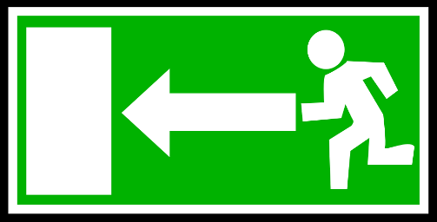

Background and Legislation

Fire safety arrangements and procedures should be assessed during the fire safety risk assessment process.

What Am I Responsible For?

As a Responsible Person in charge of the premises, you must ensure that there are adequate fire safety arrangements in place for your premises. Such arrangements must include:

- Fire drills
- Emergency fire action plan
- Evacuation procedures
- Fire systems impairment plan  and where appropriate:
- Local fire safety plan

What Do I Have To Do And When?

Frequency | Task
Initially | Check that appropriate fire safety arrangements are in place. Create fire safety arrangements if they do not already exist.
Incidentally | Review fire safety arrangements following a fire, fire near miss or when practice drills indicate a weakness in the arrangements.
Ongoing | Regularly check that no one requires a personal evacuation plan. Be aware of anyone who is temporarily disabled, perhaps due to an injury.
Six months | Carry out a fire drill at least twice every year.
Annually | Review fire safety arrangements to ensure they are up to date.

(Continued)

How will I know that my duties are being met?

Up-to-date and completed fire safety arrangements documents are available.

Fire safety drills have been carried out and recorded in the Premises Management Logbook.

Section 4.6 Fire Safety Information and Training

This section deals with the requirement to provide fire safety information and training to persons using the premises

Background and Legislation

The premises fire safety risk assessment and action plan may include recommendations regarding the provision of information and training.

What Am I Responsible For?

As a Responsible Person, your duties include providing fire safety information and instruction, which includes:

- Delivering fire safety awareness training to any staff you directly manage on the premises. See ‘What to tell employees’ (below)
- Providing any other local managers with relevant and appropriate information on the fire safety provisions and arrangements in the premises so they can cascade this to their staff. See ‘What to tell employees’ below
- Making arrangements to provide fire safety information to visitors

What to Tell Employees

All staff (including volunteers, temporary and agency staff) should be given information, training and instruction on the fire safety measures to be taken or observed on the premises, including the action to be taken in case of fire.

The specific fire safety training needs of any young persons employed should be considered. Training of each member of staff should take place as soon as possible after they are appointed and regularly, at predetermined intervals after that, to ensure that they remain familiar with procedures.

Staff that have a supervisory role should be given details of the findings of the fire safety risk assessments and should receive additional training which will enable them to discharge their specific responsibility.

(Continued)

Training for this role may include:

- Detailed knowledge of the fire safety strategy of the premises
- Instruction on the operation of any fire alarm control panel installed within the building, with particular attention to the information displayed and how to interpret this information
- How to search safely and recognise areas that are unsafe to enter
- The difficulties that disabled persons may have in escaping and associated special evacuation arrangements

Staff that have a supervisory role must arrange for their staff to be provided with adequate fire safety information and instruction, which should be delivered:

- When a staff member is first employed
- Whenever a staff member is exposed to new or increased fire risks

Training Must:

- Include sufficient instruction and training on the appropriate precautions and actions to be taken by the employee to safeguard himself or herself and other relevant persons on the premises (see what to tell employees, below)
- Be repeated periodically – at periods not exceeding 3 years
- Be adapted to take account of any new or changed risks
- Be provided in a manner appropriate to the risk identified by the fire safety risk assessment
- Take place during working hours.

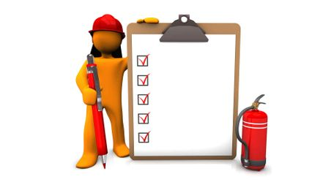

(Continued)

Section 5 Maintenance Arrangements

5.1 Requesting Maintenance Work

You should ensure that:
- There are local procedures to identify defects and everyone is aware of them
- Health and safety risks are managed until repairs can be made or another action is taken to control the risk
- There is cooperation and assistance given to visiting contractors to allow them to carry out their work

Planned Maintenance

Planned maintenance includes:
- Scheduled routine maintenance and inspections
- Planned repair, replacement or upgrade of building components

Reactive Repairs - Routine Requests

Urgent repairs are defined as work that if not done, could cause reactive repairs.

Reactive Repairs - Urgent Requests

Emergency work is defined as work which, if not done, would result in:
- Closure/non-effective operation of the School – e.g. major heating or electrical failures
- Risk to clients, staff or members of the public – e.g. bulging ceilings, gas escape, falling masonry, slates, etc.
- Further serious property damage– e.g. burst pipes, security issues

Health and Safety Issues

It is your responsibility to ensure building defects or faults that are perceived to constitute health and safety risks are properly managed. This responsibility remains until the hazard has been removed.

How Will I Know If My Duties Are Being Met?

Procedures are in place to identify and notify defects and repairs.

Perceived health and safety hazards are managed.

There is an up-to-date record of repair requests and corresponding actions taken.

Section 5.2 Safety during Construction Work



Background

Construction work in occupied premises is likely to introduce a range of safety risks for premises users that must be properly managed during the life of the project.

General health and safety legislation applies to construction projects whatever their size or nature, whether maintenance, refurbishment, repair or development. In particular, the Construction Design & Management Regulations 2015 require that health and safety be planned and managed at every stage of construction projects.

What Am I Responsible For?

- Health and safety procedures
- Programming and timing
- Zoning and phasing arrangements
- Decanting of staff and others (pupils, etc.)
- Arrangements for moving into and commissioning new buildings

Every effort should be made at this planning stage to anticipate potential health and safety issues and make arrangements to minimise disruption to the normal running of the premises during the construction project.

Responsibility for health and safety during construction projects is shared between the different duty holders so your cooperation is essential, and a legal obligation.

(Continued)

Section 5.3 Cleaning Arrangements

What Am I Responsible For?

Frequency | Task
Initially | Identify what the cleaning and window cleaning arrangements are.
Ongoing | Monitor standards of cleanliness and liaise with cleaning providers, when required, if there are issues with standards or changes to arrangements.

How Do I Do It?

Frequency | Task
Initially | Identify what the cleaning and window cleaning arrangements are.
Ongoing | Monitor standards of cleanliness and liaise with cleaning providers, when required, if there are issues with standards or changes to arrangements.

How Will I Know If My Duties Are Being Met?

Floors, fixtures, fittings, internal surfaces and windows are free from accumulation of dirt, dust and general soiling.

Waste bins and buckets are not overflowing with waste materials.

Recycling materials are regularly removed. Recycling ‘stations’ should not overflow

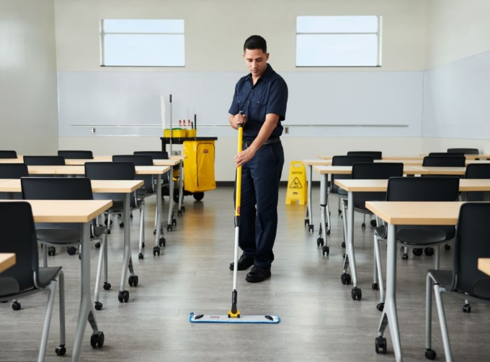

(Continued)

Section 5.4 Window Maintenance



This section deals with the requirement to maintain windows and to keep records of maintenance carried out.

What Do I Do And When?

- Check that the windows receive maintenance in accordance with the schedule of maintenance at the beginning of this handbook

Frequency | Task
Ongoing | Keep records of checks, inspections and actions taken in the Premises Management Logbook.
Annually | Check that all windows have been serviced by a competent contractor/person in the last 12 months.

(Continued)

Section 6 Plant and Equipment

Section 6.1 Boilers
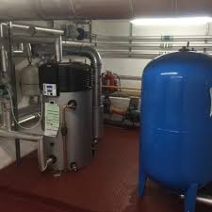

This section deals with actions to be taken to help ensure the safe operation of boilers and heating plant.

What Do I Have To Do And When?

You are responsible for checking that maintenance, inspection and testing of boilers and heating plant is being carried out in accordance with the schedule of maintenance.

What Am I Responsible For?

Frequency | Task
Ongoing | Details of all boiler and heating plant maintenance, checks, testing and inspection have been recorded within the Premises Management Logbook.
Daily | Check that boilers and heating plant are operating satisfactorily and, if not, report faults
Quarterly | Check and ensure that all boiler and plant rooms are free from unnecessary storage, particularly, combustible or flammable materials.
Six monthly | Check that boilers and heating plant have received routine maintenance, checks and tests in the last 6 months. Report any missed services or inspection
Annually | Check that boilers and heating plant have been inspected by a competent person in the last 12 months. Report any missed services or inspections.

How Will I Know My Duties Are Being Met?

An up-to-date record of maintenance, inspection and testing will be present in the compliance logbook.

For gas appliances, a copy of the annual gas safety inspection certificate will be kept at the premises.

Section 6.2 Kitchen Canopy Extraction Systems

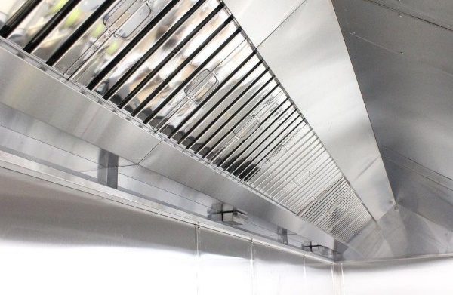

What Am I Responsible For?

You are responsible for ensuring that kitchen canopy extraction systems in your premises are cleaned, at least, annually by a competent contractor.

What Do I Have To Do?

Frequency | Task
Initially | Identify if a kitchen extract system is installed on your premises.
Annually | Check that all kitchen extraction systems in your premises have been cleaned during the last 12 months.

How Do I Do It?

Task | Instruction
Check that all kitchen canopy extract systems in your premises have been cleaned during the last 12 months. | Where kitchen extraction systems are installed in your premises ensure that a record of cleaning and maintenance is kept within the compliance logbook.  Carry out an annual review and check that the most recent cleaning date recorded is within the last 12 months.

How Will I Know If My Duties Are Being Met?

A Record of the cleaning of the kitchen extraction systems is kept in the Premises Manager Logbook

Cleaning of the kitchen extraction systems has been carried out in the last 12 months.

Section 6.3 Local Exhaust Ventilation (LEV)

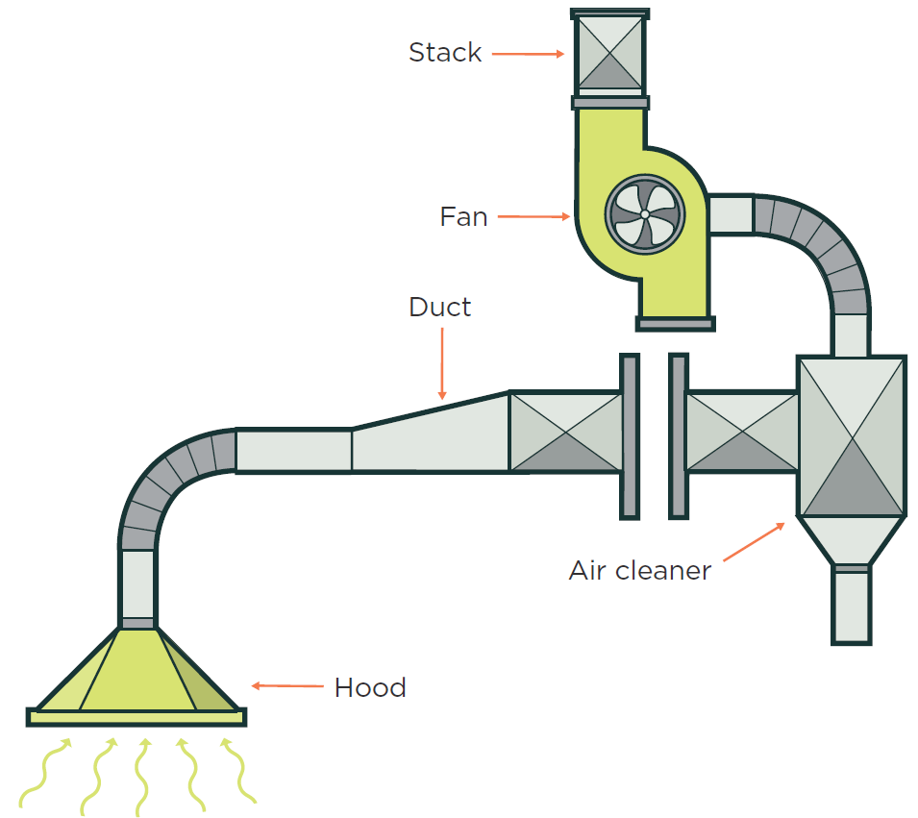

This section deals with checks and tests necessary to ensure that local exhaust ventilation systems are operating correctly.

A local exhaust ventilation system uses extract ventilation to prevent or reduce airborne hazardous substances from being breathed in by people in the workplace.

Typically these systems consist of an inlet placed close to the point where hazardous substances are released, ductwork and a fan or air mover. Air removed is either exhausted to the outside atmosphere or returned to the workplace after having been cleaned to make it safe for release.

What Am I Responsible For?

You should be aware of any local exhaust ventilation systems in use at your premises and ensure that the operators have made sufficient arrangements for inspection, maintenance and controls to ensure that thorough examinations are carried out.

You should do this by identifying if local exhaust ventilation systems are used in your premises and checking that the operators keep up-to-date records of maintenance and examinations.

(Continued)

Section 6.4 Fall Arrest Anchors

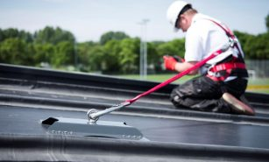

This section deals with actions to be taken to ensure the safe and correct performance of anchor points or anchor devices intended to be used as part of a personal fall arrest system.

Background and Legislation

Anchor points or anchor devices must be removed, wherever possible, to prevent them from being used. If they cannot be removed then they should be clearly tagged to indicate that they have been tested and a note of the test date. These devices should not be used if it is found to be out of test date or marked as having failed the test.

What Am I Responsible For?

You should determine if fall arrest anchors are installed, or likely to be installed, at your premises.

If you are aware that fall arrest anchors are likely to be fitted you must include the certificate of testing and any failure within the information you provide to visiting contractors.

What Do I Have To Do And When?

Frequency | Task
Initially | Identify if anchor devices are fitted at your premises.
Ongoing | Advise visiting contractors that anchor points and fall arrest systems have been tested and if there are any defects.

How Will I Know If My Duties Are Being Met?

You are aware that fall arrest anchors are likely to be installed.

You have included advice on the testing of fall arrest anchors in your information for visiting contractors.

Section 6.6 Gas Safety

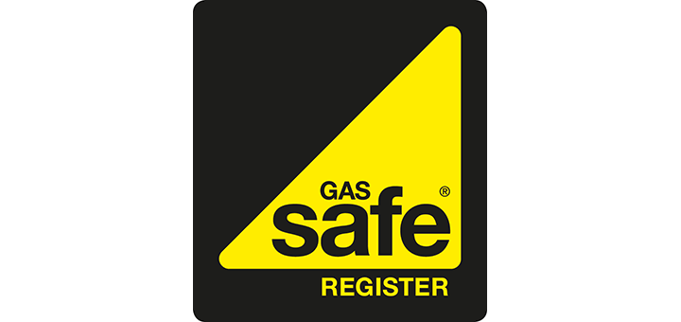

Anyone carrying out work to gas appliances or fittings must by law be competent and registered to do so. Competence to carry out gas work can be established by ensuring that contractors are a member of the UK Gas Safety Register.

What Am I Responsible For?

You are responsible for checking that:

- Contractors visiting your premises to carry out gas work are members of the United Kingdom Gas Safe Register
- Gas appliances suspected of being unsafe or faulty are not used
- A gas certificate has been compiled and a copy is kept at the premises
- Faults or concerns about gas appliances are reported
- Appropriate action is taken if a gas leak is suspected – refer to the following guidance titled ‘In the event of a gas leak’
- Maintenance of gas-fired appliances is being carried out
- Annual gas safety checks of gas-fired appliances are being carried out

What Do I Have To Do And When?

Frequency | Task
Initially | Check whether your premises have a gas supply and, if so, that a copy of the gas supply system health and safety file is kept on site.
Ongoing | Contractors visiting to carry out gas work are competent.
Ongoing | Prevent the use of any gas appliance suspected to be faulty or unsafe. Report faults promptly

(Continued)

Frequency | Task
Ongoing | Retain records of gas contractor visits in the compliance logbook and a copy of the most recent gas safety inspection certificate(s) supplied by the contractors.
Ongoing | If a gas leak is suspected, follow ‘In the event of a gas leak’ procedures.
6 months | Check that a contractor has visited to carry out maintenance of gas-fired appliances. Report missed maintenance visits
Annually | Check that gas safety inspection of gas appliances has been carried out in the last 12 months. Report missed safety inspections

How Will I Know That My Duties Are Being Met?

A Gas safety inspection has been carried out in the last 12 months.

A gas supply system health and safety file is kept at the premises.

If You Suspect a Gas Leak

All gas escapes or gas emergencies must be reported immediately

If you do smell gas, follow these simple steps:

DON’T:
- Smoke or strike matches;
- Turn electrical switches on or off.

DO:
- Consider evacuating the area.
- Put out naked flames;
- Open doors and windows to ventilate the property;
- Turn off the gas supply at the meter;
(Unless the smell of gas and the meter are in a cellar)
- Make sure any gas appliances are turned off;
- Report the leak to the Property Maintenance Helpdesk.

(Continued)

Section 6.7 Lifts

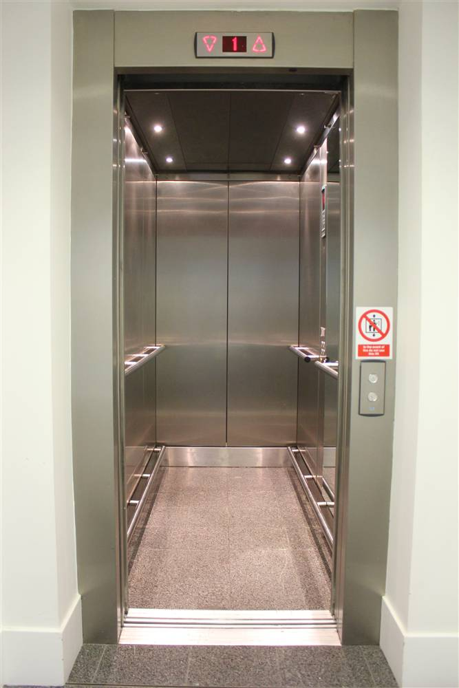

What Am I Responsible For?

This responsibility includes:

- Checking lifts for any obvious signs of fault or failure
- Maintaining a site record of lift maintenance and thorough examination
- Checking that maintenance and thorough examinations are being carried out.

What Do I Have To Do And When?

Frequency | Task
Initially | Identify all lifts on your premises and record them in the Premises Audit
Ongoing | Record dates of lift maintenance and thorough examinations in the Premises Management Logbook.
Daily | Check lifts for obvious signs of fault.
Monthly | Check that monthly lift servicing has been carried out. Report any missed servicing.
Six monthly | Check that a thorough examination of all passenger-carrying lifts has been carried out within the last 6 months. Report any missed examinations
Annually | Check that a thorough examination of all non-passenger carrying lifts has been carried out within the last 12 months. Report any missed examinations.

How Do I Do It?

Task | Instruction
Check lifts for obvious signs of fault | Lifts should be checked daily for obvious signs of fault.  Things to look for include:  - The lifts are inoperative  - The lift does not travel smoothly  - There are abnormal noises or smells  - The internal lights have failed  - The lift doors do not open and close smoothly  - The lift does not return to floor level  - Signs and notices are missing or illegible

Task | Instruction
Check that maintenance and thorough examinations are being carried out | Maintain a lift maintenance record for each communal use lift and use this as a check that maintenance is being carried out.

How Will I Know That My Duties Are Being Met?

An up-to-date record of lift monthly servicing will be available for each installation.

Up-to-date thorough examination reports/certificates will be available for each lift installation

(Continued)

Section 6.8 Playground and Gymnasium Equipment

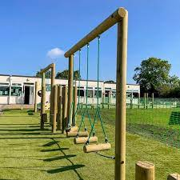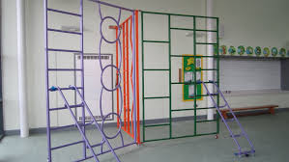

What Am I Responsible For?

You are responsible for ensuring that playground and gymnasium equipment provided is inspected and maintained in a safe condition and that any equipment considered unsafe is not used until it is repaired or otherwise altered to remove the hazard.

You must also ensure that existing equipment is not altered, and no new equipment is installed, unless this is done in accordance with applicable published standards and guidance.

If gymnasium or playground facilities are provided in your premises by another service or third-party organisation you should check that they have arrangements in place for the maintenance of equipment under their control.

What Do I Have To Do And When?

Frequency | Task
Initially | Create and implement a ‘user’ inspection schedule for gymnasium and playground equipment.
Ongoing | Review and amend the inspection schedule based on observations made.
1 to 3 months | Operational inspections in accordance with manufacturer’s instructions or best practice.
Annually | Main inspections in accordance with manufacturer’s instructions or best practice.

Section 7 Electricity

Section 7.1 Fixed Electrical Installations

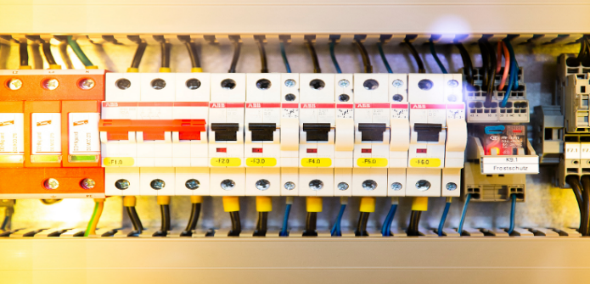

Such periodic inspection is normally carried out at 5 years but the period may be reduced depending upon the age and condition of the installation and/or the type of building in which the electrical system is installed.

What Am I Responsible For?

You are responsible for:

- Checking that a competent person has inspected the fixed electrical wiring within the last 5 years, or shorter interval, if appropriate
- Ensuring that all switch-gear and electrical plant cupboards are kept free from rubbish and not used as general storage; These areas should be locked at all times with appropriate warning signs

What Do I Have To Do And When?

Frequency | Task
Ongoing | Should you become aware of or suspect any faults with electrical systems
Annually | Check that periodic inspections of electrical systems have been carried out

How Will I Know If My Duties Are Being Met?

Electrical inspections have been carried out within the required period.

Reported electrical faults have been rectified.

There is no apparent physical damage or sign of fault in electrical installations.

Section 7.2 Portable Electrical Appliances

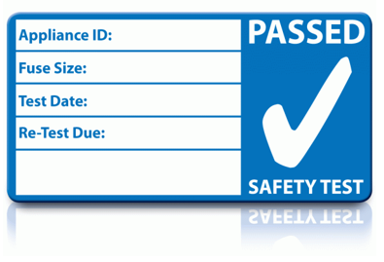
This section deals with the safety of portable electrical appliances in low-risk environments

Definition of Portable Electrical Appliance

A portable electrical appliance is an electrical appliance that is intended or likely to be moved whilst in operation and whilst connected to the electrical supply or an appliance that can be disconnected, moved, reconnected and operated in different locations. In general, portable electrical appliances are connected to a power supply [either a fixed installation or a generator] via a flexible power lead and a plug.

Users of Electrical Appliances

Are responsible for carrying out pre-use and regular safety checks of electrical appliances they use in the workplace in accordance with manufacturer’s instructions or recommended best practice.

What Do I Have To Do And When?

Frequency | Task
Annually | From your records check that annual inspection and testing of portable electrical appliances has been carried out by a competent contractor.
Incidentally | Ensure any appliances provided for communal use in the premises e.g. photocopiers, fridges etc. are maintained in accordance with the manufacturer’s instructions. You may have a maintenance agreement with the supplier or other arrangements may be in place.
Incidentally | Ensure any appliance provided for communal use that is suspected of being faulty is not used until it is repaired or removed.

Section 8 Water Hygiene

Section 8.1 Control of Legionella



This section deals with the control of legionella bacteria in water systems.

What Am I Responsible For?

You are responsible for:

- Checking the legionella contractor is making regular monthly visits to the premises to carry out monitoring and testing
- Ensuring the water logbook is made available to legionella control contractors who visit the premises to carry out monitoring and testing of water systems
- Ensuring the flushing of little-used outlets is carried out and recorded
- Identifying little-used water outlets, carrying out regular flushing of these outlets and recording the action in the appropriate section of the Water Logbook

What do I Have to Do and When?

Frequency | Task
Ongoing | Identify little-used outlets.
Weekly | Flush little-used outlets and record.
Monthly | Check Legionella contractor has visited.

(Continued)

How Do I Do It?

Task | Instruction
Identify  little-used  outlets | Instruction:  Specific water outlets i.e. taps, showers, WCs etc. at your premises may be used infrequently, which can result in increased legionella risks.
Identify  little-used  outlets | Little-used outlets:  You should identify, based on your knowledge and observation of your premises, where water outlets are used infrequently and record their location in the water logbook on the sheet titled ‘Little-Used Outlets’. The legionella control contractor may also be able to assist in the identification of little-used outlets, based upon their monitoring regime.
Identify  little-used  outlets | Irregular use of premises:  If premises or parts of premises are not used for 7 to 28 consecutive days then all water outlets in the unused areas should be flushed by the Responsible Person in charge of the premises when the premises or areas are re-opened.
Identify  little-used  outlets | Temporary closures:  If the legionella control contractor has not been able to access premises, or areas of premises, for more than 28 days due to a temporary closure, then a request to have the legionella contractor visit to flush water systems and carry out legionella checks before the premises, or closed-off areas, being re-opened.
Identify  little-used  outlets | School holidays:  For school premises that close for the summer holidays and are not used during those weeks, arrangements are in place for the legionella control contractor to visit in the week before the school reopens to flush the water systems and carry out legionella checks.

How Will I Know My Duties Are Being Met?

A water logbook is present on the premises.

Monthly checks are being carried out by the legionella control contractor in the Water Logbook

Little-used outlets are being flushed and actions are recorded in the Water Logbook

(Continued)

Section 9 Asbestos

Section 9.1 Asbestos Information



The Control of Asbestos Regulations states that duty holders are those who are responsible for any maintenance and repair of premises and also those who have control of access to the premises.

Duty Holders Must:

- Identify if there are materials in their premises that contain, or are suspected to contain asbestos
- Record the location and condition of asbestos-containing materials
- Make information on the location and condition of asbestos-containing materials available to anyone liable to disturb them
- Keep these records up to date

Training requirements are as per the Asbestos Policy, each service area is responsible for coordinating training for their service.

ASBESTOS SURVEY PROGRAMME

Asbestos Management Surveys - include inspections of immediate surfaces and accessible void spaces in the full premises. This level of survey allows ongoing management of those asbestos materials identified and this information is included in the premises compliance folder. It does not include surveys of an intrusive nature.

(Continued)

Asbestos Refurbishment Surveys - include localised intrusive surveys of inaccessible areas (above ceilings, inside walls, below floors, risers and boxing). This level of survey may be tailored to the specific scope of your work and is used for specific projects or planned improvements to premises.

Asbestos Demolition Surveys - are only applicable when the premises or partial premises are being demolished. These are fully intrusive surveys and apply to the full area being demolished.

Section 9.2 Asbestos Management

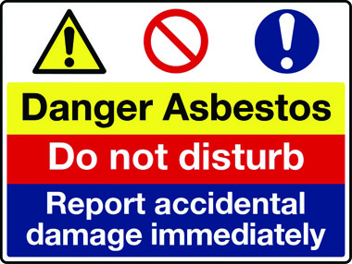

Site-Specific Asbestos Management Plan/Asbestos Register

Ensure that copies of the asbestos management survey and plans are available and shared with all relevant persons including contractors. The management plan should be read in conjunction with this report where required as it may contain equally important information on materials which do not contain asbestos as well as those which do.

Who Should View The Asbestos Management Plan And Register?

Both the asbestos management plan and the register must be viewed by anyone whose work activities involve maintenance or repair within the premises.

Work where the fabric of the building will be disturbed requires a more detailed survey in which the location of asbestos-containing materials will be identified in relation to the scope of the works. Anyone attending your premises to carry out intrusive works should not proceed until evidence that a relevant asbestos refurbishment survey has been undertaken and that all necessary precautions have been taken.

Please be aware that intrusive work may also require asbestos removal work to take place. This should be taken into consideration before the work commences

(Continued)

What Information Is Included On The Asbestos Register?

The asbestos register contains information on the asbestos type, condition and location of asbestos-containing materials or strongly presumed asbestos-containing materials identified in the premises during the asbestos management survey.

It will also indicate full locations where no survey was possible and therefore asbestos is presumed to exist.

What Is An Asbestos Re-Inspection Survey?

Where asbestos-containing materials have been identified they must be re-inspected on an annual basis to check for change to their condition.

Site-Specific Inspections

As the Responsible Person, you may conduct or delegate additional inspections throughout the premises for several health and safety or maintenance reasons. If checking the asbestos information and you notice any changes in the condition of the material that give you concern please contact your asbestos advisor

Section 9.3 Asbestos Emergency Procedures

What Information Is Not Included On The Asbestos Register?

Information on asbestos contained in live electrical equipment and plant are not included in the asbestos register.

As noted above, asbestos refurbishment survey information on asbestos contained within concealed areas of the premises (i.e. ceiling voids, risers or service voids, walls voids, floor voids etc.) may or may not be included on the register.

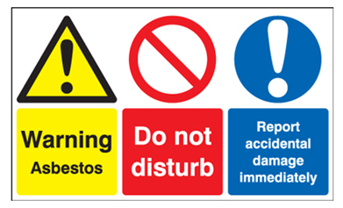

Guidance Version Control
Name Of Document | Version | Last Review date
Premises Management Handbook | NASPM V2 | September 2024

Copyright © 2024 NASPM

All rights reserved.

No part of any NASPM document may be reproduced, distributed, or transmitted in any form or by any means, including photocopying, recording, or other electronic or mechanical methods, to any individual, school, or organisation outside of the school named in the school membership agreement.

Should membership terminate, no part of any NASPM document may be used, reproduced, distributed or transmitted by any individual, school, or organisation.

