Winter Weather

Gritting

Guidelines

Document 68

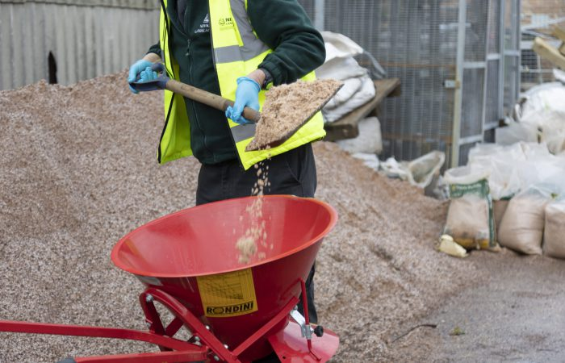

Winter Weather Gritting Guidelines

If the temperature drops or is predicted to drop below +1°C within any subsequent 24-hour period then gritting will be proactively undertaken as on the Site Gritting Plan. The site grit plan includes the pedestrian access and egress route to provide a safe gritted route for pupils, staff and visitors.

The Premises Manager and SLT will check the BBC weather forecast https://www.bbc.co.uk/weather or Met Office https://www.metoffice.gov.uk/
to ensure there is a planned process and weather monitoring in place.

This task will be undertaken Monday to Friday excluding Bank Holidays and School Holidays unless otherwise requested in advance by the School. If the weather is snow and forecasted snow the premises staff may not be able or expected to clear snow and the snow/extreme weather risk assessment activated.

Gritting will normally be undertaken between 7 am and 8 am first thing in the morning before the school opening. In the event of extreme weather conditions premises staff will be supported may be supported by staff and/or external contractors to complete this task.

A Plan has been provided to understand the areas that detail the gritting plan. These areas are generally limited to primary circulation paths, the intersections of paths and primary routes into car parking areas, however, exclude Car Parking Bays.

The Premises Team will ensure all indicated routes are well-gritted, especially areas where there are inclines, changes in levels or direction and including all emergency escape routes (not assembly points).

Please monitor the weather forecast diligently, enabling you to be as proactive as possible in its approach to safe access and egress within the School boundary during winter weather conditions.

Additionally, ensure there is an adequate stock of gritting salt and equipment to enable you to facilitate this task. Follow the school extreme weather risk assessment and ensure that you have completed manual handling training and have appropriate PPE, this includes essential safety boots and warm clothing. Ensure that you take regular breaks to warm up and take care of yourself, this means a dynamic risk assessment when gritting pathways.

The site gritting plan can be added below.



Guidance Version Control
Name Of Document | Version | Last Review date
Winter Weather Gritting Guidelines | NASPM V2 | September 2024

Copyright © 2024 NASPM

All rights reserved.

No part of any NASPM document may be reproduced, distributed, or transmitted in any form or by any means, including photocopying, recording, or other electronic or mechanical methods, to any individual, school, or organisation outside of the school named in the school membership agreement.

Should membership terminate, no part of any NASPM document may be used, reproduced, distributed or transmitted by any individual, school, or organisation.

