Fire Brigade Safety School Audit

Advisory Notes

Document 62

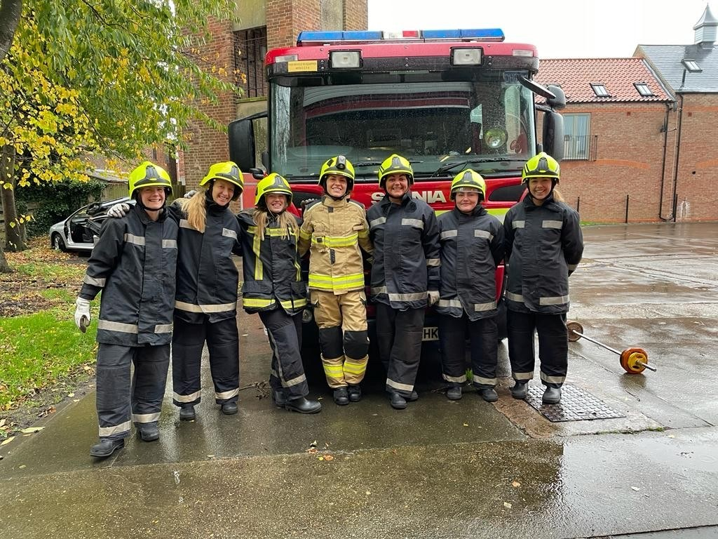

Fire Brigade Safety School Audit Advisory Notes

This is a typical advisory note from the fire brigade that is sent out to schools when notifying of a school fire audit
Advisory Notes – What to Expect

We aim to carry out visits fairly and openly as stated in the local authority area Fire & Rescue Authority’s Enforcement Policy Statement. (You can view this on their local authority websites for example, www.bedsfire.com )

Fire Safety Inspectors

We will show you evidence of our authority if you ask for it.
We will be happy to explain our powers to you.

What We Consider During the Visit

During the visit, we will try to establish whether your premises are safe in case of fire. We might ask questions and ask you to provide evidence to support your answers.

We will consider all of the following:

- What you are doing to reduce the risk of fire
- What you are doing to reduce the risk of the spread of fire
- What you are doing to detect fire and raise an alarm
- Whether people understand what to do if a fire breaks out
- What you are doing to fight outbreaks of fire safely
- What you are doing to ensure that the effects of a fire are as small as possible
- Are there enough escape routes (corridors, stairs and doors) for people in case of fire
- What you are doing to make sure that escape routes (corridors, stairs and doors) are safe to use when needed

Fire Safety Standards

As part of the visit, we will look at the fire safety standards in all or part(s) of the building. We will consider that safety against appropriate recognised standards. We may also wish to talk to employees to confirm their level of fire safety awareness.

If you need further advice please consult the relevant publication which provides information about the Regulatory Reform (Fire Safety) Order 2005.

This publication is available from the Government website at:

https://www.gov.uk/workplace-fire-safety-your-responsibilities

Fire Alarm System

The fire alarm test, where provided, should be carried out in accordance with the manufacturer’s instructions and current British Standard 5839.

Daily Tests

- Inspect the panel for normal operation of the system.
- Where provided, check that the connection to the monitoring centre is functioning correctly.

Weekly Test by User

Carry out a test and examination to ensure that the system is capable of operating under alarm conditions, namely:-

- Operate a manual call point at approximately the same time each week using a
different call points for each successive test.
- Where appropriate inform the monitoring control centre prior to the test.

Periodic Inspections and Tests by a Fire Alarm Engineer

- These should be carried out by a competent person, e.g. a fire alarm engineer.
- Requirements for these inspections and tests will depend upon the type and design of the system but will generally be carried out six monthly.

Emergency Lighting

Emergency lighting tests, where provided, should be carried out in accordance with the manufacturer’s instructions and current British Standard 5266.

Monthly

- Simulate a failure of the normal lighting supply for sufficient time to allow all luminaires to be checked for correct operation.
- Check each luminaire for any obvious signs of damage or deterioration, including the cleanliness and general condition of lenses and diffusers.
Annually

- Simulate a failure of the normal lighting supply for the full duration of the battery
- Carry out a check of the charging arrangements to ensure proper functioning.

Note

- All checks, tests and maintenance including faults and remedial action taken, should be recorded.
- The date on which each fault is rectified should also be recorded.

Guidance Version Control
Name Of Document | Version | Last Review date
Fire Brigade Safety School Audit Advisory Notes | NASPM V3 | September 2024

Copyright © 2024 NASPM

All rights reserved.

No part of any NASPM document may be reproduced, distributed, or transmitted in any form or by any means, including photocopying, recording, or other electronic or mechanical methods, to any individual, school, or organisation outside of the school named in the school membership agreement.

Should membership terminate, no part of any NASPM document may be used, reproduced, distributed or transmitted by any individual, school, or organisation.

