Ladder Register

Document 60

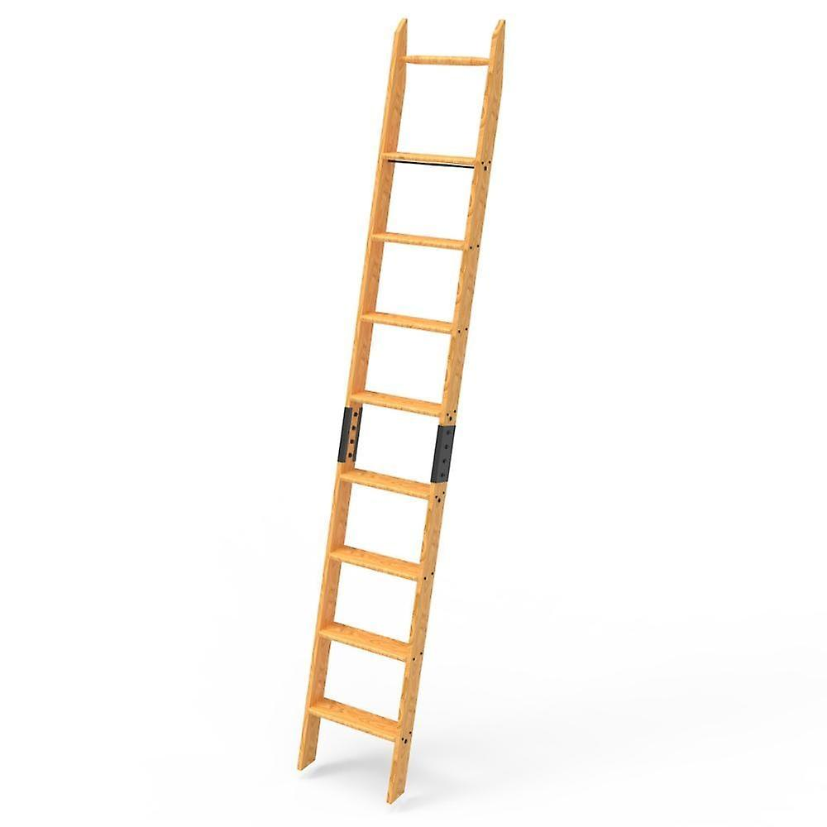

Ladder Register

This is a 6 monthly ladder inspection form, the premises staff will take out the ladders from storage, open them up and complete a careful inspection of the ladders following the checklist above, this ladder inspection is in addition to the user checks that are completed but not recorded each time the ladders are used.

 | Ladder Ref No | Have you? | Signed | No  Action | Action | Date
 |  | - Checked feet are not missing or damaged  - Checked rungs are not damaged  - Checked there are no bolts/screws missing  - Checked no contamination on the ladder
- Checked feet are not missing or damaged
- Checked rungs are not damaged
- Checked there are no bolts/screws missing
- Checked no contamination on the ladder

 | Ladder Ref No | Have you? | Signed | No  Action | Action | Date
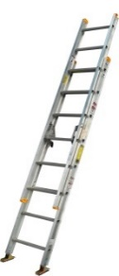 |  | - Checked feet are not missing or damaged  - Checked rungs are not damaged  - Checked there are no bolts/screws missing  - Checked no contamination on the ladder
- Checked feet are not missing or damaged
- Checked rungs are not damaged
- Checked there are no bolts/screws missing
- Checked no contamination on the ladder

- Checked feet are not missing or damaged
- Checked rungs are not damaged
- Checked there are no bolts/screws missing
- Checked no contamination on the ladder

 | Ladder Ref No | Have you? | Signed | No  Action | Action | Date
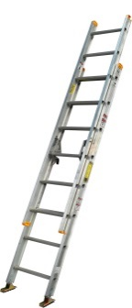 |  | - Checked feet are not missing or damaged  - Checked rungs are not damaged  - Checked there are no bolts/screws missing  - Checked no contamination on the ladder
- Checked feet are not missing or damaged
- Checked rungs are not damaged
- Checked there are no bolts/screws missing
- Checked no contamination on the ladder

- Checked feet are not missing or damaged
- Checked rungs are not damaged
- Checked there are no bolts/screws missing
- Checked no contamination on the ladder

 | Ladder Ref No | Have you? | Signed | No  Action | Action | Date
- Checked feet are not missing or damaged
- Checked rungs are not damaged
- Checked there are no bolts/screws missing
- Checked no contamination on the ladder

Guidance Version Control
Name Of Document | Version | Last Review date
Ladder Register | NASPM V3 | September 2024

Copyright © 2024 NASPM

All rights reserved.

No part of any NASPM document may be reproduced, distributed, or transmitted in any form or by any means, including photocopying, recording, or other electronic or mechanical methods, to any individual, school, or organisation outside of the school named in the school membership agreement.

Should membership terminate, no part of any NASPM document may be used, reproduced, distributed or transmitted by any individual, school, or organisation.

