Security Premises

Audit

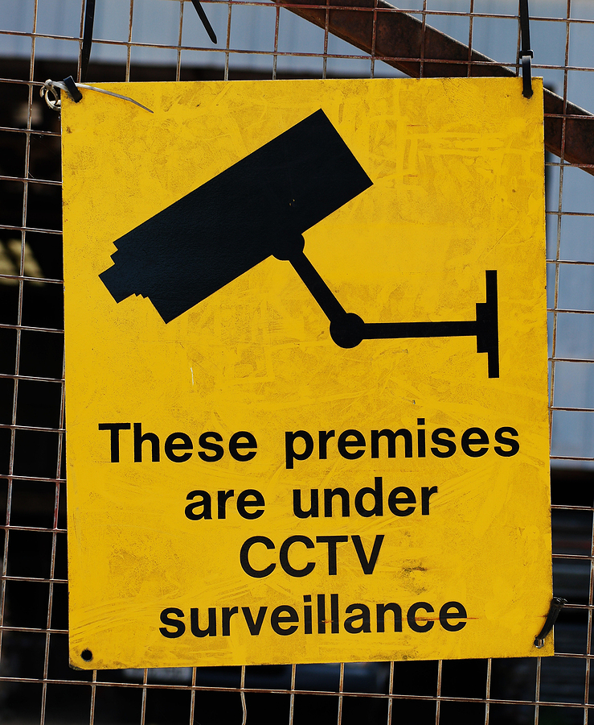

Security Premises Audit

Management Information and Practice | Yes | No | N/A | Action
Have you carried out a meaningful assessment of crime and fire prevention measures?

Is your Critical Incidents Policy/or Business Continuity policy up to date and are all staff aware of it?

Is there a nominated person who is responsible for recording suspicious incidents, crime and vandalism?

Do you record the nature, time, place and cost of any theft and vandalism including minor incidents?

Are these incidents reported promptly, on discovery, both internally and to the Police?

Is damage quickly made good to discourage further similar damage?

Do you have established emergency procedures, such as who the Receptionist might call if there is a suspicious or threatening person in reception?

Liaison | Yes |  | No | N/A |  | Action
Do you feel supported by the police in preventing crimes?

Have the police followed up crimes?

Do you have regular contact with your neighbourhood policing team?

Has guidance on security and damage control been sought from the Police Crime Reduction Officer?

Training | Yes | No |  |  | N/A | Action
Are staff warned to note suspicious activities?

Is there a policy where staff are warned to notify management when strangers are seen on the premises?

Are staff and employees trained in security awareness?

Do you test and monitor management protocols?

Are your vulnerable groups, given appropriate information re possible dangers and security?

Contingency Planning | Yes |  | No | N/A | Action
In the event of a break in, is there an established procedure for contacting your key holders/ security?

Do you have a business plan to minimise disruption to normal activities after a serious incident such as loss of computers?

Are duplicate records and back-up copies of computer files kept in a separate location?

Security of Buildings | Yes | No |  | N/A | Action
Are the premises in good repair and free from flimsy construction, such as low-level glazing or lightweight panelling?

Is the boundary of the premises clearly defined and are there access restrictions in place?

Has consideration been given to protecting or eliminating recessed doorways, concealed yards, shrubs, planted areas and similar features which can give cover to intruders?

Are all entrance doors locked and windows and skylights secured when the premises are not in use?

Security of Buildings | Yes | No | N/A | Action
Have steps been taken to restrict easy access to the roof from points such as lower, adjacent structures, compounds, walls & down pipes?

Are tools and ladders locked securely away?

Have any areas been identified which might be particularly vulnerable to vandalism or forced entry?

Have any areas been identified which might be particularly vulnerable to arson? Do you have a current fire risk assessment?

Has a comprehensive intruder alarm system covering all the Premises been installed?

Does the intruder alarm automatically notify the police via a central monitoring station?

Does the intruder alarm system activate lights?

Is the alarm system set and unset solely by designated persons who are trained for the task and are the codes regularly changed?

Is the alarm system regularly maintained and inspected?

Security of Buildings | Yes |  | No | N/A | Action
Is the alarm installer a member of the British Security Industry Association (BSIA) or the National Approved Council for Security Systems (NACOSS)?

Is CCTV installed

Is CCTV working properly and maintained with a policy in operation?

Keys and Locking Up | Yes | No |  | N/A | Action
Is there a proper system to control the issue of keys/ access codes?
Is there an established ‘locking up procedure’ which includes checking there is no one concealed in the building and all windows and internal doors are closed?
Is there a procedure for periodically checking security fittings such as locks, catches and bolts?

(Continued)

Security During Working Hours | Yes | No | N/A | Action
Are buildings designed to prevent access except through controlled Entrances?

Are suitable access procedures in place for deliveries?

Are any doors left open during the day and for what reason?

Are visitors encouraged to use the main door and is this clearly signposted?

Is it clear to visitors that they are on private property?

Do you have a procedure to monitor the arrival and departure of Visitors?

Are visitors asked for identification and provided with passes, which are collected when they leave?

Have arrangements been made to protect vulnerable groups

Have arrangements been made to protect vulnerable groups (e.g. pupils) at closing time?

Security During Working Hours | Yes | No | N/A | Action
Are employees encouraged to confront strangers they see in the building?

Are visitors escorted to and from their destination and monitored whilst waiting in reception?

Are members of the public prevented from entering unauthorised parts of the building?

Have arrangements been made for the personal safety of staff and employees working in isolated areas?

Do you have a procedure for monitoring all the activities of contractors on your premises?

Anti-Social Behaviour | Yes | No | N/A | Action
Have there been incidents of threats to staff?

Have there been incidents of abusive behaviour?

Have there been incidents of vandalism/criminal damage?

Have thefts occurred during these incidents?

Has there been evidence of drunkenness?

Security During Working Hours | Yes |  | No | N/A |  | Action
Has there been evidence of drug taking?

Has there been any violent behaviour?

Security Outside Working Hours | Yes |  | No | N/A |  | Action
Are special arrangements made for surveillance during vulnerable times such as holidays?

Are the premises checked by security?

Are the premises well lit when not in use?

Is external security lighting provided?

Is there natural surveillance from surrounding buildings or passing members of the public?

Is there a Premises Manager on site?

Is the Premises Manager easily contactable?

Can the Premises Manager quickly contact the security company, police and fire service?

Are cleaning operators supervised or suitably vetted?

Theft | Yes | No | N/A |  | Action
Are there secure storerooms or containers for securing attractive Items such as audiovisual equipment, computers and videos and are these always used and kept locked?

Is equipment marked so as to identify the owner and are signs displayed to this effect to deter thieves (Smartwater)?

Are cash holdings kept to a minimum and in line with local authority policy?

Is cash counted out of sight?

Are staff and employees advised on the need to safeguard personal property?

Is money removed from premises overnight?

Have special arrangements been made to protect items of particular interest to thieves, such as food stocks, shop supplies, tools and solvents?

Are secure worktop fittings provided for attractive portable equipment?

CCTV Compliance | Yes | No |  | N/A | Action
Is there a CCTV policy in place?

Are staff trained in the use of CCTV and is use restricted?

Are the screens and recorder in a secure location?

Are all the camera locations relevant and adequate?

Is an Incident Log Book maintained?

Is the system time and date correct?

Is the system maintained (who by)?

Vehicles | Yes |  | No | N/A | Action
Do you have a management policy to protect vehicles of both staff and visitors?
Do you have a policy to ensure that employees do not leave company valuables in vulnerable vehicles?

Guidance Version Control

Name of document | Version | Last Review date
Security Premises Audit | NASPM V2 | October 2024

Copyright © 2024 NASPM

All rights reserved.

No part of any NASPM document may be reproduced, distributed, or transmitted in any form or by any means, including photocopying, recording, or other electronic or mechanical methods, to any individual, school, or organisation outside of the school named in the school membership agreement.

Should membership terminate, no part of any NASPM document may be used, reproduced, distributed or transmitted by any individual, school, or organisation.

