Control of Substances

Hazardous to Health

(COSHH)

Risk Assessment

Template

Document 46

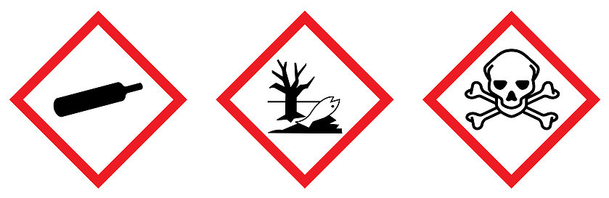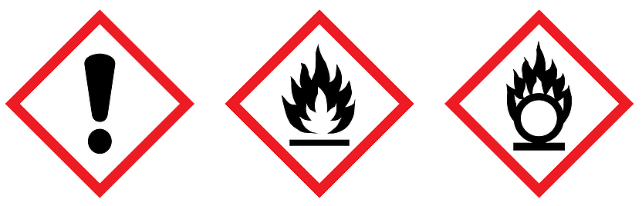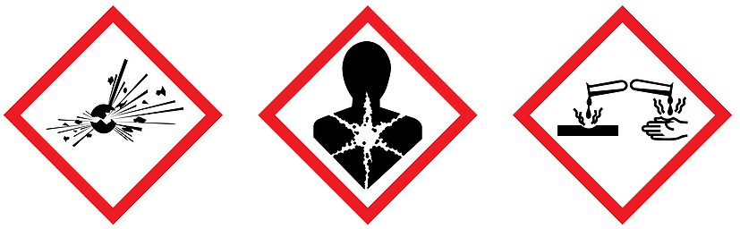

Control of Substances Hazardous to Health (COSHH)
Risk Assessment Form (Template)

Name of Establishment |  |  |  |  |  | Name of Assessor |  |  |  |  |  |  | Trade Name of Product |  |  |  |  |  |  |  | Name of Chemical Compound/s |  |  |  |  |  |  |  |  |  |  | Supplier |  |  |  |  |  |  | Who Will Be Exposed?
Describe The Activity Or Process Where It Is Used and What It Is Used For |  |  |  |  |  |  |  |  |  |  |  |  |  |  |  |  |  | Frequency of Use |  |  |  |  |  |  |  |  |  |  |  |  |  |  |  |  |  |  | Quantity of Use |  |  |  |  |  |  |  | Exposure Time
Training Requirements (List Any Specialised Training Requirements Before The Activity Can Begin) |  |  |  |  |  |  |  |  |  |  |  |  |  |  |  |  |  |  |  |  |  |  |  |  |  |  | Date of Assessment |  |  |  |  |  |  |  |  |  |  |  |  | Date to Review
Classification Labelling & Packaging (CLP) Sign: This Product Has No Classification Under CLP
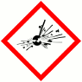 |  | 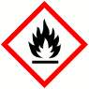 |  |  |  |  | 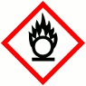 |  |  |  |  |  |  | 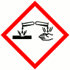 |  |  |  |  |  | 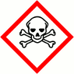 |  |  |  |  | 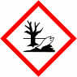 |  |  |  |  |  | 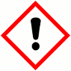 |  |  |  |  | 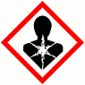 |  |  |  |  |  |  |  | 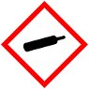
Hazards Can Exist in the Form of:
 | Gas |  |  |  | Vapour |  |  |  |  |  |  | Mist |  |  |  |  |  |  | Fume |  |  |  |  |  | Dust |  |  |  |  |  | Liquid |  |  |  |  |  |  | Solid |  |  |  |  |  |  |  |  | Other e.g. Gel
Route of Exposure
 | Inhalation |  |  |  |  |  |  |  | Skin |  |  |  |  |  |  |  | Eyes |  |  |  |  |  |  |  |  | Mouth |  |  |  |  |  |  |  | Puncture |  |  |  |  |  |  |  |  |  |  |  | Other e.g. Hand

Workplace Exposure Limits  (can be found in the DS) |  |  |  |  | Risks to Health  (Harmonised Warning & Precautionary Statement) H300’s
Long Term  (8hr TWA) | Refer to the safety data sheet |  |  |  | Hazard statements (CLP) :  Precautionary statements (CLP) :
Short Term  (15 mins) | Refer to the safety data sheet |  |  |  | Hazard statements (CLP) :  Precautionary statements (CLP) :
Is Health Surveillance required? | Yes |  | No |  | Hazard statements (CLP) :  Precautionary statements (CLP) :
Is Monitoring Required? | Yes |  | No |  | Hazard statements (CLP) :  Precautionary statements (CLP) :
Control Measures:
Consider if the risk can be eliminated or reduced by using a less harmful substance

Personal Protective Equipment (PPE ) is to be used as the last resort for controlling exposure
 |  |  |  |  |  |  |  |  |  |  |  |  |  | 
First Aid Procedures If The Substance Has Entered The Body Through Ingestion/Skin/Eyes/Mouth/Inhalation

Additional Safety Information |  |  |  |  |  |  |  |  | Is Exposure Adequately Controlled? |  |  |  | Yes |  |  | No
Storage
Disposal
Spill Procedure
Local Exhaust Ventilation (LEV), Fume Cupboards Or Other Engineering Control?
Required | Yes |  |  |  | No |  |  | If Yes: The Date Of Examination and Test
Risk Rating After Control Measures Are Implemented
HIGH |  |  |  |  |  |  | MEDIUM |  |  |  | LOW

Guidance Version Control
Name Of Document | Version | Last Review date
Control of Substances Hazardous to Health (COSHH) Risk Assessment Template | NASPM V5 | February 2025

Copyright © 2024 NASPM

All rights reserved.

No part of any NASPM document may be reproduced, distributed, or transmitted in any form or by any means, including photocopying, recording, or other electronic or mechanical methods, to any individual, school, or organisation outside of the school named in the school membership agreement.

Should membership terminate, no part of any NASPM document may be used, reproduced, distributed or transmitted by any individual, school, or organisation.

