Lockdown Procedure

Document 44

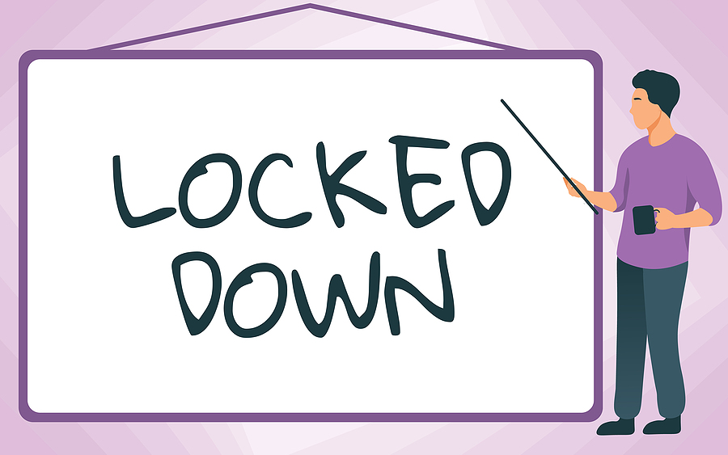

Lockdown Procedure

- Introduction

Lockdown procedures may be triggered in response to any external or internal incident which has the potential to pose a threat to the safety of staff and students, some of these incidents include but are not limited to:

- An unauthorised person(s) considered dangerous are on school grounds
- A civil disturbance in the local community that poses a potential threat to staff and pupils
- Bomb threats
- A parent/carer that has become a threat to staff or pupils or a specific pupil whether on a routine meeting, visit, or as a pre-warning to the school not to allow access
- Firearms and weapon attacks
It is vital that lockdown procedures are familiar to all staff and pupils. To achieve this, a lockdown drill is undertaken [enter frequency here]. (This should be once per year as a minimum.

- Roles and Responsibilities

The following listed persons and their roles and responsibilities during a lockdown are:

Role | Name | Emergency Contact Number

- Alarms & Signals

The following table documents how we will alert all persons present in the building of a lockdown:

Alarm or signal for part lockdown
Alarm signal for full lockdown
Signal for all -clear

- Locations

It is very important to remember that unless the location of an intruder is known, a blind “evacuation” may be putting people in more danger (e.g. from the intruder or device at one of the entrances/exits) than if they had remained in the building.

The following table documents the most suitable rooms on the premises for lockdown.

Rooms Most Suitable for Lockdown
(Consider locations behind substantial brickwork and heavy reinforced walls)
E.g. Classrooms, Offices or Sports hall

- Communication

Wherever possible use silent communications and keep noise to a minimum. Ensure mobile phones are turned off or turned on silent.

Communication devices should be secure and not easily intercepted.

The following table documents the communication arrangements in the event of a lockdown.

Communication Arrangements
E.g. Two-way radios – internal communication
Mobile phones – internal and external communication
Instant messaging/email
Communicating with Parents
In the event of an actual lockdown, the development will be communicated to parents as soon as practicable via (insert)

- Alternative Sites

The following table documents alternative places of safety in the area, should it be necessary to leave the site.

Pre-identified alternative place of safety/buddy school/rest center
if it is considered necessary to leave the site
Name of Premises
Type of Premises
Contact name and details of the key holder(s)
Address
Telephone number
Directions/map
Est. travel time(walking with pupils)
Est. travel time(by coach with pupils)
Capacity (including sleeping)
Facilities/resources
Notes

- Specified Lockdown Procedure

Lockdown arrangements should be divided into “partial” and “full”

Partial Lockdown Procedure

In a partial lockdown staff and pupils should remain in the school building and all doors leading outside should be locked.

No one should be allowed to enter or leave the building, unless it is safer to leave the school site, this may lead to full evacuation or part evacuation.

Procedure for Partial Lockdown  (This is only a guide and should be modified to suit the school) | Completed by  (Sign and time)
Sound Alert - Lockdown procedures are activated immediately (All outside activities should cease immediately)

Dial 999

Staff and pupils may stay in their classroom, signed-in visitors to a safe place and movement may be allowed (depending on what and where the risk is)

Turn off lights, fans

Close windows/blinds

Hide, sit on the floor under desks, and away from windows

Stay as silent as possible - put any mobile devices on silent (consider writing/displaying instructions on whiteboards/TVs etc. as long as it can’t be seen by the intruder)

Ensure that students, staff and visitors are aware of an exit point in case the intruder does manage to gain access

If possible, check for missing/injured students, staff and visitors

Keep doors and windows locked shut and remain inside until an all-clear has been given, or unless told to evacuate by the emergency services

A “partial lockdown” may also be a precautionary measure but helps to put the school in a state of readiness should the situation escalate

Full Lockdown Procedure

This is an immediate threat to the school. Aim for the school and its rooms to appear empty.

Procedure for full lockdown ( this is only a guide and should be modified to suit the school) | Completed by  (Sign and time)
Sound Alert - Lockdown procedures are activated immediately (All outside activities should cease immediately)

Dial 999

Direct all staff and pupils, signed in visitors to a safe place

Turn off lights, fans

Close windows/blinds

Hide, sit on the floor under desks, and away from windows

Stay as silent as possible - put any mobile devices on silent (consider writing/displaying instructions on whiteboards/TVs etc. as long as it can’t be seen by the intruder)

Ensure that students, staff and visitors are aware of an exit point in case the intruder does manage to gain access

Take a register of all staff/pupils in each classroom. If possible, check for missing/injured students, staff and visitors

Keep doors and windows locked shut and remain inside until an all-clear has been given, or unless told to evacuate by the emergency services

Consideration of how the school contact and stop any off-site visits coming back into the school

Consideration of safe areas for those outside the school

(Continued)

- Additional Information to Note

- Specific arrangements should be made for pupils/staff with different needs (visual impairment/ mobility needs)
- Areas in the school that cannot be effectively locked down should be identified and lockdown instructions should include how to remove staff/pupils from these areas to a place of safety, lockdown room/zone
- In the event of a lockdown and the fire alarm sounds, the school should contact emergency services as in a normal fire alarm activation. The school should devise a method to identify the fire zone, update emergency services and evacuate the school.
- Ensure that the school has completed a security audit as this will identify and assist in any physical protection weaknesses and the need for improvements

Guidance Version Control
Name Of Document | Version | Last Review date
Lockdown Procedure | NASPM V3 | August 2024

Copyright © 2024 NASPM

All rights reserved.

No part of any NASPM document may be reproduced, distributed, or transmitted in any form or by any means, including photocopying, recording, or other electronic or mechanical methods, to any individual, school, or organisation outside of the school named in the school membership agreement.

Should membership terminate, no part of any NASPM document may be used, reproduced, distributed or transmitted by any individual, school, or organisation.

