Working at Height

Risk Assessment

Document 41

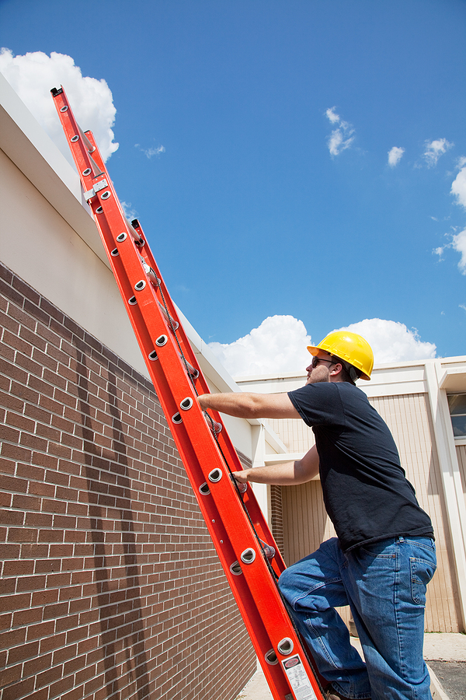

Working at Height Risk Assessment

Name of the Risk Assessment | Working at Height

Name of the School
Date of Assessment |  | Risk Assessment Reference
Name of the Assessor |  | Signature | Next Review Date
Activity Description - Describe either the activity or subject being assessed
Working at Height Activities

This is a generic work at height risk assessment.

Specific risk assessments should be completed for tasks presenting significant risks

What are the hazards? | Who might be  harmed and how? | What are you already doing? | Risk  L/M/H | Anything else to manage this risk? | Action by whom & when? | Done?
Unsafe working at height on school roofs  Collecting balls/objects and cleaning guttering/drains from open flat roofs (not having barrier edge protection or man-safe systems) | Premises staff collecting items from the roof  Contractors working on unsafe roofs re no edge protection  Falling from height causing harm, fractures, death as not having a safe access and working at height – i.e. no edge protection or man safe systems | - Prohibit all working on unsafe flat roofs (having no edge protection or man-safe systems)  - Arrange for quotations for either edge protection or man-safe systems  - The use of contractors to complete the premises tasks that include safe systems of work – safe working at height – safe access and egress, for example the use of scaffolding and temporary edge protection
Using inappropriate work at height equipment  E.g. tables/chairs; | School employees  Premises Manager  Serious injury  Death | - Employees are reminded through emails and team meetings not to use tables or chairs to hang posters, displays or reach objects stored at height  - Employees do not use ladders, step ladders or elephant stools (delete as appropriate) and ask for assistance from the premises team when work at height activity is to be completed  - All employees who make use of step ladders and elephant stools have received training/instruction on working at height  - Ladders are only used for short- duration work (less than 30 minutes) and where the risk of injury is low and only by the premises team  - Employees avoid the risk by not working at height e.g. using long-reach equipment  - Employees do not hang posters or displays at height and ask for assistance from the premises team if this is required

(Continued)

What are the hazards? | Who might be  harmed and how? | What are you already doing? | Risk  L/M/H | Anything else to manage this risk? | Action by whom & when? | Done?
Faulty access equipment  (Continued)  E.g. stepladders, kick stools, ladders  Faulty access equipment | School employees  Premises Manager  Serious injury  Death | - A pre-use check is completed before any access equipment is used  - Access equipment is inspected termly by the premises manager to ensure they remain undamaged and suitable for use. These inspections are recorded  - Access equipment is inspected more frequently if used or stored in environments that could lead to deterioration  - Faulty equipment is taken out of use immediately
Overreaching or overbalancing when on a step ladder or ladder | School employees  Premises Manager  Serious injury  Death | - When using ladders/stepladders employees do not stand and work on the top 3 rungs, or the top three steps (including a step forming the very top of the stepladder) unless there is a suitable handhold  - Where possible an alternative method of working is used, e.g. using extendable poles to clean high-level areas  - Ladders are properly set up to avoid overreaching  - Mobile towers are used where practicable and a specific risk assessment has been completed

(Continued)

What are the hazards? | Who might be  harmed and how? | What are you already doing? | Risk  L/M/H | Anything else to manage this risk? | Action by whom & when? | Done?
Overloading the ladder | School employees  Premises Manager  Serious injury  Death | - The weight of the employee and the equipment or materials being carried are considered before working at height  - Ladders are only used for light work and not for work that involves carrying heavy or awkward items

(Continued)

What are the hazards? | Who might be  harmed and how? | What are you already doing? | Risk  L/M/H | Anything else to manage this risk? | Action by whom & when? | Done?
Unsecured Ladders | School employees  Premises Manager  Serious injury  Death | - Ladder stiles are tied with straps or ropes to a suitable point to prevent them from slipping either outwards or sideways.  - All four stepladder feet are in contact with the ground and the steps are level  - Ladder stabilization devices are used  (Name the device used or delete if not applicable)  - If a ladder cannot be tied or stabilizes are not used, then it can be held by a second person  - Ladders are rested against strong upper resting points (do not rest the ladder against weak upper surfaces such as glazing or plastic gutters)  - Make sure the ladder angle is at 75° – you should use the 1-in-4 rule (i.e. one unit out for every four units up  - Ladders are not placed on a drum, box or other unstable base  - Ladders are removed to storage at the end of each working day to ensure that unauthorized access to the roof etc. by others, particularly students, is prevented  - 3 points of contact are maintained at the working position

What are the hazards? | Who might be  harmed and how? | What are you already doing? | Risk  L/M/H | Anything else to manage this risk? | Action by whom & when? | Done?
Slippery substances transferred onto access equipment  E.g. mud | School employees.  Premises Manager.  Serious  Injury  Death | - Footwear is free from mud/grease before climbing a ladder/stepladder  - Suitable footwear is worn on school premises

(Continued)

What are the hazards? | Who might be  harmed and how? | What are you already doing? | Risk  L/M/H | Anything else to manage this risk? | Action by whom & when? | Done?
Incorrect use of ladders/  Stepladders | School employees  Premises Manager  Serious injury  Death | - The premises manager is trained to work at height.  - No moving or extending the ladder while standing on the rungs;  - Always grip the ladder and face the ladder rungs while climbing or descending – don’t slide down the stiles;  - Avoid holding items when climbing (consider using a tool belt);  - Non-conductive ladder (e.g. fibreglass or timber) is used for any electrical work  - Always read and follow the manufacturer’s instructions on how to use the ladder  - Higher risk activities such as accessing fragile roofs, Cleaning out gutters; Cleaning windows that cannot be reached from ground level; Changing a bulb/florescent tube at a high level etc. must have specific risk assessments if they are completed by the premises manager  - When contractors are used to carry out any work at height, risk assessment and method statements must be provided before work is carried out.

What are the hazards? | Who might be  harmed and how? | What are you already doing? | Risk  L/M/H | Anything else to manage this risk? | Action by whom & when? | Done?
Weather conditions  E.g. high winds, heavy rain, hot weather etc. | School employees  Premises Manager  Serious injury  Death | - The premises manager assesses the weather conditions before undertaking any external work at height activity and does not undertake the task if conditions are unsuitable.
Manual handling of access equipment | School employees  Premises Manager  Musculoskeletal  Injuries  Bruising  Fractures | - The premises manager has completed manual handling training  - The premises manager can always ask for help to move ladders

(Continued)

What are the hazards? | Who might be  harmed and how? | What are you already doing? | Risk  L/M/H | Anything else to manage this risk? | Action by whom & when? | Done?
Fragile Surfaces  Fragile roofs  Fragile glass | School employees.  Premises Manager  Falls from height resulting in death, serious injury | - Fragile roofs are identified with warning signs;  - No roof work is carried out by the school employee/premises manager
Poor reporting of incidents related to work at height | School employees.  Premises Manager.  Lack of data to identify opportunities for improvement e.g. introducing secure low-level storage in classrooms | - As part of the school’s policy and reinforced during induction, all incidents and near misses are to be reported using the  (Name of the school’s accident reporting software or accident book)
Inadequate emergency procedures | School employees  Premises Manager  Inadequate supply of first aiders or first aid supplies | - No lone working when working at height  - A rescue plan specific to each task has been included in the risk assessment for high-risk work at height activities  - First aid cover is available and in place at all times  - The school is in close proximity to (Name of hospital/GP)

Schools should review and amend where necessary

Overall Risk Rating | Choose an item.

Please ensure that every item has a risk rating based on the below colours in the appropriate column above and then select the overall risk rating from the drop-down box above.

Overall Residual Risk | LOW
Level of Risk | Suggested Action
LOW | Control measures are adequate but continue to monitor and review  Ensure that they remain satisfactory and appropriate
MEDIUM | Control measures need to be introduced within a specified time  Continue to monitor and review
HIGH | Unless control measures can be immediately introduced to reduce the risk so far as is reasonably practicable  The task or activity should be suspended

Guidance Version Control
Name Of Document | Version | Last Review date
Working at Height Risk Assessment | NASPM V3 | September 2024

Copyright © 2024 NASPM

All rights reserved.

No part of any NASPM document may be reproduced, distributed, or transmitted in any form or by any means, including photocopying, recording, or other electronic or mechanical methods, to any individual, school, or organisation outside of the school named in the school membership agreement.

Should membership terminate, no part of any NASPM document may be used, reproduced, distributed or transmitted by any individual, school, or organisation.

