Work Equipment

PUWER Assessment

Document 40

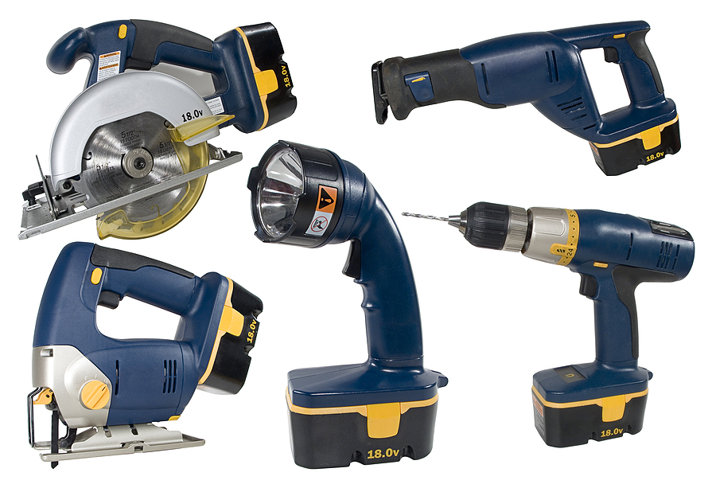

Work Equipment PUWER Assessment
Provision and Use of Work Equipment Regulations 1998 (PUWER)

The Equipment That Is Being Assessed | Activity Undertaken | Assessors Name | Date of the Assessment
1 | Identification | Yes | No | N/A | Comments
 | Is the equipment CE/UKCA marked? Some work equipment that is not powered or used to lift might not be CE marked e.g. hand tools, ladders | ☐ | ☐ | ☐
 | Is an operating manual provided with this equipment? | ☐ | ☐ | ☐
2 | Suitability and Stability | Yes | No | N/A | Comments
 | What will this equipment be used for? | ☐ | ☐ | ☐
 | Is the work equipment suitable for its intended use? | ☐ | ☐ | ☐
 | Where will this equipment be used?
 | Can the equipment be used/operated safely in its intended location? | ☐ | ☐ | ☐
 | Is the equipment secured to prevent movement? | ☐ | ☐ | ☐
3 | Training | Yes | No | N/A | Comments
 | Have all operatives received suitable information, instruction and training on the safe use of the equipment? | ☐ | ☐ | ☐
 | Are training records kept? | ☐ | ☐ | ☐
 | Are there any restrictions on the use of the equipment by young people? | ☐ | ☐ | ☐

4 | Protection against Specified Hazards | Yes | No | N/A | Comments
 | Does the equipment produce excessive noise? | ☐ | ☐ | ☐
 | Is the equipment excessively heavy? | ☐ | ☐ | ☐
 | Does the equipment produce arm or whole-body vibration? | ☐ | ☐ | ☐
 | Does the equipment eject particles when operated? | ☐ | ☐ | ☐
 | Does the equipment produce excessive heat when operated? | ☐ | ☐ | ☐
 | Are there any components that can rupture or disintegrate when operated? | ☐ | ☐ | ☐
 | Does the equipment discharge any article such as gas, dust, liquid, vapour or other substance which in each case, is produced, used or stored in the work equipment? | ☐ | ☐ | ☐
 | Is the machine subject to specific legal requirements, e.g. LOLER? | ☐ | ☐ | ☐
 | Are there any other hazards you can think of?

5 | Dangerous Parts of Machinery | Yes | No | N/A | Comments
 | Does this equipment require fixed enclosing guards, other guards or protection devices such as interlocked guards and pressure mats; protection appliances such as jigs, holders, push-sticks etc.? | ☐ | ☐ | ☐
 | Are these in place? | ☐ | ☐ | ☐
 | Are guards and protection devices suitable and not easily bypassed? | ☐ | ☐ | ☐

6 | Maintenance and Inspections |  | Yes | No | N/A | Comments
 | Is a pre-use check required, if yes, Is the operator aware? |  | ☐ | ☐ | ☐
 | Is a planned preventative maintenance program required? |  | ☐ | ☐ | ☐
 | Are there suitable maintenance records for the equipment? |  | ☐ | ☐ | ☐
 | Are operatives aware that they need to check maintenance records? |  | ☐ | ☐ | ☐
 | Are regular inspections/testing carried out on the equipment? e.g. PAT |  | ☐ | ☐ | ☐
 | Is the repair, modification, cleaning or servicing of the equipment restricted to those staff designated to carry this out |  | ☐ | ☐ | ☐
7 | Environment Conditions |  | Yes | No | N/A | Comments
 | Is general lighting suitable in the area where the equipment is to be operated? |  | ☐ | ☐ | ☐
 | Is the work area overcrowded and are operatives at risk? |  | ☐ | ☐ | ☐
 | Is good housekeeping practised? |  | ☐ | ☐ | ☐
 | Is Local Exhaust Ventilation LEV required? |  | ☐ | ☐ | ☐
 | Do operatives ensure the weather is suitable for the task? |  | ☐ | ☐ | ☐
 | Any other hazards in the work environment?
8 | PPE |  | Yes | No | N/A | Comments
 | List the PPE required for the safe operation of the equipment
 | Will the wearing of PPE introduce an additional Hazard when the machine is being used? |  | ☐ | ☐ | ☐
 | Action Summary
 | Have you identified any actions that need to be carried out to ensure the equipment is used safely? |  | Yes  ☐ | No  ☐ | N/A  ☐
 | Actions to be carried out | Responsible Person |  |  |  | Completion Date

Guidance Version Control
Name Of Document | Version | Last Review date
Work Equipment PUWER Assessment | NASPM V3 | September 2024

Copyright © 2024 NASPM

All rights reserved.

No part of any NASPM document may be reproduced, distributed, or transmitted in any form or by any means, including photocopying, recording, or other electronic or mechanical methods, to any individual, school, or organisation outside of the school named in the school membership agreement.

Should membership terminate, no part of any NASPM document may be used, reproduced, distributed or transmitted by any individual, school, or organisation.

