Premises Risk Assessment

Document 37

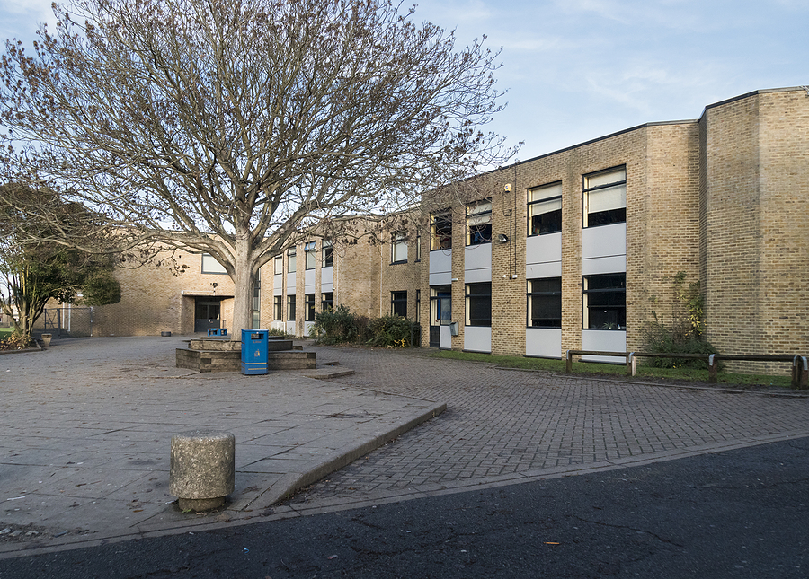

Name of the Risk Assessment |  |  | Premises
Name of the School
Reviewed Date |  | Risk Assessment Reference | Date of Assessment
Name of Assessor |  | Signature | Next Review Date
Activity Description - Describe either the activity or subject being assessed

What are the hazards? | Who might be harmed and how they might be harmed? | What are you currently doing to control risks? | Risk Rating  Low/  Med/  High | What else do you need to do? (if applicable) | Action by who /when? | Date Completed
General lifting and carrying | Premises Staff  Colleagues  Pupils  Visitors  Cuts/abrasions  muscular-skeletal and other physical injuries | - Specific manual handling assessment carried out for all one-off tasks presenting significant risk/for individuals with medical conditions etc.  - Manual handling minimised as far as possible, broken down into smaller loads/assistance sought.  - Made aware of correct lifting techniques to reduce the risk of injury.  - Appropriate footwear worn  - Mechanical lifting aids available (trolleys etc.)  - Good housekeeping and workplace layout.  - Heavy items stored at waist level  - Floor surfaces are unobstructed and  slip free

(Continued)

What are the hazards? | Who might be harmed and how they might be harmed? | What are you currently doing to control risks? | Risk Rating  Low/  Med/  High | What else do you need to do? (if applicable) | Action by who /when? | Date Completed
Cleaning using equipment | Premises staff  Colleagues  Children  Visitors  Cuts/abrasions  Muscular-skeletal and other physical injuries | - Manual Handling Assessment carried out for use of floor buffer etc.  - Training is given in the correct procedure for the use of such equipment

(Continued)
What are the hazards? | Who might be harmed and how they might be harmed? | What are you currently doing to control risks? | Risk Rating  Low/  Med/  High | What else do you need to do? (if applicable) | Action by who /when? | Date Completed
Use of hand/power tools  E.g.  Drills, wood cutting equipment, hedge cutters, strimmers etc.) | Premises Staff  Colleagues  Children  Visitors  Electric shocks/burns  Cuts/abrasions  Impact injury  Entanglement with rotating parts  Inhalation of dust/fume  Irritation to eyes, nose and upper respiratory tract  Skin sensitisation/  disorders | - Machinery maintained in good condition  - Any formal servicing/inspection requirements identified, pre-use check conducted by the user.  - Any specific training/instruction requirements identified and provided.  - Equipment is appropriate (being used for its intended purpose), restricted to authorised users and securely stored.  - Tools/blades kept sharp and in good condition  - Work and cutter guards in place.  - Suitable personal protective equipment (PPE) available to users as required (e.g. eye, hearing protection, boots and overalls)  - All items of PPE are stored carefully, kept clean (not open to potential contaminants) and readily available.  - For machine operations producing large quantities of dust/fume appropriate RPE (respiratory protective equipment) may be required.  - Long hair must be tied back; jewellery should be removed or covered and loose clothing covered by a secure apron or overall. |  | Where there is a significant risk then ensure that a specific work equipment risk assessment is carried out.

What are the hazards? | Who might be harmed and how they might be harmed? | What are you currently doing to control risks? | Risk Rating  Low/  Med/  High | What else do you need to do? (if applicable) | Action by who /when? | Date Completed
Noise/ vibration from equipment  E.g. Sanding machines, leaf blowers | Premises staff  Hearing damage  Circulatory problems  Miscommunication  Stress  Carpel tunnel syndrome | - Noise/vibration level from machinery known and displayed  - Limit exposure times to employees  - Personal protective equipment issued e.g. ear defenders  - Limited/ minimal use of vibrating equipment

(Continued)

What are the hazards? | Who might be harmed and how they might be harmed? | What are you currently doing to control risks? | Risk Rating  Low  Medium High | What else do you need to do? (if applicable) | Action by who & when? | Date Completed
Use of electrical equipment | Premises staff  Colleagues  Children  Visitors  Electrical shock  Burns  Fire  Power leads present a tripping hazard  Cuts/abrasions  Muscular-skeletal and other physical injuries | - Pre-use checks conducted by users  - Electrical equipment subject to regular safety inspection and test ('PAT testing')  - Sufficient outlets to support the range of equipment normally used. Use extension leads and adaptors only where necessary.  - Mains-powered portable equipment to be protected by RCD in higher-risk situations, e.g., equipment used outside or in wet conditions, and for equipment where there is a risk of cables being severed.  - System for reporting faults and taking  - equipment out of service in place

What are the hazards? | Who might be harmed and how they might be harmed? | What are you currently doing to control risks? | Risk Rating  Low  Medium High | What else do you need to do? (if applicable) | Action by who & when? | Date Completed
Using chemicals  E.g.  Paints, solvents, greases, oils, cleaning materials, pesticides | Premises staff  Colleagues  Children  Visitors  Irritation/harm to eyes, nose and upper respiratory tract  Skin sensitisation/  disorders  Poisoning  Burns | - Less hazardous chemicals are used wherever possible.  - Material Safety Data Sheet for substances obtained from supplier and guidance followed.  - All containers are clearly labelled  - Chemicals are stored appropriately, and access is restricted.  - No mixing of chemicals.  - Activities are undertaken outside of school hours where possible.  - Immediate cleaning up of any spillage  - COSHH Assessment completed for all hazardous chemicals and control measures implemented.  - Appropriate Personal Protective Equipment (e.g. gloves, goggles etc.) provided and worn where identified in COSHH assessment.

What are the hazards? | Who might be harmed and how they might be harmed? | What are you currently doing to control risks? | Risk Rating  Low Medium High | What else do you need to do (if applicable)? | Action by who & when? | Date Completed
Repair/  maintenance  Damage to asbestos-containing material  releasing fibres into the atmosphere | Premises staff  Colleagues  Children  Visitors  Asbestosis  Mesothelioma  Pleural thickening  Lung cancer | - Check site asbestos log information for the location of asbestos-containing material prior to undertaking any work on the fabric of the building  - Permission to work/managed by Head/manager/school premises manager for any work on the fabric of the building, as per asbestos management plan  - All site staff are to be aware of the location of ACMs remaining on site.  - Where there is any doubt about whether a substance or structure may contain asbestos, then no work can be undertaken.

(Continued)

What are the hazards? | Who might be harmed and how they might be harmed? | What are you currently doing to control risks? | Risk Rating  Low Medium High | What else do you need to do (if applicable)? | Action by who & when? | Date Completed
Exposure to sharps  E.g. glass, whilst cleaning public areas | Premises staff  Colleagues  Children  Visitors  Puncture injuries  Cuts  Infection | - Pre-cleaning general inspection to identify areas of risk e.g. broken glass, syringes  - Suitable equipment available  - Safe disposal procedures  - Personal protective equipment e.g. gloves when retrieving items or collecting rubbish

(Continued)

What are the hazards? | Who might be harmed and how they might be harmed? | What are you currently doing to control risks? | Risk Rating  Low Medium High | What else do you need to do (if applicable)? | Action by who & when? | Date Completed
Work at height | Premises staff  Colleagues  Children  Visitors  Fractures  Bruises  Cuts from objects falling  Concussion  Vertigo or dizziness resulting in falls | - All-access equipment suitable for the purpose, is checked before use and maintained in good condition.  - Frequent documented checks to ensure equipment is in good condition (termly)  - User -trained in the use of ladders for minor inspection/maintenance tasks.  - Floor surfaces suitable (firm and even surface)  - No lone working and working at height
What are the hazards? | Who might be harmed and how they might be harmed? | What are you currently doing to control risks? | Risk Rating  Low Medium High | What else do you need to do (if applicable)? | Action by who & when? | Date Completed
Lone working – locking/  unlocking the building | Premises staff  Colleagues  Children  Visitors  Accident/injury  Physical assault  Delayed assistance in emergency  Cuts/abrasions  Muscular-skeletal and other physical injuries | - Ensure there is adequate lighting. If possible follow different procedures daily.  - The Building is locked down as soon as possible at the end of the school day.  - On-site security system, controlled access to building e.g. through coded doors etc.  - Use of visitor badges/signing in book  - Challenging unknown visitors where safe to do so.  - Key holders should be strictly controlled and numbers kept to a minimum.  - Mobile phone carried/radio communication

What are the hazards? | Who might be harmed and how they might be harmed? | What are you currently doing to control risks? | Risk Rating  Low Medium High | What else do you need to do (if applicable)? | Action by who & when? | Date Completed
Lone working - working in a school/centre alone in isolated locations | Premises staff  Colleagues  Children  Visitors  Accident/injury  Delayed assistance in emergency  Cuts/abrasions  Muscular-skeletal and other physical injuries | - Only agreed-risk tasks are to be undertaken, Avoid high-risk activities (e.g. working at height);  - Mobile phone carried/radio or other communication  - Notify staff on-site of location/estimated duration of task if working on-site remotely from others.  - Reduce time spent working alone as far as is reasonably practicable.  - Notify the manager of your start time and when finished.

(Continued)

What are the hazards? | Who might be harmed and how they might be harmed? | What are you currently doing to control risks? | Risk Rating  Low Medium High | What else do you need to do (if applicable)? | Action by who & when? | Date Completed
Responding to intruder alarm holiday periods/out of hours | Premises staff  Head Teacher  Contractor  Accident/injury  Physical assault  Delayed assistance in emergency  Cut /abrasions  Muscular-skeletal and other physical injuries | - Carry a mobile phone to call for help.  - Before entering the grounds, notify someone of the situation, and the intention to investigate.  - Make regular calls to those notified above to update them as to the situation.  - If a break-in has occurred, do not attempt to enter the premises until the police arrive.  - If confronted by an intruder(s) before the police arrive, do not attempt to tackle or restrain them.  - Restraining intruders should be left to the police who are trained in dealing with such situations

(Continued)

What are the hazards? | Who might be harmed and how they might be harmed? | What are you currently doing to control risks? | Risk Rating  Low Medium High | What else do you need to do (if applicable)? | Action by who & when? | Date Completed
Slips, trips and falls | Premises staff  Clients  Staff  Pupils  Visitors  Contractors | - Good housekeeping  - Non-slip footwear  - Warning notices of wet floor  - Clearing up spillages immediately

(Continued)

Overall Risk Rating | Choose an item.

Please ensure that every item has a risk rating based on the below colours in the appropriate column above and then select the overall risk rating from the drop-down box above.
Level of Risk | Suggested Action
LOW | Control measures are adequate but continue to monitor and review  Ensure that they remain satisfactory and appropriate
MEDIUM | Control measures need to be introduced within a specified time  Continue to monitor and review
HIGH | Unless control measures can be immediately introduced to reduce the risk so far as is reasonably practicable  The task or activity should be suspended

Guidance Version Control
Name Of Document | Version | Last Review date
Premises Risk Assessment | NASPM V3 | September 2024

Copyright © 2024 NASPM

All rights reserved.

No part of any NASPM document may be reproduced, distributed, or transmitted in any form or by any means, including photocopying, recording, or other electronic or mechanical methods, to any individual, school, or organisation outside of the school named in the school membership agreement.

Should membership terminate, no part of any NASPM document may be used, reproduced, distributed or transmitted by any individual, school, or organisation.

