Checklist
For
Lithium-ion Batteries

Document 36

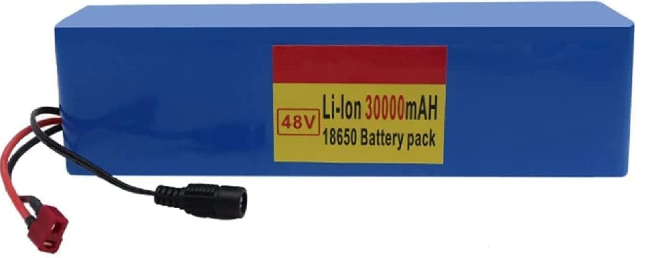

Section 1 – Small Volume Storage

Question | Yes | No | N/A | Action | To be completed by
Have fire risk assessments been updated to cover: The location of Lithium-ion Batteries
Have storage conditions been identified (based on the battery manufacturer/ supplier data)?
Are batteries held in a non-combustible store?
Are batteries stored away from sources of heat?
Is the battery store weatherproof?
Is the battery store covered by fixed fire-detection
Have emergency response plans (including site fire plans) been revised to include battery storage locations?
Have safe systems of work for the storage of batteries been prepared, and issued to staff?
Have inspection programmes been updated to include battery stores?

Section 2 – Bulk Storage

Question | Yes | No | N/A | Action | To be completed by
Has a competent fixed fire suppression specialist been consulted on the protection of bulk storage?
Has a dedicated storage location been prepared outside of your building?

Section 2 – Bulk Storage Continued

Question | Yes | No | N/A | Action | To be completed by
Have your insurers been notified of bulk storage locations?
Is fixed suppression installed?
Are storage restrictions (such as storage heights and maintenance of rack flue spaces) understood and maintained?
Are inspection schedules in place for fixed fire suppression?
Is fixed fire suppression maintained by a competent maintenance provider?
Have fire risk assessments been updated to cover: The location of Lithium-ion Batteries
Have storage conditions been identified (based on the battery manufacturer/ supplier data)?
Are batteries held in a non-combustible store?
Are batteries stored away from sources of heat?
Is the battery store weatherproof?
Is the battery store covered by fixed fire-detection
Have emergency response plans (including site fire plans) been revised to include battery storage locations?
Have safe systems of work for the storage of batteries been prepared, and issued to staff?

Section 2 – Bulk Storage continued

Question | Yes | No | N/A | Action | To be completed by
Have inspection programmes been updated to include battery stores?

Section 3 – Handling

Question | Yes | No | N/A |  | Action | To be completed by
Have safe systems of work been prepared to cover the handling, use and movement of Lithium-ion batteries?
Have the staff been trained on the safe handling, use and movement of batteries?

Section 4 – Charging

Question | Yes | No | N/A |  | Action | To be completed by
Has your fire risk assessment been updated to include battery charging?
Have you identified charging locations based on the manufacturer’s recommended conditions (optimum temperature, ventilation etc.)?
Are charging units housed on non-combustible, insulated housings?
Are charging units sited in a non-combustible room?

(Continued)

Section 4 – Charging Continued

Question | Yes | No | N/A | Action | To be completed by
Are charging units covered by remotely monitored automatic fire detection?
Are charging units sited away from stores of combustible material?
Have charging/discharging times been formally agreed upon?
Is out-of-hours charging prohibited?
Are thermal imaging surveys carried out on charging units and associated electrical equipment?
Are electrical supplies interlocked with the fire alarm system?
Are electrical isolators incorporated into the charging units (and are they accessible)?
Are CO2/Dry powder extinguisher units located near the charging units?
Are formal maintenance programmes in place for charging units?
Have charging units been added to regular formal site inspections?

Section 5 – Disposal of Waste Battery Units

Question | Yes | No | N/A | Action | To be completed by
Has a non-combustible waste battery store been prepared?

Section 5 – Disposal of Waste Battery Units Continued

Question | Yes | No | N/A | Action | To be completed by
Is the store outside, and sited 10 metres from your buildings?
Is the store weatherproofed?
Are Lithium-ion batteries held separately from other waste batteries?
Are batteries collected by a competent, licenced waste contractor?
Have the staff received training on battery disposal processes?

Section 6 – Storage of damaged Lithium-ion Batteries

Question | Yes | No | N/A | Action | To be completed by
Is there a formal method for inspecting Lithium-ion battery packs, and associated equipment, being returned to stores or to be placed on charge?
Is there a formal process for notifying damage to Lithium-ion battery packs and work equipment?
Do you have a quarantine area for holding damaged battery packs and work equipment?
Is the quarantine area built of non-combustible materials, insulated and sited away from stores of combustible materials?
Have you updated your fire risk assessment/fire plans to include the location of the quarantine area(s)?

Guidance Version Control
Name Of Document | Version | Last Review date
Checklist for Lithium-ion Batteries | NASPM V2 | September 2024

Copyright © 2024 NASPM

All rights reserved.

No part of any NASPM document may be reproduced, distributed, or transmitted in any form or by any means, including photocopying, recording, or other electronic or mechanical methods, to any individual, school, or organisation outside of the school named in the school membership agreement.

Should membership terminate, no part of any NASPM document may be used, reproduced, distributed or transmitted by any individual, school, or organisation.

