Events – Summer Fayre

Risk Assessment

Document 35

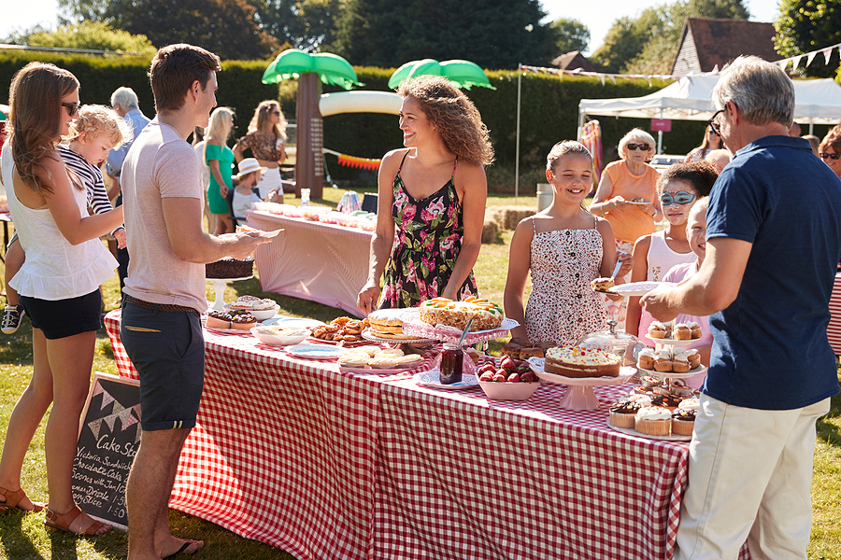

Name of the Risk Assessment |  | Events - Summer Fayre
Name of the School
Reviewed Date | Risk Assessment Reference | Date of Assessment
Name of Assessor | Signature | Next Review Date
Activity Description - Describe either the activity or subject being assessed

What are the hazards? | Who might be harmed and how they might be harmed? | What are you currently doing to control risks? | Risk Rating  Low/  Med/  High | What else do you need to do?  (if applicable) | Action by who & when? | Date Completed
Tripping over power cables | Attendees  Stallholders  Trip and fall injuries. | - Make sure all power cables are covered with hazard tape.  - Keep cables away from doorways and entrances.  - Ensure easy access to power points to turn the power on and off.  - Cables routed to avoid crossing traffic paths
BBQ - Food poisoning/ Poor food hygiene | Attendees  Sickness Food poisoning | - Food probes are to be used to check the temperature of all meat before serving.  - Meat is to be stored in the correct fridge/freezer.  - Utensils to be cleaned in between serving food.  - Food to be kept separate from raw meat, - separate utensils to be used for cooked and raw  - Access to hand washing facilities.  - Signage to be prominent that food (cakes etc.) may contain nuts etc.

What are the hazards? | Who might be harmed and how they might be harmed? | What are you currently doing to control risks? | Risk Rating  Low/  Med/  High | What else do you need to do?  (if applicable) | Action by who & when? | Date Completed
BBQ - Possible heat injury | Attendees  Stallholders  Burns or scalds  Fire  Explosion  Death | - BBQ positioned away from the front of stall / BBQ staff to be briefed regarding safety.  - Any burn injuries are to be reported to first aid.  - No children are allowed behind the table where the BBQ is situated.  - Appropriate fire extinguishers are available within easy access.
Working at height to put up decorations | Attendees  Stallholders  Sprains  Broken limbs  Death | - Appropriate, step ladders/ladders are securely stored and available for use.  - Stepladder/ladder only to be used by competent and authorised persons.  - Ladders to be supported by a person on the ground

(Continued)

What are the hazards? | Who might be harmed and how they might be harmed? | What are you currently doing to control risks? | Risk Rating  Low/  Med/  High | What else do you need to do (if applicable)? | Action by who & when? | Date Completed
Hot weather conditions | All Attendees  Heat exhaustion  Sunburn | - Adequate areas of shade are available (under trees, in buildings, under canopies etc.).  - Regular breaks for marshals and volunteers running stalls and activities.  - Adequate first aid facilities in place.  - Adequate supplies of drinking water available.  - All those involved in the event (volunteers, organisers) are briefed on the need to protect themselves against overexposure to the sun, how to spot the symptoms of heat exhaustion and the facilities in place on the day so that they can react to and manage situations if necessary.  - Those in the sun are to wear something on their heads
Disposal of all waste | Attendees  Stallholders  Public hygiene | - Arrangements are in place to clear the site of litter after the event to prevent any vermin.  - Any spillages on hard ground or breakages to be cleared properly.

What are the hazards? | Who might be harmed and how they might be harmed? | What are you currently doing to control risks? | Risk Rating  Low/  Med/  High | What else do you need to do (if applicable)? | Action by who & when? | Date Completed
Toilet facilities | All Attendees  Public hygiene | - Toilets in school to be made available. Signage informing the public to be clearly displayed and regular checks to be conducted to ensure that sufficient toilet tissue and hand soap are available.  - Consider any special requirements for those attending the event e.g. disabled access. The Key for the lift is to be on site with a member of staff.
Public disorder/  Security | All attendees  Disorderly behaviour  Property damage | - 'Lost children' arrangements to be in place.  - Close liaison with local police.  - The Highly visible presence of event marshals.  - The entrance is to be manned at all times.

(Continued)

What are the hazards? | Who might be harmed and how they might be harmed? | What are you currently doing to control risks? | Risk Rating  Low/ Med/  High | What else do you need to do (if applicable)? | Action by who & when? | Date Completed
Bouncy Castle related injuries | All attendees  Impact Injuries  Falling Injuries  Head Collision  Bouncy Castle lifting into air due to wind or unsecure setup  Limb injuries  Head/neck injuries  Death | - Volunteers to keep the number of children on bouncy castles within the safe number for the appliance  - Keep age groups separate (e.g. no Y4-6 children with the Reception-Y2)  - Parents are to remain in charge of and responsible for their children at all times  - The Area around the bouncy castles is to remain clear from shoes etc.  - The Bouncy castle ADIP PIPA confirmation  - The Bouncy castle is secured to the ground with the appropriate number of secure points/pegs following the correct standards, this is the responsibility of the hiring company  - The Bouncy castle – the provider will stop and take down if any concerns with the weather and wind speed following the correct standards  - The Bouncy castle hirer managing the number of people using it

Overall Risk Rating | Choose an item.

Please ensure that every item has a risk rating based on the below colours in the appropriate column above and then select the overall risk rating from the drop-down box above.

Level of Risk | Suggested Action
LOW | Control measures are adequate but continue to monitor and review  Ensure that they remain satisfactory and appropriate
MEDIUM | Control measures need to be introduced within a specified time  Continue to monitor and review
HIGH | Unless control measures can be immediately introduced to reduce the risk so far as is reasonably practicable  The task or activity should be suspended

Guidance Version Control
Name Of Document | Version | Last Review date
Events - Summer Fayre Risk Assessment | NASPM V3 | September 2024

Copyright © 2024 NASPM

All rights reserved.

No part of any NASPM document may be reproduced, distributed, or transmitted in any form or by any means, including photocopying, recording, or other electronic or mechanical methods, to any individual, school, or organisation outside of the school named in the school membership agreement.

Should membership terminate, no part of any NASPM document may be used, reproduced, distributed or transmitted by any individual, school, or organisation.

