Tree

Safety

Guidance

Document 23

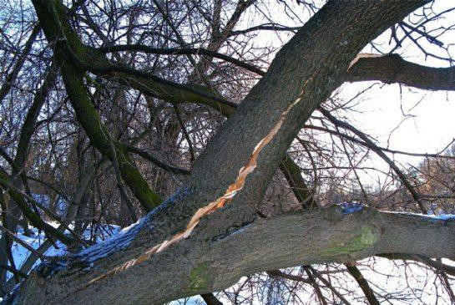

Tree Safety

- Applicable Legislation

- Health and Safety at Work etc. Act 1974 to provide a safe place and safe systems of work
- Management of Health & Safety at Work Regulations 1999 (as amended) to provide suitable and sufficient risk assessments to identify and control hazards
- Occupiers’ Liability Act 1984

- Introduction

Your School has a statutory ‘duty of care’ to the pupils, members of the public/visitors and its’ employees who must not be put at risk because of any failure by the School to take all reasonable precautions to ensure their safety.

There is therefore a need to periodically inspect trees within the school and around the perimeter to assess whether they present a risk to life or property and to take appropriate remedial action as identified in the risk assessment.

- Purpose

This document sets out the responsibilities, guidelines and control measures to manage trees. Within this document, there is a minimum standard of inspection, competence and record-keeping in relation to tree inspections. The main purpose is to ensure the school have a tree management system to ensure that all trees are deemed to be safe and with no risk of falling as we know that trees can kill and have the potential to be a significant risk if not carefully managed.

- Scope

This procedure applies to all trees located on the school property for which you are responsible and where the School has a duty of care to make sure that tree(s) are kept in a safe manner. Schools must ensure that a competent tree survey inspection and risk assessment has been completed and that the recommended programs of inspections are being completed. This may include annual inspections for higher-risk trees, as detailed within the tree survey risk assessment.

- Manager Responsibilities

Premises Managers must monitor the condition of the state of the trees in and around their school properties and report any tree defects that they are concerned about to the competent tree contractor, appointed tree expert, following the tree safety management plan.

- What are the Hazards?

All trees are subject to decline, stress, old age and collapse. They can be damaged physically by disease and/or invaded by organisms. As trees deteriorate they are increasingly likely to shed branches or fall over in strong winds. Some trees can shed branches without any form of prior warning and this may include heavy branches as well as much smaller branches.

- What are the Risks?

Risk is the likelihood that an unsafe tree will cause actual injury and/or damage. The risk screening of trees also relates to the location of the tree and the intensity of people in and around the immediate surrounding area of the tree. Further consideration will be the proximity of the tree to buildings or other structures, within potential fall zones including playing fields and playgrounds/school buildings and school outbuildings.

- The Environmental Impact

Trees including old and young may be in a condition of decay and offer unique habitats for wildlife. However many trees can have structural weaknesses and/or are in poor physiological condition. As such they may have defects that could cause them to potentially fail. In order to mitigate these defects it will be necessary to undertake a tree inspection program and action any remedial works deemed to be necessary to either part of the tree or the whole tree to reduce the risk that it poses to the site or users of the site. When considering the tree risks and current conditions of trees it is extremely important to recognize that these structures are single-point structures which means that in the event of structural failure, there is no other support that prevents the tree from falling, hence the potential significant risk and severity of harm being a high risk.

- Tree Inspection Programme

It is the Schools responsibility to ensure that tree inspection procedures are in place for all its properties and that persons undertaking these inspections are deemed to be competent.

- Competent Person

A ‘competent’ person is someone who has relevant experience and qualifications, in relation to tree competence this is obtained via arboricultural training and relevant professional experience. This person must be able to understand the hazards pertinent to the task being carried out and the methods to be implemented to eliminate or reduce the risks that can arise. This person should ideally hold the LANTRA Professional Tree Inspection Certificate and must be able to recognise a wide range of tree defects. Using the Arboricultural Association to seek approved members within the association will ensure that the school is using a competent approved company.

- Tree Inspection Methodology

A competent tree inspector will follow the very basic principles of a Visual Tree Assessment

- An assessment of the hazard.
- An assessment of the risk.
- Propose remedial actions.

Assessing the Hazards

The tree hazard assessment must be undertaken by a competent person. It is the responsibility of this person to identify the tree location and ensure that hazards are assessed and recorded accurately. Any high-risk finding must be communicated to the Headteacher as soon as practically possible to ensure that there is a follow-up direct action, this may include creating exclusion zones and arranging for immediate urgent works.

Assessing the Level of Risk

On school sites, the risk zone is considered to be high for the whole site simply because they may be hundreds of children and staff within the proximity of the trees including car parks, buildings, play areas, outbuildings, perimeter areas Etc.

Trees are potentially hazardous as they may contain either structural or physiological defects. Some of these defects that can cause a total collapse or branch failure are visible from ground level and some are not as they may be present within the upper crown or on top of branches. It is therefore only practical to expect the visible defects to be identified when the survey is being undertaken from ground level.

Technical Assessment of Trees

Trees will be inspected from ground level initially unless a more detailed climbing or internal inspection of the tree is required by a competent person.

Further methods of assessing the internal structure of a tree with identified defects should be available to the competent person. These include a simple mallet and probe or various electronic devices.

These methods will only be used if it is deemed necessary by the competent person at the time of inspection.

The frequency and method of inspection must be determined by the risk area.

Risk Zones | Inspect | Method
High Risk* | 1 to 2 Years  (Site dependent) | A rapid but careful inspection for clear defects  (Especially in the crown and around the base of the tree).
Medium Risk | 3 – 5 years  (Site dependent) | Rapid but careful search for clear defects.
Low Risk | Within 5 years | No formal inspection, but general observations.
*Retained trees  (not felled)  in High-Risk areas showing significant defects | Annually or after storms | Thorough inspection and monitoring rate of decline.  A probe and ladder may be required.

Determining Remedial Action

Only a competent person may prescribe remedial actions. Within these remedial actions proposals and priorities (with defined timescales) must be recorded so that a competent specialist can clearly understand what is required of them. These remedial actions will be based on an assessment of the hazards and the risks posed by the tree.

On some sites, it may be necessary to exclude all persons from an area until the risks have been removed and the site has been declared safe by a competent person.

Arboricultural Contractors

The school should have an approved Arboricultural contractor for the school’s proactive tree survey and risk assessment, but should also have access to these competent contractor/s if you feel that your tree(s) may be unsafe then you should obtain advice from a qualified person. This person must have undertaken the relevant arboricultural training that will allow them to clearly identify any defects that may be present in your trees. This individual must also hold appropriate insurance for the works that they are undertaking and you should ask to see this prior to instructing them to undertake work. They should provide risk assessments and method statements of their work, and the school should review this in relation to the school area use and ensure segregation of works is implemented and any clear zones are physically set up and supervised at all times.

If you require further information about choosing an appropriate contractor you can either contact the Arboricultural Association for a list of their approved members.

All works must be carried out in accordance with the current relevant British Standard 3998:2010 Tree Work Recommendations.

Any arboricultural consultants that are required by establishments/settings should be recognised by the Arboricultural Association (www.tree.org.uk) as registered consultants.

Notification of Defects

All employees have a duty to report any obvious defects on trees to the head of the establishment/setting as soon as practicable.

Any trees on neighbouring land that require work must be reported to the land owner as soon as is practicable.

Legal Constraints

Some trees are protected by means of a Tree Preservation Order (TPO) or they are deemed to be within a conservation area. If you have trees on your site that are afforded this protection you must not prune them without seeking prior permission from the Local Planning Authority as you may be committing a criminal offence.

For Further Information and Advice

Health and Safety Executive (HSE) http://www.hse.gov.uk/foi/internalops/sims/ag_food/010705.htm

Forestry Commission – National Tree Safety Group
Detailed Guidance: Common Sense Risk Management of Trees
Common sense tree management

(Continued)

Appendix 1

Schools can use this simple guide for premises visual checks on trees, this is in addition to the competent tree survey and risk assessments. If any safety concerns are raised, the school must contact the competent tree contractor as soon as possible.

Unsafe Trees - Things to Look Out For

Damage or Injury

- Splits or cracks in the trunk or branches.
- Branches that are broken, hanging or that has dropped.
- Sections of bark are damaged or stripped to show the wood beneath (remember that some trees such as Plane or Eucalyptus naturally shed their bark).
- Soil movement around the base of the tree in strong winds.

Ill health, Disease or Infestation  - Sections showing signs of rotting.  - Growth of fungi on the bark, wood or around the base of the tree.  - Sections of infestations show holes and damaged material.  - Foliage dying back or going brown for no apparent reason on evergreen trees, or out of season for deciduous trees. | 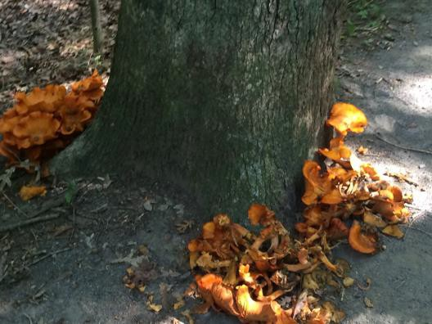

(Continued)

Horse Chestnut Leaf Miner  (Tree Pest)  This affects the photosynthetic capabilities of the trees and causes the tree to look unsightly. Rake up the leaves that have fallen and compost or dispose of them away from the affected tree or other horse chestnut trees. | 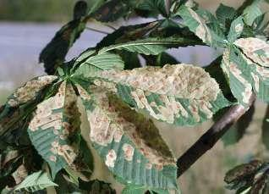
Oak Processionary Moth  (Tree Pest)  This is an insect that has the potential to cause serious damage, financially, sociologically and environmentally to some areas of the south. The caterpillars defoliate oak trees and can cause respiratory issues in humans and animals. If you think you have seen this insect please contact your tree specialist immediately and do not under any circumstances touch the caterpillars or nests on the trees. | 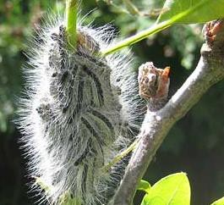
Acute Oak Decline  (Tree Disease)  This very aggressive bacterial disease affects our native oak trees. Symptoms include bleeding lesions on the stems of trees and results in the rapid death of the tree. | 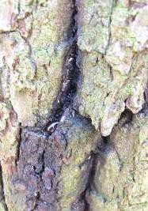

(Continued)

Bleeding Canker  (Tree Disease)  This is a bacterial disease caused by the genus of Phytopthora that affects our horse chestnut trees. It affects trees' ability to move water and nutrients around and can cause death to the whole or part of a tree. Not all trees affected will die as there are five different forms of the disease, each with its own level of aggressiveness. | 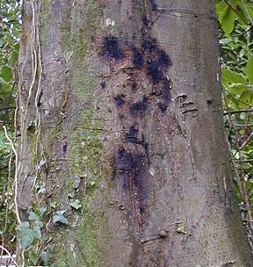
Ganoderma spp  (Fungal Disease)  A root decaying fungi, visible by a fungal bracket at the base of the tree. | 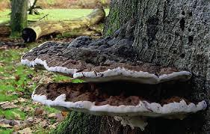
Kretzschmaria deusta  (Fungal Disease)  A root rotting fungi, present as a black or grey patch at the base of a tree. | 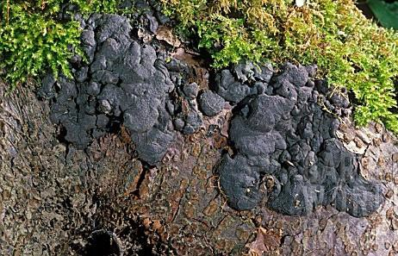
Inonotus hispidus  (Fungal Disease)  A black fungal bracket affects the trunks and branches of ash trees in hedgerows, causing a brittle fracture and tree failure. | 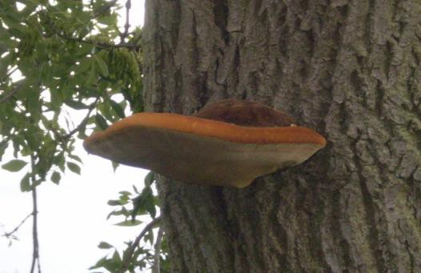

Guidance Version Control
Name Of Document | Version | Last Review date
Tree Safety Guidance | NASPM V3 | August 2024

Copyright © 2024 NASPM

All rights reserved.

No part of any NASPM document may be reproduced, distributed, or transmitted in any form or by any means, including photocopying, recording, or other electronic or mechanical methods, to any individual, school, or organisation outside of the school named in the school membership agreement.

Should membership terminate, no part of any NASPM document may be used, reproduced, distributed or transmitted by any individual, school, or organisation.

