Guidance

On

Charger Safety

Document Number 3

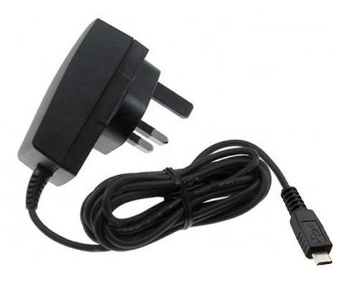

Charger Safety Considerations

- Buying Chargers

Counterfeit chargers can be deadly, with case studies of fires starting due to counterfeit chargers. A national test was completed on a range of fake chargers and found that 98% of them had the potential to cause a lethal electric shock or start a fire.

Ensure that the school has a procedure for school-purchased electrical goods that includes using a reputable company, with evidence of CE marking and information reviewed before purchasing. Not allowing the purchase of such items from markets or websites due to saving money on cheaper versions that may be a potential fire or danger to the school.

With that in mind, it's important to be aware of the risks when buying a charger.

- The 3-Point Safety Check

Plug Pins

- Check that there is at least 9.5 mm between the edge of the pins and the edge of the charger (9.5 mm is about the width of a ballpoint pen). If the distance between the edge of the pins and the edge of the charger is less than 9.5 mm, there is a risk of electric shock when plugging in and unplugging the charger from a socket.
- Plug the charger into a socket but don’t switch it on or connect it to your appliance.
- Does it plug in easily? If the charger does not easily plug into a socket, the pins may be the wrong size or length, or the distance between the pins may be wrong. If pins do not fit properly into the socket, overheating, arcing and mechanical damage can occur to both the socket and the charger, which can be dangerous.

Markings

- Look for a manufacturer’s brand name or logo, model and batch number.
- Check for a CE mark
- Check that the output voltage and current ratings marked on the charger and your electrical device are the same.
- Do not rely on a CE mark alone as a guarantee of safety – it’s simply a declaration by the manufacturer that the product meets all the safety requirements of European law, but they can be easily forged.

(Continued)

Warnings and Instructions

- Adequate warnings and instructions must be provided. As a minimum, user instructions should provide information on conditions and limitations of use, how to operate the charger safely, basic electrical safety guidance and details of how to safely dispose of the charger when it is no longer required.

- School Procedures and Rules For Staff Charging Items

- A ban on the charging and use of vaping machines
- A ban on the charging and use of electrical bikes indoors, unless there is a thorough review of the careful appropriate selection of purchased bikes and a risk assessment on the safe storage and charging of items, taking guidance from the school fire risk assessor. Never to be left alone on charge, and never to be located in an escape route

Guidance Version Control
Name Of Document | Version | Last Review date
Guidance on Charger Safety | NASPM V3 | August 2024

Copyright © 2024 NASPM

All rights reserved.

No part of any NASPM document may be reproduced, distributed, or transmitted in any form or by any means, including photocopying, recording, or other electronic or mechanical methods, to any individual, school, or organisation outside of the school named in the school membership agreement.

Should membership terminate, no part of any NASPM document may be used, reproduced, distributed or transmitted by any individual, school, or organisation.

