Fire Alarm Testing Record

(Weekly)

Document 29

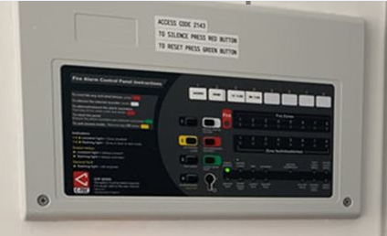

Fire Alarm Testing Record (Weekly)

Date | Time | Zone | Device Number Location | Principle Signal Confirmed | Print Name and Sign

Guidance Version Control
Name Of Document | Version | Last Review date
Fire Alarm Testing Record (Weekly) | NASPM V3 | September 2024

Copyright © 2024 NASPM

All rights reserved.

No part of any NASPM document may be reproduced, distributed, or transmitted in any form or by any means, including photocopying, recording, or other electronic or mechanical methods, to any individual, school, or organisation outside of the school named in the school membership agreement.

Should membership terminate, no part of any NASPM document may be used, reproduced, distributed or transmitted by any individual, school, or organisation.

