Boiler Room

Risk Assessment

Document 23

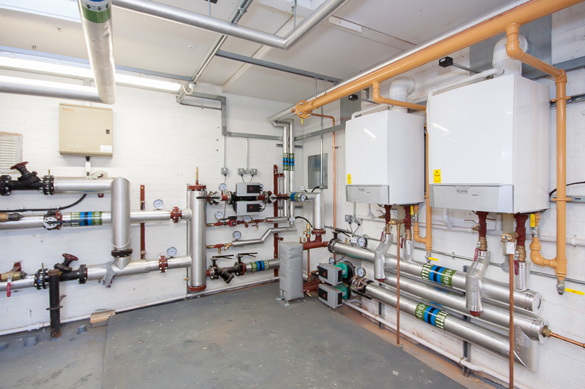

Name of the Risk Assessment |  |  | Boiler Room
Name of the School
Reviewed Date |  | Risk Assessment Reference | Date of Assessment
Name of Assessor |  | Signature | Next review date
Activity description - Describe either the activity or subject being assessed

What are  the hazards? | Who might be harmed and how? | What are you currently doing to control risks? | Risk Rating  Low/ Med/  High | What else do you need to do?  (if applicable) | Action by who & when? | Date Completed
Environment | Staff  Contractors | - The boiler room is clean, the floor is painted, and nothing is stored in there. It is used for authorised persons only.  - Any Asbestos is identified and recorded and managed as detailed within the school asbestos management plan.  - Visual weekly inspections completed by the premises manager
Electricity | Staff  Contractors | - The plant is maintained as legally required including the gas and electrical service requirements.  - Contractor Risk assessments are reviewed prior to any works completed within these areas whether routine or emergency
Chemicals | Staff  Contractors | - COSHH assessment has been carried out on hazardous materials and the safety data sheet is available.  - Follow the fire risk assessment for the management and control of storage in these areas including the prohibition of hazardous chemicals being stored.  - Appropriate Personal Protective Equipment has been provided and worn

What are the hazards? | Who might be harmed and how? | What are you already doing? | Risk Rating  Low/ Med/  High | What else do you need to do?  (if applicable) | Action by who & when? | Date Completed
Slips and Trips | Staff  Contractors | - There is adequate lighting in place  - The condition of the flooring is good and any raised areas are defined and marked to show a height difference, this may include painting a different colour to warn others, and an induction to users to make them aware of the dangers of potential trips.  - Good housekeeping and no storage,  - Any spillages will be cleaned asap, and  - Any leaks to be reported to the schools approved contractor immediately
Manual Handling | Staff  Contractors | - Manual handling assessments are carried out where tasks present significant risks  - Manual handling minimised as far as possible when moving equipment - two-person job  - Staff are made aware of correct lifting techniques to reduce the risk of injury appropriate footwear worn  - Good housekeeping and workplace layout

What are the hazards? | Who might be harmed and how? | What are you already doing? | Risk Rating  Low/ Med/  High | What else do you need to do?  (if applicable) | Action by who & when? | Date Completed
Hot Surfaces | Staff  Contractors | - Hot surfaces are appropriately lagged  - A safe system of work/permit work is available before commencing any hot work.  - A hot work permit is adhered to by all staff/contractors, and an authorisation to work in these areas is enforced
Gas | Staff  Contractors | - All equipment is suitable for its intended purpose and is installed correctly by a Gas Safe registered contractor  - Gas safety checks are to be completed annually and a copy is held on site  - No repairs/alterations should be carried out unless by a Gas Safe registered person  - Protective devices are fitted which causes shutdown
Fire | Staff  Contractors | - Adequate fire extinguishing appliances and automatic detection are available in the plant room.  - No storage is allowed within these rooms  - Weekly monitoring is in place.  - An annual fire risk assessment is completed.  - A compartmentation review to ensure that there are no concerns with breaches to the ceiling floor and walls into the school building

What are the hazards? | Who might be harmed and how? | What are you already doing? | Risk Rating  Low/ Med/  High | What else do you need to do?  (if applicable) | Action by who & when? | Date Completed
Lone Working | Staff  Contractors | - Lone working is avoided as best possible.  - Care is taken in deciding when certain tasks should be undertaken and in some cases defer the task until assistance is available  - All staff notify their supervisor prior to entry and when leaving plant room
Unauthorised Access |  | - The boiler house / plant room is kept locked at all times.  - Only nominated personnel are allowed access  - Strict key control is ensured.  - Anyone wishing to access the boiler room must report to reception  - All appropriate signage is in place

(Continued)

Further control measures in place are:

Overall Risk Rating | Choose an item.

Please ensure that every item has a risk rating based on the below colours in the appropriate column above and then select the overall risk rating from the drop-down box above.

Overall Residual Risk | LOW
Level of Risk | Suggested Action
LOW | Control measures are adequate but continue to monitor and review  Ensure that they remain satisfactory and appropriate
MEDIUM | Control measures need to be introduced within a specified time period  Continue to monitor and review
HIGH | Unless control measures can be immediately introduced to reduce the risk so far as is reasonably practicable  The task or activity should be suspended

Guidance Version Control
Name Of Document | Version | Last Review date
Boiler Room Risk Assessment | NASPM V3 | September 2024

Copyright © 2024 NASPM

All rights reserved.

No part of any NASPM document may be reproduced, distributed, or transmitted in any form or by any means, including photocopying, recording, or other electronic or mechanical methods, to any individual, school, or organisation outside of the school named in the school membership agreement.

Should membership terminate, no part of any NASPM document may be used, reproduced, distributed or transmitted by any individual, school, or organisation.

