Window/Glazing

Risk Assessment

Document 22

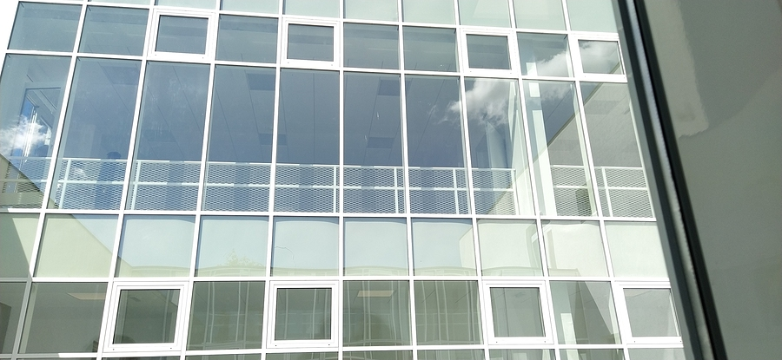

Name of the Risk Assessment |  |  |  | Window/Glazing
Name of the School
Reviewed Date |  | Risk Assessment Reference |  | Date of Assessment
Name of Assessor |  | Signature |  | Next Review Date
Activity Description - Describe either the activity or subject being assessed

- Consideration of location of glazing, the activities taking place, the volume of traffic and pedestrians and any previous experience of incidents and near misses.
- If assessed as no risk which included higher levels of glazing with no risk of harm from the use of area such as high-level glazing within corridors, then no further action is required.
- Where a risk has been identified, it is detailed below with control measures that either include an upgrade to safety glazing or preventing people/objects from coming into contact with the glazing or applying safety film in areas.

Note: This was a visual glazed risk assessment with no testing of glazed units but assessing on the glazing make up and markings.

This risk assessment is a template for schools to use and develop to ensure a full glazing assessment has been completed.
If there are any concerns or the school is unsure if the glazing is safety rated, the school should seek professional competent assistance.

What are the hazards? | Who might be harmed and how they might be harmed? | What are you currently doing to control risks? | Risk Rating  Low/  Med/  High |  | What else do you need to do?  (if applicable) | Action by who & when? | Date Completed
Non-safety related glazing | Staff  Pupils  Visitors  Impact of hands/body into non-safety rated glazing  Cuts  Death  Impact of objects into glazed areas causing breakage and potential falling glass injury  Glass impact  Death | - Windows and glazing including in and around doors on access routes below shoulder height level are safety-rated glazing  - Windows/glazing along corridors and stairwells must be safety-rated to shoulder height (adult)  - Windows/glazing in unsupervised areas must have safety glazing to head height (such as toilets/changing rooms)  - Windows/glazing in sports/halls used for sports are ALL safety-rated glazing |  |  | Replacement of non-safety glazing in the following areas:

Further control measures in place are:

Overall Risk Rating | Choose an item.

Please ensure that every item has a risk rating based on the below colours in the appropriate column above and then select the overall risk rating from the drop-down box above.

Overall Residual Risk | LOW
Level of Risk | Suggested Action
LOW | Control measures are adequate but continue to monitor and review  Ensure that they remain satisfactory and appropriate
MEDIUM | Control measures need to be introduced within a specified time  Continue to monitor and review
HIGH | Unless control measures can be immediately introduced to reduce the risk so far as is reasonably practicable  The task or activity should be suspended

APPENDIX 1
Education
The Health and Safety at Work Act 1974 has required employers, including self-employed and those in a position of control over workplaces to take reasonable practical steps to ensure the health and safety of those who might be affected by their work activities. The act covers a wide range of workplaces, including schools.

Since 1996, safety glazing has been a requirement in the workplace in accordance with Regulation 14 of the Workplace (Health, Safety and Welfare) Regulations 1992. Therefore, if window glazing constitutes a risk, reasonably practicable measures must be taken to rectify the situation.

Glass Health And Safety Regulations – Regulation 14
Regulation 14 states that all windows, or other transparent or translucent surfaces in a wall, partition, door or gate should be of a safety material or be protected against breakage where necessary for reasons of health and safety.

Critical Locations
British Standard BS 6262: Part 4: 2005 and Section N1 of Approved Document N of the Building Regulations outlines that all glazing that is fitted in ‘critical locations within a building should either:
- If broken, break in such a way which is unlikely to cause injury, or
- Resist impact without breaking
- Be shielded or protected from impact

Critical locations include low-level glazing (below shoulder height) and windows and glazing that are adjacent to doors. However, this is the minimum requirement and in locations of special risk, such as schools, gyms, sports halls or colleges, it’s recommended that safety glazing is installed on all glass panes

Assessing The Risk
Risk assessments should also be carried out in these critical locations taking into account activities that take place in these areas, the volume of traffic these areas see and whether or not any previous incidents have taken place. It may be necessary to put up barriers to protect the window panes, reorganise heavy traffic routes or modify the panes by adding a safety film.

Guidance Version Control
Name Of Document | Version | Last Review date
Window/Glazing Risk Assessment | NASPM V3 | September 2024

Copyright © 2024 NASPM

All rights reserved.

No part of any NASPM document may be reproduced, distributed, or transmitted in any form or by any means, including photocopying, recording, or other electronic or mechanical methods, to any individual, school, or organisation outside of the school named in the school membership agreement.

Should membership terminate, no part of any NASPM document may be used, reproduced, distributed or transmitted by any individual, school, or organisation.

