Stress

Risk Assessment

Guidance

Document 106

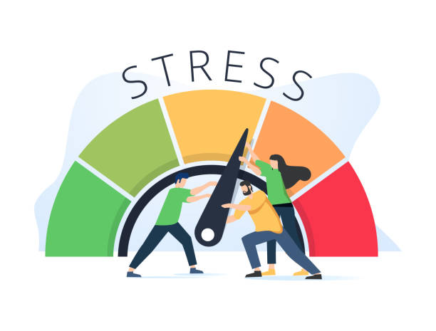

Stress Risk Assessment

Existing Workplace Hazards | Nature of the Risk | Control Measures to Consider
Work Demands | How much work is there?  - Are staff comfortable with the amount of work?  - Are there set time scales for workload – are these too much/too little time to achieve?  - Is the intensity of the workload too great for individuals?  - Is there consistency and clarity in the job role – do the team members have to provide work to different staff groups? | - Insufficient resources - seek guidance from management or help employees with advice on priorities.  - Consider renegotiating deadlines if able.  - Can workloads be covered when staff are absent?  - Adjust work patterns to cope with peaks (need to be fair and agreed with employees)  - If people are ‘under loaded’, think about additional tasks/responsibilities.  - Develop personal work plans to ensure that staff know what their job involves.
Work Demands | Are they able to do their job?  - Have they received appropriate training so that they can do the role effectively? | - Review training needs.  - Devise systems to keep training records up to date to ensure employees are competent and comfortable in undertaking the core functions of their job.

(Continued)

Existing Workplace Hazards | Nature of the Risk | Control Measures to Consider
Work Demands | Communication  - Do employees feel comfortable in raising concerns?  - Do the employees feel that they are kept informed about current business  needs/developments/reasons for some actions taken? | - Encourage staff to talk at an early stage if they feel they are unable to cope.  - Take time to talk to the team regularly & update them on business aspects.  - Take time to understand the challenges the team are facing.  - Discuss ways of sharing work sensibly and agree on a way forward.  - Gain understanding and commitment to unplanned tight deadlines & need for additional hours etc.  - Lead by example.
Work Demands | Environment  - Are there any issues regarding the work environment that are impacting how effectively employees can do their role? | - Ensure risk assessments are  up-to-date.  - Consider environmental factors that may impact their efficiency of work demands.
Control | Are staff enabled to have their say?  - Do staff feel involved in deciding what work they do, and when and how they do it?  - Is the work repetitive or do the staff have a variety of activities to complete?  - Is the working time flexible?  - Can staff decide when to take breaks? | - Can you consider giving staff more control by enabling them to plan their own work and make decisions on how their work should be completed?  - Can tasks be varied if repetitive to make the day more interesting?  - Are they able to decide when to take a break?  - Can their working hours be flexible?

Existing Workplace Hazards | Nature of the Risk | Control Measures to Consider
Control | Skills and abilities?  - Do staff feel that their skills are being used appropriately?  - Is there room to develop new skills for employees if wanted?  - Does the work require initiative? Do staff feel that they are encouraged to use it?  - Do staff feel that they are considered when planning the work? | - Employees may feel more enriched if they can use a variety of skills to get tasks completed.  - Are employee’s skills being used to their full potential?  - Consider how employees can be part of work planning – assign projects/give objectives and goals.
Control | Supervision  - Is work regularly monitored? Do employees feel this is too much/too little?  - Do managers meet with staff to see how work is going? | - Only monitor the employee’s output if essential.  - Encourage employees to share with managers how work is going and raise any concerns at an early stage.

(Continued)

Existing Workplace Hazards | Nature of the Risk | Control Measures to Consider
Support | How supportive are you?  - Do staff feel they are being offered adequate managerial support with new work, everyday work issues or personal issues if needed?  - Do staff feel that they are well supported from their colleagues? | - Give support and encouragement to staff, even when things go wrong.  - Encourage staff to share any concerns with you.  - Hold regular team meetings to discuss pressure/issues.  - Hold one-to-one meetings to talk about any emerging issues/pressures.  - Ask them how they would like to access managerial support – open door/agreed one-to-one sessions etc.  - Ensure induction programmes are undertaken for new staff.  - Review ongoing training needs  - Guide staff if have conflicting priorities.
Support | Team/working time  - Do staff feel that you support a healthy work/life balance? | - Encourage staff to take their annual leave at regular intervals.  - Ensure staff have appropriate meal breaks in a working day.  - Consideration for flexibility in working hours if have domestic situations/commitments.

(Continued)

Existing Workplace Hazards | Nature of the Risk | Control Measures to Consider
Support | Listening  - How well do you listen to your staff – do they feel this occurs? | - Ensure you listen and agree on a plan of action when staff are discussing issues with you.  - Encourage staff to do their bit – identify problems and then listen to them – agree on a way forward.  - Identify if there are any supportive measures available through the organisation if an individual is experiencing personal issues – find other resources e.g. counselling/occupational health/fit for work advice line/Human Resources.
Relationships | Relationships within the team/Unacceptable behaviour  - Are there any issues concerning workplace relationship conflicts within the team for the employee?  - Are there problems with bullying/harassment?  - Are there policies where staff can raise concerns about another member of staff? | - Ensure there is an effective bullying/harassment/disciplinary/ grievance policy in place so that situations can be managed if they arise.  - Agree and implement procedures to prevent or quickly resolve conflict at work – can mediation assist if necessary.  - Set up a confidential reporting system to enable the reporting of unacceptable behaviour.  - Communicate the policies so all employees are aware of the process along with the consequences if policies are breached.

(Continued)

Existing Workplace Hazards | Nature of the Risk | Control Measures to Consider
Relationships | Does the organisation care?  - Does the employee feel that the organisation as a whole (managers and colleagues) is caring/trusting? | - Develop ways of encouraging team achievements and recognising the contributions of all team members.  - Develop skills in the team for listening/coaching/mentoring if appropriate.  - Identify ways to celebrate success.
Role | Role ambiguity  - Are staff clear about what is expected of them?  - Do staff have a clear plan of work which is agreed with their manager?  - Are staff encouraged to talk to managers at an early stage if unclear of the priorities of the task to be undertaken?  - Are staff struggling with multiple/conflicting roles?  - Do they understand how their role fits into the overall business aims? | - Make sure staff have clear job descriptions and clear job plans which enables them to understand exactly what their role is.  - Encourage staff to communicate, at an early stage if unsure about aspects of their role/nature of a task.  - Meet with staff so they are clear about what is expected of them.  - Review work plans at least annually – check if they understand what is expected of them if roles change.  - Give guidance/advice on any work conflicts – may need to negotiate if expected to meet deadlines for different projects.  - Display team targets/objectives to help clarify the role of individuals and organisation aims.

(Continued)

Existing Workplace Hazards | Nature of the Risk | Control Measures to Consider
Role | New staff members | - Make sure new staff members receive a comprehensive induction to their role.  - Make sure other staff understand the role and responsibilities of the new recruit.
Change | Change Management  - Do staff feel that they’ve receive adequate and regular communication and consultation about organisational change when occurring?  - Do staff feel they understand why organisational change needs to occur? | - Communicate regularly and at all stages when change is likely to/in the process of occurring.  - Ensure that communication takes place even if there is nothing to tell – sometimes it is easy for people to think the worst if nothing is said. It is better to communicate that there is no news to tell at present than to say nothing at all.  - Communicate new developments quickly to avoid spreading rumours  - Where possible, involve employees in the change management process/get their ideas so that change is accepted more readily.  - Consider the impact on the role and ensure this is clarified after a change process so that there are no role ambiguity issues arising.

Guidance Version Control
Name Of Document | Version | Last Review date
Stress Risk Assessment Guidance | NASPM V2 | October 2024

Copyright © 2024 NASPM

All rights reserved.

No part of any NASPM document may be reproduced, distributed, or transmitted in any form or by any means, including photocopying, recording, or other electronic or mechanical methods, to any individual, school, or organisation outside of the school named in the school membership agreement.

Should membership terminate, no part of any NASPM document may be used, reproduced, distributed or transmitted by any individual, school, or organisation.

