Premises Compliance

Audit

Checklist

Document 103

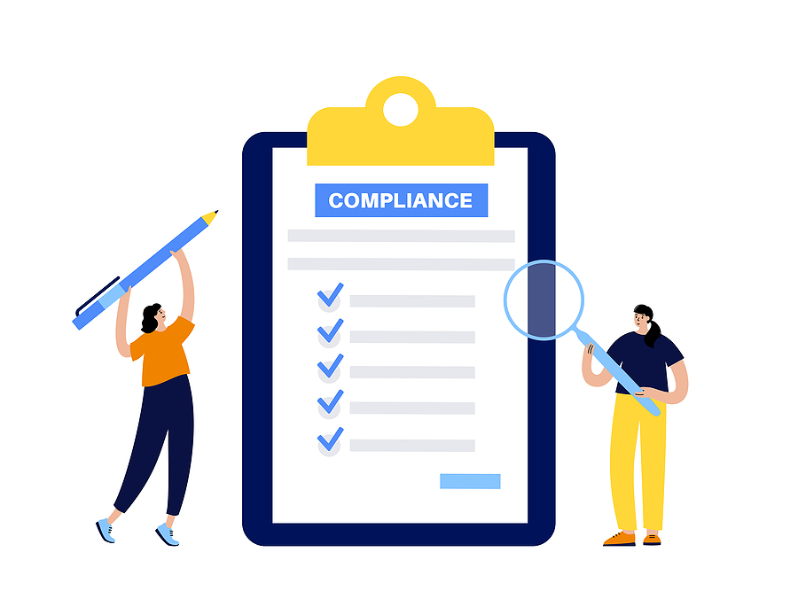

School Premises Compliance Audit

Name of Headteacher
Name of Business Manager
Name of Premises Manager
Total Number of Pupils on roll
Total Number of Staff
Age of the School

Water Hygiene and Safety | Yes | No
Is there a water risk assessment available for the premises? | ☐ | ☐
Is there evidence that the water risk assessment is reviewed every 2 years? | ☐ | ☐
If there is a risk, has a scheme for preventing or controlling the risk been developed for the premises? | ☐ | ☐
Is there guidance based around L8 for control of legionella available for reference? | ☐ | ☐
Is someone identified as competent for your premises in relation to legionella? | ☐ | ☐
Has the competent person for legionella received appropriate training to allow them to carry out their responsibilities? | ☐ | ☐
Are all records in relation to legionella kept? i.e. temperature checks, flushing of little used outlets etc. | ☐ | ☐
Is the competent person for legionella involved in any planned work on water or air conditioning systems? | ☐ | ☐
Is there evidence that annual chlorination of stored portable water supplies is being carried out? | ☐ | ☐
Is there evidence that 6 monthly water tank inspections are being carried out? | ☐ | ☐
Is there adequate system in place for ensuring any issues regarding legionella are highlighted so that remedial action can be undertaken? | ☐ | ☐

Asbestos | Yes | No
Is there any Asbestos on site? | ☐ | ☐
Does the building have an Asbestos risk assessment? | ☐ | ☐
Does the building have an Asbestos management plan? | ☐ | ☐
Is there evidence that an annual review of the Asbestos risk assessment and management plan has been carried out? | ☐ | ☐
Has an Asbestos Duty Holder received appropriate training to allow them to carry out their responsibilities? | ☐ | ☐
Are employees that work in the building made aware of the presence and position of asbestos in the building if they are likely to disturb it during normal work? | ☐ | ☐
Are warning labels/stickers provided where appropriate? | ☐ | ☐
Does the duty holder regularly inspect the condition of any identified Asbestos in the Asbestos building file? Are these checks recorded in the register? | ☐ | ☐
Do all building contractors sign in and check the Asbestos register prior to starting work? | ☐ | ☐
Are the procedures known and understood if asbestos is disturbed in the building? | ☐ | ☐

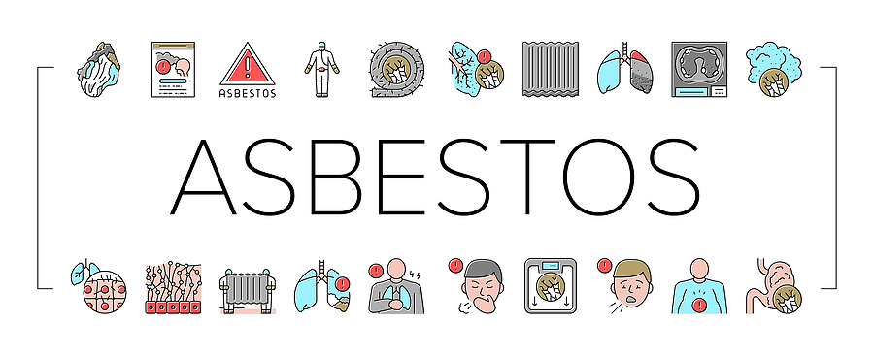

Control of Substances Hazardous to Health (COSHH) and Radiation | Yes | No
Is there evidence of a COSHH inventory which identifies all hazardous substances used on site? | ☐ | ☐
Have COSHH risk assessments been carried out for all products, substances and processes and the findings been formally disseminated to relevant employees? | ☐ | ☐
Are the products and COSHH assessments reviewed on a regular basis? | ☐ | ☐
Has adequate information, instruction and training been provided for employees using substances that may be hazardous to health? | ☐ | ☐
Is there a system in place to request manufacturers hazard data sheets (MSDSs) for new products introduced in school? | ☐ | ☐
Are hazardous substances stored safely and suitably labelled? | ☐ | ☐
Are there adequate welfare and emergency facilities where appropriate? | ☐ | ☐
Are adequate clean up procedures in place to deal with a chemical spillage? | ☐ | ☐
Has a radiation protection officer been appointed within the school? | ☐ | ☐
Has the school registered any radioactive sources with the HSE? | ☐ | ☐
How are the radioactive sources stored? | ☐ | ☐

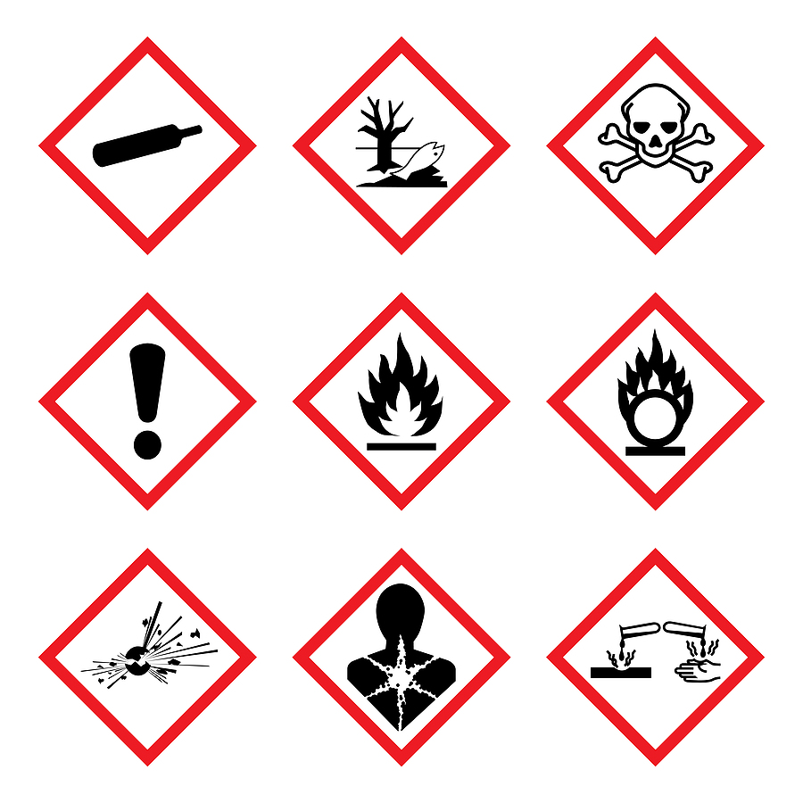

Electrical Safety | Yes | No
Is there evidence that periodic inspection of Fixed Wiring Installations are carried out every 5 years. | ☐ | ☐
Is there evidence that Portable Electrical Equipment is tested on a regular basis? | ☐ | ☐
Electrical panels are clearly marked and unobstructed, restricted access? | ☐ | ☐
Cable management acceptable? (no split/taped cords) | ☐ | ☐
Any loose or damaged conduit/trunking? | ☐ | ☐
Any unauthorized private equipment being used? | ☐ | ☐
Do any power sockets appear to be overloaded? | ☐ | ☐
Is there evidence that monthly inspections of the external lighting is being carried out? | ☐ | ☐
Is there evidence that monthly testing test of emergency lighting is carried out? | ☐ | ☐
Is there evidence that an annual full discharge test of emergency lighting is carried out? | ☐ | ☐



Fire Safety | Yes | No
Has a Fire Risk Assessment been carried out for the premises and if so has an action plan been developed to implement the recommendations? | ☐ | ☐
Is there evidence that an annual review of the Fire Risk Assessment has been carried out? | ☐ | ☐
All fire exits are clearly marked? | ☐ | ☐
Fire extinguishers are properly mounted? | ☐ | ☐
Is there evidence that weekly visual inspections of Fire Fighting Equipment is being carried out? | ☐ | ☐
Is there evidence that Fire Extinguishers are inspected on an annual basis? | ☐ | ☐
Fire doors and exits are free of obstructions? | ☐ | ☐
Vision panels are unobstructed and in good condition? | ☐ | ☐
Is there evidence that fire doors are inspected for fit and correct closure? | ☐ | ☐
Are external storage / waste bins secured and located a suitable distance away from the buildings? | ☐ | ☐
Weekly fire alarm tests are carried out and recorded? | ☐ | ☐
Is there evidence that testing/servicing of the fire alarm is carried out by a competent person on a regular basis? | ☐ | ☐
Is the fire alarm remotely monitored? If not, is somebody tasked with calling the Fire Brigade in a genuine emergency? | ☐ | ☐
Is there evidence that automatic extinguishing systems in computer rooms/kitchens are inspected/serviced on an annual basis? | ☐ | ☐
Is there evidence that regular testing of the Disabled Toilet Alarm system is being carried out | ☐ | ☐
Is there evidence that regular testing of the Disabled Refuge Point communication system is carried out? | ☐ | ☐
Is there evidence that regular testing of the Lift Emergency Call system is being carried out? | ☐ | ☐

Fire Safety (Continued) | Yes | No
Is there evidence that sprinkler systems are inspected/serviced on an annual basis? | ☐ | ☐
Is there evidence that wet/dry risers are inspected/serviced on an annual basis? | ☐ | ☐
Is there evidence that private hydrants are inspected/serviced on an annual basis? | ☐ | ☐
Is there evidence that smoke extraction/ventilation systems are inspected/serviced on an annual basis? | ☐ | ☐
Are regular fire evacuation drills carried out (at least every 6 months)? | ☐ | ☐
Is there evidence that monthly visual inspections of Evac Chairs is being carried out? | ☐ | ☐
Are all Refuge Points suitably signed and uniquely identified? | ☐ | ☐
Gas and Boiler House Safety | Yes | No
Are all gas appliances installed, fitted and maintained by competent persons? | ☐ | ☐
Are all appliances subjected to an annual gas safety test? | ☐ | ☐
Is there evidence that 5 yearly testing of Gas Systems (pipe work) is carried out? | ☐ | ☐
Is a gas shut off valve installed and are staff aware of its location? | ☐ | ☐
Are only trained persons involved in resetting gas safety systems? | ☐ | ☐
Are boiler houses free of combustible materials? | ☐ | ☐

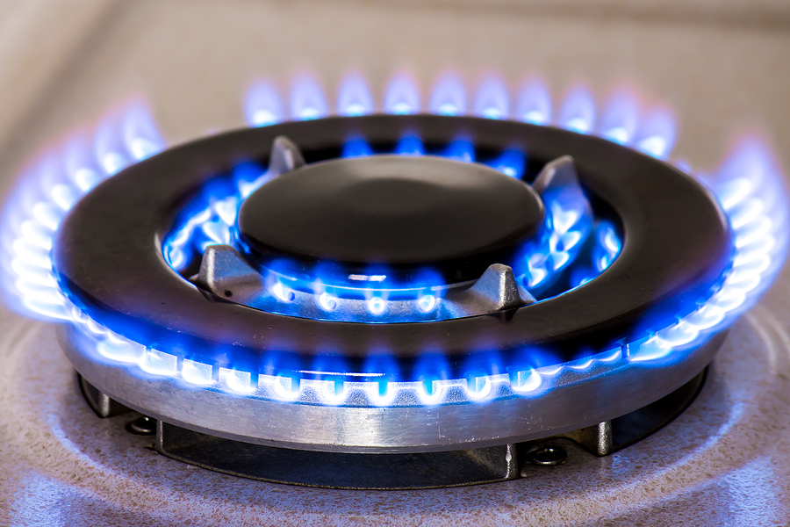

Work Equipment | Yes | No
Has suitable work equipment been provided? | ☐ | ☐
Have hazards relating to specific work equipment been identified and adequately controlled? | ☐ | ☐
Have Risk Assessments been carried out on specific work equipment? | ☐ | ☐
Have employees received information, instruction and training in the use of specific work equipment? | ☐ | ☐
Have relevant staff received training in Abrasive Wheels? | ☐ | ☐
Have suitable Noise and Vibration risk assessments been carried out? | ☐ | ☐
Are all Local Exhaust Ventilation (LEV) systems inspected every 14 months? | ☐ | ☐
Is all dining equipment (i.e. Tables, Chairs etc. belonging to the school/college) in good condition and adequately maintained? | ☐ | ☐



Premises Management | Yes | No
Are all windows above first floor fitted with suitable window restrictors? | ☐ | ☐
Is there a Tree Safety Risk Assessment? | ☐ | ☐
Are work areas adequately lit? | ☐ | ☐
Is there adequate ventilation (fresh air) through work areas? | ☐ | ☐
Is the heating system capable of maintaining a temperature between 16 – 24 Celsius? | ☐ | ☐
Are arrangements in place for reporting defects to the building and remedial action carried out? | ☐ | ☐
Anti-slip surfaces provided where appropriate? | ☐ | ☐
Is there an adequate provision of drinking water? | ☐ | ☐
Is there an adequate number of sanitary conveniences? | ☐ | ☐
Are all gates protected against trapping points? | ☐ | ☐
Are all staircases fitted with handrails/guardrails? | ☐ | ☐
Is the perimeter wall/fence/railings in a good state of repair? | ☐ | ☐
Is the external waste area clearly identified/secure/away from the main building? | ☐ | ☐
Have relevant staff received training in Confined Spaces? | ☐ | ☐
Is there evidence that daily checks of significant building related risks are carried out? | ☐ | ☐
Is there evidence that regular inspections of External Areas are being carried out? | ☐ | ☐


Housekeeping | Yes | No
Are classrooms and other areas clean and tidy? | ☐ | ☐
Corridors/halls/walkways clear of debris and obstructions? | ☐ | ☐
All spills cleaned up speedily? | ☐ | ☐
Carpets in good condition? (No holes or curled edges) | ☐ | ☐
Are toilets kept clean and tidy? | ☐ | ☐
Floors, stairs and walkways have non-slip surfaces where appropriate? | ☐ | ☐
Waste bins are available and emptied regularly? | ☐ | ☐
Floors are free of holes, protrusions, loose boards and splinters? | ☐ | ☐
Items are stored correctly and empty boxes, etc. are disposed of? | ☐ | ☐
Combustible materials are kept away from heat sources? | ☐ | ☐
Play and Sports Areas/Activities | Yes | No
Is PE Equipment inspected within the past 12 months by a competent person? Are regular informal checks conducted by staff? | ☐ | ☐
Are windows opening onto external walkways/play areas restricted? Are barriers in place? | ☐ | ☐
Is safety glazing to BS 6206 or glazing filmed in the vulnerable areas? (e.g. panes > 250mm wide in or adjacent to doors, PE areas, etc.) | ☐ | ☐
Are windows restricted to prevent collisions? | ☐ | ☐
Are pathways / walkways stable underfoot and without significant trip hazards? (e.g. no potholes, no raised/sunken slabs) | ☐ | ☐
Is outdoor play equipment adequately maintained and in good condition? (checked annually by competent person, weekly checks by site staff) | ☐ | ☐
Is there sufficient storage space and is it reasonably tidy? | ☐ | ☐
Are playing fields / pitches visually inspected before use and free from hazardous materials? | ☐ | ☐

Personal Protective Equipment (PPE) | Yes | No
Is PPE available, suitable for the task/job? | ☐ | ☐
Are employees trained in the use and limitations of PPE? | ☐ | ☐
Work at Height | Yes | No
Is there awareness of where work at height takes place on the premises and who carries it out? | ☐ | ☐
Is there evidence that work at height risks specific to the premises have been assessed including existing places of work and fragile surfaces? | ☐ | ☐
Have people who are required to work at height undergone appropriate training? | ☐ | ☐
Are staff aware of the restrictions on roof work? | ☐ | ☐
Is there evidence that work equipment has been selected appropriate to the tasks and areas of work? | ☐ | ☐
Where equipment is premises based is there awareness and systems to ensure that this equipment is only for use by school/college employees? | ☐ | ☐
Is there evidence that equipment for work at height is subject to inspection, examination and test by competent people? | ☐ | ☐
Is access to low roofs restricted and are any fragile surfaces identified with suitable signage? | ☐ | ☐
Has planning for rescue from work at height situations been taken into account? | ☐ | ☐

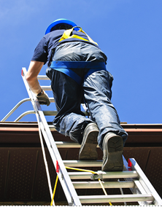

Lone Working | Yes | No
Have individuals or groups of employees been identified as lone workers? | ☐ | ☐
Is there a suitable lone worker policy in place? | ☐ | ☐
Have specific risk assessments been undertaken identifying the risks associated with lone working? Are they suitable and sufficient? | ☐ | ☐
Have all relevant employees been trained and are they aware of the lone working procedures in place and their responsibility for working within them? | ☐ | ☐
Manual Handling Operations | Yes | No
Are manual handling operations assessed taking into account the load, the nature of the task, the working environment and the individuals' capabilities? | ☐ | ☐
Where a significant risk is identified, has a specific manual handling assessment been carried out and formally recorded? | ☐ | ☐
Where hazards exist are the control measures identified in the assessments implemented and monitored by supervisors/managers? | ☐ | ☐
Have employees received appropriate training to carry out those manual handling tasks which cannot be eliminated? | ☐ | ☐
Where mechanical aids are provided to assist employees with lifting and handling - are they easily accessible, suitably maintained and serviced where necessary and employees suitably trained in their use? | ☐ | ☐

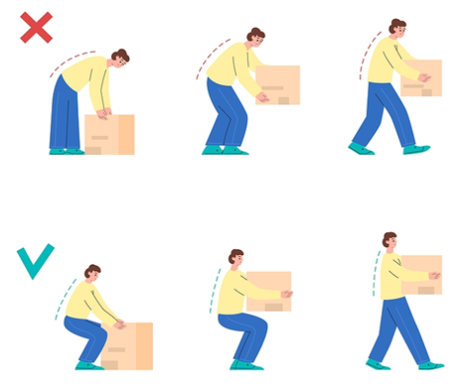

Lifts and Lifting Equipment | Yes | No
Are there any lifts or lifting equipment? | ☐ | ☐
Are all passenger lifts fitted with safety devices to prevent a person being crushed, trapped, struck or falling from the lift? | ☐ | ☐
Are lifts/equipment marked with its safe working load? | ☐ | ☐
Is there a means of raising alarm in all lifts in event of failure, are these tested and recorded? | ☐ | ☐
Is there a clear procedure to be followed in event of a person becoming trapped in the lift/equipment and are people competent to follow the procedure? | ☐ | ☐
Are all lifts/equipment examined at statutory intervals (every 6 months for people or 12 months for loads only) by competent person, recorded in terms of inspections, maintenance and testing? | ☐ | ☐
Are window cleaning hoist/safety eye bolts inspected by a competent person? | ☐ | ☐

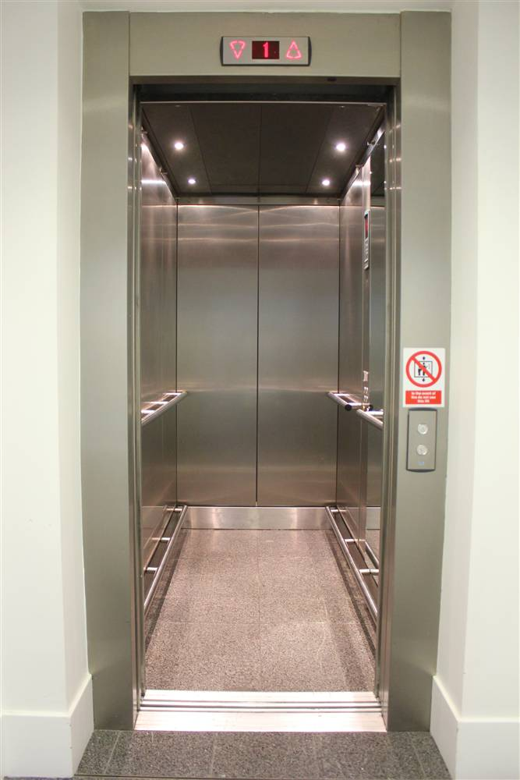

(Continued)

Swimming Pool Management | Yes | No
Is there a swimming pool? | ☐ | ☐
Does the school/college have a swimming pool policy? | ☐ | ☐
Does the policy include the Normal Operating Procedures (NOP) and the Emergency Action Plan? (EAP) | ☐ | ☐
Are staff suitably qualified to carry out pool rescues? | ☐ | ☐
Is sufficient rescue equipment and signage in place? | ☐ | ☐
Are suitable and sufficient risk assessments available that specifically deal with the issue of pool safety? | ☐ | ☐
Can the area be closed off/secured when no staff are in the pool area? | ☐ | ☐
Are pool plant records kept? i.e. water readings - free, combined, PH, Air and Water temperature | ☐ | ☐
Does the plant operator hold the PWTAG Approved Pool Plant Operator Certificate? | ☐ | ☐
Are water samples taken each month and tested for micro-organism issues by a UKAS accredited Laboratory? Are records kept of the results? | ☐ | ☐
Are Procedures in place for hiring out the pool to outside organizations? | ☐ | ☐
First Aid | Yes | No
Is there an adequate number of First Aiders on site at all times? | ☐ | ☐
Is there an adequate amount of First Aid kits available at all times? | ☐ | ☐
Is there evidence that an annual review of First Aid provision is carried out? | ☐ | ☐
Is there evidence that regular checks of First Aid Equipment is carried out? | ☐ | ☐
Are there adequate facilities available for the disposal of Sharps? | ☐ | ☐

(Continued)

Car Parking Vehicle/Pedestrian Segregation | Yes | No
Is there sufficient numbers of parking spaces available for the number of staff? | ☐ | ☐
Are traffic routes and parking bays clearly marked? | ☐ | ☐
Are speed restrictions and/or one way systems in place to manage traffic? | ☐ | ☐
Is there adequate vehicle/pedestrian separation within the premises? | ☐ | ☐
Heating/Ventilation/Extraction Systems | Yes | No
Are there any Air Conditioning units on site? | ☐ | ☐
Is there evidence that servicing and F Gas checks of Air Conditioning equipment is carried out every 6 months. | ☐ | ☐
Control of Contractors | Yes | No
Is a competent person involved in preparing specifications for the work or agreeing that any proposed work is acceptable? | ☐ | ☐
Are all contractors vetted, prior to commencement of works? | ☐ | ☐
Are job specific method statements and risk assessments obtained from contractors, checked by a competent person and communicated to the school/college? | ☐ | ☐
Are meetings held directly with the contractor to discuss the intended work and how it will affect normal school/college operation? | ☐ | ☐
Are contractors monitored whilst undertaking work? If so, how? | ☐ | ☐
Is a Permit to Work system used for controlling high risk activities? | ☐ | ☐
Are health and safety files held onsite for all completed construction works? | ☐ | ☐



Minibuses | Yes | No
Does the school/college own or operate Minibuses? | ☐ | ☐
Are all Drivers' licences checked to ensure they have the right class of licence to drive minibuses? i.e. D or D1 on the licence or did they pass their test pre-January 1997? | ☐ | ☐
Are all Minibus drivers MIDAS trained? | ☐ | ☐
Are suitable and sufficient risk assessments carried out for the use of the minibus? | ☐ | ☐
Is there a procedure in place to ensure all minibus drivers are medically fit? | ☐ | ☐
Are pre-use checks of the minibus carried out each day and documented? | ☐ | ☐
Does the minibus have a current MOT and is it regularly serviced? | ☐ | ☐
Are seat belts fitted to the minibus? | ☐ | ☐
Does the minibus carry a first aid kit, fire extinguisher, high visibility vest and warning triangle? | ☐ | ☐
Are powered lifts tested and inspected every 6 months and are documents available? | ☐ | ☐
Site Risk Assessments | Yes | No
Are Risk Assessments completed for high risk activities carried out by the Site team? | ☐ | ☐
List examples of the risk assessments reviewed at the time of the audit: | ☐ | ☐
Are Risk Assessments reviewed periodically i.e. every 12 months? | ☐ | ☐


Oil Storage Tanks | Yes | No
Are there any Oil Storage Tanks on site? | ☐ | ☐
Is there evidence that regular inspections of Oil Storage Tanks, Bunds, Pipework and surrounding areas is being carried out? | ☐ | ☐
Automatic Doors/Gates/Barriers | Yes | No
Are there any Automatic Doors/Gates/Barriers on site? | ☐ | ☐
Is there evidence that regular servicing of Automatic Doors/Gates/Barriers is carried out? | ☐ | ☐
Catering Equipment | Yes | No
Is there any Commercial Catering Equipment on site? | ☐ | ☐
Is there evidence that cleaning, sterilising and testing of Extraction Fans/Canopies is carried out every 6/12 months? | ☐ | ☐
Lightning Conductors | Yes | No
Is the building fitted with a Lightning Conductor? | ☐ | ☐
Is there evidence that annual visual inspection of Lightning Conductors is carried out? | ☐ | ☐
Is there evidence that any remedial works have been completed following any recommendations? | ☐ | ☐

Sewage/Water Treatment/Septic Tank and Oil interceptors | Yes | No
Are there any Sewage/Water Treatment/Septic Tank or Oil Interceptors on site? | ☐ | ☐
Is there evidence that tanks are being pumped out every 6 months? | ☐ | ☐
Is there evidence that annual servicing of lift pumps is being carried out? | ☐ | ☐

(Continued)

High Risk Curriculum Areas Inspected
Area Number
Department
Health and Safety issue identified
Location
Photo
if available/required

High Risk Curriculum Areas Inspected
Area Number
Department
Health and Safety issue identified
Location
Photo
if available/required

High Risk Curriculum Areas Inspected
Area Number
Department
Health and Safety issue identified
Location
Photo
if available/required

Guidance Version Control
Name Of Document | Version | Last Review date
Premises Compliance Audit Checklist | NASPM V2 | October 2024

Copyright © 2024 NASPM

All rights reserved.

No part of any NASPM document may be reproduced, distributed, or transmitted in any form or by any means, including photocopying, recording, or other electronic or mechanical methods, to any individual, school, or organisation outside of the school named in the school membership agreement.

Should membership terminate, no part of any NASPM document may be used, reproduced, distributed or transmitted by any individual, school, or organisation.

