Strategic

Premises Management Overview

Document 102



Premises Management Overview

School buildings can be complex to manage and maintain and every school has varying challenges with the safe running and regular maintenance of school buildings. This document is an overview of the key areas for managing school estates.

Legal Duties

The Health and Safety at Work Act 1974 requires the employer to have a safe place of work, safe access and egress, safe equipment and safe systems of work to ensure no one is harmed. The employee has duties to ensure their own safety and the safety of others on the premises.

Schools have statutory frameworks regardless of the type of school or who the employer is. This legal framework sets out the duty holder’s roles and responsibilities to ensure that the school is a safe and secure environment. The building regulations cover all school buildings together with many health and safety regulations, including;

- The Management of Health and Safety Regulations 1999
- The Control of Asbestos at Work Regulations 2012
- Health and Safety (First Aid) Regulations 1981
- The Control of Substances Hazardous to Health Regulations 2002
- The Health and Safety (Display Screen Equipment) Regulations 1992
- The School Premises (England) Regulation 2012
- The Construction Design Management Regulations 2015
- The School Premises (England) Regulations 2012

Failure to maintain the school's structures and services in a safe and hygienic condition may constitute a criminal offence. Both the school and individuals with specific responsibilities may be held liable.

In a maintained school, the overall responsibility for the premises remains with the local authority (LA). Most authorities will have an estates lead or property department.

The proprietors, trustees or governing body of an academy or independent school are responsible for overseeing the management and safety of its premises and facilities.

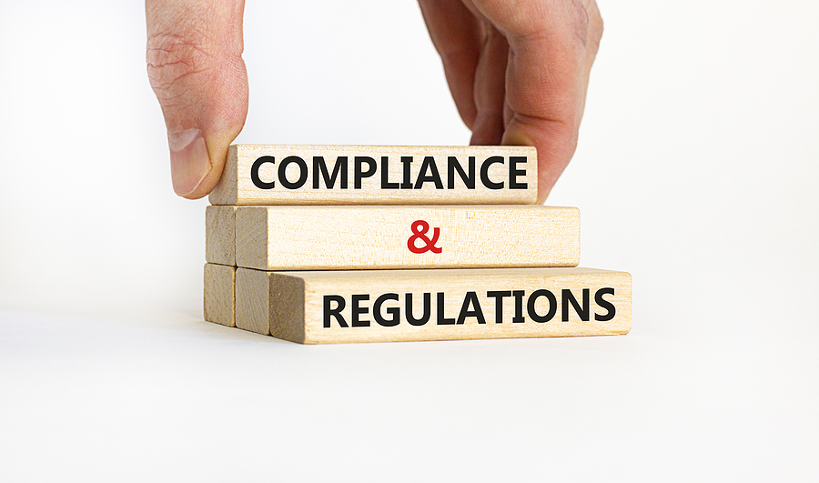

The Premises Manager

The Premises Manager Will Be Responsible For Maintaining:

- The interior of the building (e.g. heating, lighting, doors, windows, decoration)
- Equipment (boilers/heating etc)
- Services and infrastructure and services (e.g. electricity, water, sewage, etc)
- Security (e.g. fencing, security lighting, alarms, etc).
- The fabric of the buildings (e.g. the foundations, roofs, walls, ceilings and floors)
- Management of assets within the school – asset register

Competence of the Premises Manager

- Knowledge of health and safety legislation
- School industry-related standards
- Legal requirements relating specifically to their job
- Building compliance and regulatory requirements
- Specific areas of knowledge including, legionella, fire, gas, security
- Contractor management
- Premises-related risk assessments
- Maintenance requirements
- Cleaning and Catering management
- Health and Safety Auditing
- COSHH management
- Estates management
- Management of energy
- Grounds management
- CDM and project management
- Emergency planning and business continuity

Premises Manager Work Includes;

- Regular safety inspections/recorded safety tours to ensure the buildings are in good condition
- Ensure that plant and equipment are operating correctly and efficiently to satisfy manufacturers’ safety instructions and warranties
- Identify specific maintenance needs
- Selection of contractors and contractor management
- Dealing with period inspections, servicing, maintenance
- Local testing arrangements

(Continued)

Condition Surveys
Surveys should identify specific building condition issues, deficiencies and maintenance requirements, including, but not limited to:
- Structural
- Roofs
- Building fabric
- Windows and Doors
- Mechanical and Electrical
- Asbestos
- Utilities
- Sewage and Drainage
- Fire Safety and Security
- Site Layout

DfE Suggest that the Condition of Buildings Is Generally Categorised as:

A (Good) Performing as intended and operating efficiently
B (Satisfactory) Performing as intended but exhibiting minor deterioration
C (Poor) Exhibiting major defects and/or not operating as intended
D (Bad) Life expired and/or serious risk of failure.

A suggested estimation of priority is:

1 Urgent, immediate or one-year remedial action required
2 Essential, one- to two-year remedial action required
3 Desirable, three- to five-year remedial action required
4 Long-term, outside of a five-year planning period.

Surveys should include an estimated cost for repair or replacement of buildings or building elements in bad or poor condition. Most schools will have building condition surveys completed every 5 years depending on the condition of the buildings and will follow the guidance from the previous survey.

Maintenance Planning

Maintenance plans should be based on:
- Problems found during the inspection
- Work requirements submitted by school staff
- Routine equipment servicing, e.g. the boiler, plant
- Scheduled building maintenance, e.g. repair, painting and decorating.

Maintenance Systems

Establishing suitable maintenance systems is a key factor in ensuring effective premises management. The maintenance system should cover:

- All buildings — both external and internal and including outbuildings
- Services such as gas, water and electricity
- Furnishings and fittings
- Equipment and devices
- Grounds — including fences, gates, paths, car parks, lighting and wall security

Planned Preventative Maintenance

Is the key to having preventative maintenance and is the most cost-effective. The maintenance system should form part of a fault reporting and tracking system whereby faults or potential problem areas are logged and followed up until they are recorded as having been completed.

Record Keeping

Effective records should be kept of day-to-day monitoring with actions related to premises management, including:

- Fire Safety monitoring, daily, weekly monthly checks
- Contractor works re: servicing and maintenance
- Health and Safety tours/inspections
- Security inspections
- Premises risk assessment
- Opening and Closing Checks
- Site surveys and inspections
- Legionella log book checklists
- Workplace health and safety management – local and external auditing
- Contractor management – inductions
- Asbestos management plan records/local visual inspections and external surveys
- External play inspections
- Equipment inspections
- Ladder inspections
- Plant room risk assessments/audits
- Plant/premises log books – manufacturer information
- Accident investigations, where these relate to premises
- Asset management review and development
- Contractor service and maintenance follow-up actions – development of action plans
- Contractor health and safety file review, after all significant works

Refer to the NASPM Document no.25 for the full compliance schedules and NASPM checklists for daily, weekly, monthly, termly, quarterly, 6 monthly and annual checklists.

Strategic Management

Premises managers should be involved with the development of the strategic planning of the school estate and should have the following strategic documents.

- An Estate Strategy, including the Estates Vision
- An Estates Policy
- An Asset management plan

Each of the above documents should form part of the school management of document approval, shared and agreed via the governing board/Trust sign-off. The Estates Strategy should be a plan of the school building improvements over 3-5 years. The strategy should be fully integrated into the school business and budgeting planning process.

Planning for short, medium and long-term building improvement needs, keeping the estate safe and secure for everyone and being aware of the investment needed

Premises Improvement

The estate’s vision and strategy is primarily focusing on the school improvements that include;

- Improving known higher-risk concerns, such as fire safety issues. Such as non-compliant fire doors, lack of fire alarm coverage
- improving the comfort and safety of building users
- Updating, replacing and modernising outdated facilities
- Increasing energy efficiency
- Improving accessibility
- Increasing school capacity

Training

Premises staff require a range of health safety and estates management training. Competence includes experience, skills and knowledge in addition to specific health and safety training.

(Continued)

Essential Health and Safety Training

- Health and Safety Awareness – this includes legislation and the specific school areas.
- Asbestos Awareness – if the school was built before the year 2000 and has been confirmed with asbestos or presumed asbestos
- CDM 2015 – the legal duties of all related school building works
- Fire safety — fire warden, fire safety actions, fire brigade inspection requirements, evacuation management, fire risk assessments, passive and active fire management systems, PEEPs, maintaining fire-fighting equipment, installations such as sprinkler systems, fire alarms and detection systems
- Manual handling — including safe lifting and moving. How to complete specific manual handling risk assessments
- COSHH — including the safe handling of hazardous chemicals and substances, occupational exposure limits, and surveillance. How to complete COSHH risk assessments
- Risk assessments – what does suitable and sufficient mean
- Electrical safety — including the use and maintenance of plant and electrical installations, and the use and safety of portable electrical equipment
- Working at height — including safe maintenance, use and checking of ladders and equipment for working at height, safe procedures and risk assessment, and work around flat roofs and skylights.

Refer to the NASPM training calendar for further information.

List of Relevant Legislation

- Construction (Design and Management) Regulations 2015
- Education (Independent School Standards) Regulations 2014
- Control of Asbestos Regulations 2012
- School Premises (England) Regulations 2012
- Building Regulations 2010
- Supply of Machinery (Safety) Regulations 2008 (as amended)
- Control of Noise at Work Regulations 2005
- Education (School Premises) Regulations 1999
- Management of Health and Safety at Work Regulations 1999
- Lifting Operations and Lifting Equipment Regulations 1998
- Provision and Use of Work Equipment Regulations 1998
- Lifts Regulations 1997
- Health and Safety (Safety Signs and Signals) Regulations 1996
- Electrical Equipment (Safety) Regulations 1994
- Manual Handling Operations Regulations 1992
- Personal Protective Equipment at Work Regulations 1992
- Workplace (Health, Safety and Welfare) Regulations 1992
- Electricity at Work Regulations 1989
- Fire Safety Reform Order 2005

Guidance Version Control

Name of Document | Version | Last Review date
Premises Management | NASPM V1 | October 2024

Copyright © 2024 NASPM

All rights reserved.

No part of any NASPM document may be reproduced, distributed, or transmitted in any form or by any means, including photocopying, recording, or other electronic or mechanical methods, to any individual, school, or organisation outside of the school named in the school membership agreement.

Should membership terminate, no part of any NASPM document may be used, reproduced, distributed or transmitted by any individual, school, or organisation.

