Building

User

Guide Templates

Document 101

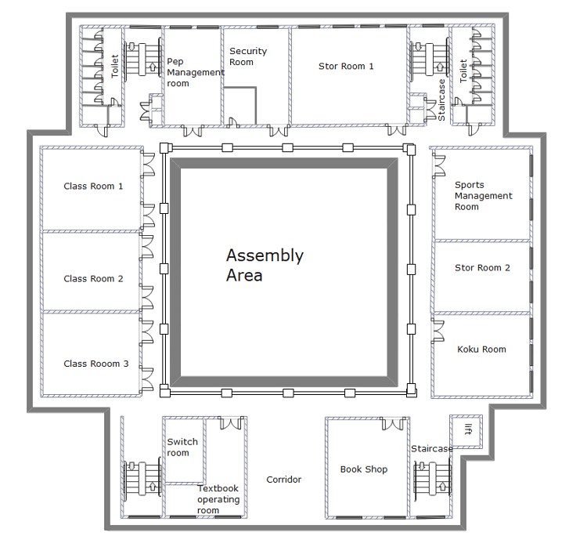

Building User Guide Template
Insert a picture of your building in this box.

School Address

Responsibility of

Position

Date

This Building User Guide should be kept at all times in

The electronic Version is located at

Contents
1
1 Building Services Information 6
1.1 General Building Information 6
1.2 Building Environment 10
1.3 Lifts and Escalators 11
1.4 Security System 11
2 Emergency information 14
2.1 Fire Response and Alarm System 14
2.2 Fire Evacuation Procedures 14
2.3 First Aid 15
3 Building Utility and Environmental Information 16
3.1 Overview of Company Policy and Practices 16
3.2 Energy and Environmental Strategy 17
3.3 Annual Building Energy Consumption 17
3.4 Energy Conservation 19
3.5 Mechanical 20
3.6 Electrical 21
3.7 Communications 22
4 Water management 23
4.1 Water Strategy 23
4.2 Domestic Water 25
5 Materials and waste management 26
5.1 Materials Purchasing Policy 26
5.2 Waste Management Policy 26
6 Transport facilities 27
6.1 Transport 27
6.2 Parking 27
7 Refit and rearrangement CONSIDERATIONS 28
7.1 Re-Fit Building/Building Sections 28
7.2 Re-Arrangement/Addition of Furniture 29
8 Reporting provision 30
8.1 Reporting Procedures 30
8.2 Responsible Parties 31
9 Training 32
9.1 Compulsory Training 32
9.2 Additional Training 33

Building User Guide Purpose
The NASPM Building User Guide has been created to assist Schools in having a template that can become a school-specific building guide.

This is in addition to any school’s original operating manuals. The aim is to make a more simplified central guide for the use and maintenance of the school buildings. It is noted that there is a themed audit finding over the 20 years of auditing schools a lack of key knowledge and management from building design to building use. This may include as some examples the poor knowledge of service isolation points such as electric, water and gas. Or a lack of understanding in the fire building design such as the lack of fire compartmentation or no awareness of the smoke ventilation system or the damper management.

This Building User Guide provides the school with a quick and easy guide to the everyday functions of the building in order to ensure the school building is safe and presents a healthy work environment and to assist the premises manager with key information on the operation of the building.

NASPM has based the headings on the BSRIA guidelines, to ensure that the standard is for the premises manager and school management has a key focus document which is developed and made specific to the school environment.

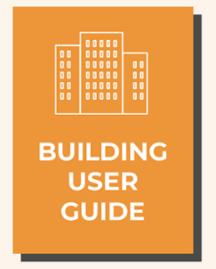

(Continued)
Building User Guide Updates and Reviews
Review 6 monthly and detail any changes to the document below

Review Date | Description of changes | Pages Updated or Removed | Premises Manager Signature

1 Building Services Information

1.1 General Building Information

Building Description
Provide a description of the school building/s here, age,
Include any shared building areas/lettings details

Insert building picture here. | Insert your picture here.

Location Map
Insert your picture here.

General Floor Plan – First Floor
General Floor Plan – Ground Floor
General Site Plan

Visitor Information

Building Shared Facilities
1.2 Building Environment

Include details on lighting, cooling, heating, ventilation, and acoustics.

You can include a floor plan showing main control point locations and state the minimum and maximum set points, operational times and any main control override. It is helpful to include a short description of who should adjust the temperatures on the main controls and how to and when to adjust the temperatures on the main controls, details of zone and or local user control settings.

Element Description | Distribution/Attenuation Method | Photos

Temperature Control |  | Photos
Time Schedule

Temperature Set Points

Out-of-Hours Operation

1.3 Lifts and Escalators

Schools should include a floor plan showing the location of the mechanical lifts and include the capacities of the lifts and a description of how to operate lifts with Emergency/stop buttons, information in case of fire, procedure in case of fault/failure, and call button/intercom.

How to Operate Lifts and Escalators
Procedure | Description | Photo
Standard operation
Emergency/stop button
In case of fault/failure, call button/intercom
In case of fire

1.4 Security System

Detail the security system and include details of the authorised staff that can activate or deactivate the system, including the approved contractors/key holding authorised persons. Details of the entry and exit procedure during normal hours and outside of normal working hours. Provide details of entry/exit procedures during normal hours and outside normal working hours.

Security System Description
Links to external organisation

Name and Contact Details of Authorised Personnel | Telephone Number

Normal operating | Times
Alarms off
Alarms on
Alarms on (out-of-office hours)

Entry Procedure During Normal Working Hours | Photos

(Continued)
Exit Procedure During Normal Working Hours | Photos

Entry Procedure Outside Normal Working Hours | Photos

Exit Procedure Outside Normal Working Hours | Photos

(Continued)

2 Emergency Information

Detail reference to key school emergency documentation

Health and Safety Documents

2.1 Fire Response and Alarm System

Type of Alarm System

2.2 Fire Evacuation Procedures

Include a briefing of premises management procedures, such as who goes to the fire panel, who communicates from the panel, who calls the fire brigade, the reporting information review at the assembly point, the meeting of the fire and rescue service the authorisation of all clear.

Fire Emergency Procedure

Use of Fire Equipment
2.3 First Aid

Calling for Assistance
Emergency First-Aid Procedure | Photo
Detail the school first aid information and ensure this is updated when any changes include the list of first-aiders. Detail the first aid equipment including the defibrillator if applicable. Also give the procedure for calling for assistance, for example, in an emergency – a person collapsed, chest pain, difficulty breathing, or serious injury, or with an incident – a person feeling unwell, a minor trip, fall or injury. Also, provide a floor plan showing the location of first aid facilities or equipment.

Minor Injury/Illness First-Aid Procedure

3 Building Utility and Environmental Information

3.1 Overview of Company Policy and Practices

Provide an overview of the company policies and practices relating to environmental standards.

Company Policies and Protocols

Canteen | Photos

(Continued)
3.2 Energy and Environmental Strategy

Provide energy and environmental policy documents, including general company policies and site-specific application of the above and or separate site policies.

Energy and Environmental Policies and Protocols | Photos

3.3 Annual Building Energy Consumption

Provide details on the main heating fuel and secondary fuel(s); gas/electricity supply and management/monitoring; gas/electricity metering and areas of sub-metering; low or zero carbon technologies and renewable energy sources; provision and location of EPC and DEC certificates and Advisory Report. Also, provide the provision of environmental rating and relevant assessment methods.

Management Monitoring

Low Or Zero Carbon Technology and Renewable Energy Sources
List Of Certificates And Reports | Location
3.4 Energy Conservation
See Section 3.3 and add any relevant protocols on energy conservation.

List Actions that Affect Energy Efficiency and Conservation
3.5 Mechanical

Provide information for manual and automated blinds, how these can be adjusted, and ventilation strategies in natural/mechanical/mixed mode. List actions that can affect the efficiency of the systems and the energy conservation in the building such as blocking supply outlets with filing cabinets or storage boxes, the use of natural ventilation when the system is in automated modes, opening windows and doors – when to and when not to, the use of blinds in winter time affecting the natural lighting, and lack of use of blinds in summer time, causing additional solar heat gain. Give high-flow temperature set points for each season.

Blind Adjustment

Ventilation Strategy
Set-Point for Winter Temperatures | Set-Point for Summertime Temperatures

3.6 Electrical

Provide information on lighting and small power strategy, provision of UPS if applicable, and the provision of emergency lighting. List actions that can affect the efficiency of the systems and the energy conservation in the building such as desk electric heaters/desk electric fans, use of override/local controls in areas with automated lighting systems and the use of lighting control procedures in lightly used areas. Provide Switch-off policy what, where and when.

Lighting and Small Power Strategy | Photos

Uninterruptible Power Supply (UPS)

Emergency Lighting

List Actions that Affect Energy Efficiency and Conservation

Switch-Off Policy
3.7 Communications

Provide information on the telephone system and operational procedures needed. And also provide information on the computer system used and include whether connectivity is by Ethernet or wireless and whether access is via intranet, extranet or internet.

Communication Procedures and Policies

Computer System Connectivity
Ethernet | Wireless

Company Network Options

4 Water Management

4.1 Water Strategy

Provide information on the water supply and management strategy, water metering, sub-metering and monitoring (BMS linked?) and water saving/recycling features such as recycled grey water, and rainwater harvesting. Provide a description of internal and external landscaped areas, irrigation system/hand watering/plants and reliance on natural precipitation only.

Water Supply and Management Strategy

Water Metering | Sub-Metering | Monitoring

Water Saving Features | Photos

Internal Landscape Areas | Photos

External Landscape Areas | Photos

Water Leaks | Photos

4.2 Domestic Water

Provide information on the areas where potable water is supplied, the location of water coolers, bottled water and hot water supplies. List water-saving features such as aerating taps, timed shut-off, proximity sensors, flow rate restriction on showers, dual/low flush toilets, waterless urinals, occupation sensors and solenoid shut-off/isolation valves.

Potable Water Locations

Water Cooler/Bottled Water Locations | Photos

Hot Water Supplies | Photos

Water Saving Features

5 Materials and Waste Management

5.1 Materials Purchasing Policy

Include information such as responsible sourcing of materials and the use of recycled materials.

Materials Purchasing Policy

5.2 Waste Management Policy

Include information about the recycling facilities used in the building, such as the use of bins, shredders, and compactors. Also include information on the use of recycling strands, such as paper, cardboard, plastic, cans, glass, and batteries. Show locations of the recycling collection points on the floor plan in section 1.1, and provide a timetable for collections and contact details for special arrangements.

Recycling Facilities

Recycling Strands

Contact Details

6 Transport Facilities

6.1 Transport

Include information on public transport, show bus stops, train stations and taxi ranks on the location map in section 1.1 and provide links to websites showing timetables, ticket prices and alternative transport, provide details of carpool/care share schemes and provide details of ‘Ride to Work’ schemes.

Public Transport

Alternative Transport

6.2 Parking

Show the location of the building, the location of offsite parking and other details on the location map in section 1.1. Show dedicated visitor parking, dedicated/preferential car share parking, general staff parking, location of bicycle racks and location of access to the site for pedestrians and cyclists, and all pedestrian and cycle routes on site on the general site plan in section 1.1.

Parking and Cycle Racks

7 Refit and Rearrangement Considerations

7.1 Re-Fit Building/Building Sections

Provide information on the following considerations, design load/occupation densities, design levels/limitations of existing building services, scope for extending/upgrading existing building services, and provision for additional building services. Include the application of the material and waste management policies (see Section 5).

Design Load/Occupational Densities

Design Levels/Limitations of Existing Building Services

Additional Building Services

Material And Waste Management Policies
7.2 Re-Arrangement/Addition of Furniture

Provide information about the impact on all aspects of the building environment (heating, cooling, ventilation, lighting and acoustics) due to moving furniture/partitions from the designed layout, adding furniture/partitions/shelving and changing occupation densities.

Also consider temporary/permanent placement of loose furnishings such as spare chairs, coat racks, filing cabinets, and storage boxes. List the impact this has on all aspects of the building environment (heating; cooling; ventilation; lighting and acoustics) through blocking or restricting access to supply grills, extract vents, control points, sensors, service and maintenance hatches, and emergency routes or services. Show the layout of furniture fittings on the floor plans in section 1.1.

Furniture and Fittings

Temporary/Permanent Furnishings

8 Reporting Provision

8.1 Reporting Procedures

Include details on the protocol for reporting conditioning requirements such as temperature setting, and ventilation. General maintenance requirements such as a faulty light fitting, leaking tap, window not opening, and blinds not working should also be provided. List operational maintenance requirements, no power supply, no telephone/internet connection, and toilet not flushing and report any emergency requirements, such as burst pipes, and electrical short or sparking (also see Section 2).

Conditional Requirements

General Maintenance Requirements

Operational Maintenance Requirements

Emergency Requirements

8.2 Responsible Parties

Include contact information for the following, help desk, health and safety manager, facilities manager and maintenance team.

Department | Contact Information
Facilities  Manager | Name:
Facilities  Manager | Telephone:
Facilities  Manager | Email:
Facilities Maintenance Manager | Name:
Facilities Maintenance Manager | Telephone:
Facilities Maintenance Manager | Email:
Administration Manager | Name:
Administration Manager | Telephone:
Administration Manager | Email:
Health & Safety Officer | Name:
Health & Safety Officer | Telephone:
Health & Safety Officer | Email:
Reception  (Help Desk) | Name:
Reception  (Help Desk) | Telephone:
Reception  (Help Desk) | Email:

(Continued)

9 Training

9.1 Compulsory Training

This should include training details on the following information: site induction for new employees (building users/occupants), visitors, and contractors. Provide specialist training for selected personnel in air conditioning and heating, lighting and control, water waste management and recyclable procedures. Also include training for emergency procedures, including general aspects covered in site induction, with specialist training for selected personnel such as fire, first aid and lift failures.

Site Induction
Visitors
New staff

Specialist Training for Building Services

Emergency Procedures

9.2 Additional Training

This should include training details on any innovative/energy-saving methods or equipment and training for general internal/external projects aimed at meeting areas of corporate social responsibility.

Additional Training

Guidance Version Control
Name Of Document | Version | Last Review date
Building User Guide Template | NASPM V2 | October 2024

Copyright © 2024 NASPM

All rights reserved.

No part of any NASPM document may be reproduced, distributed, or transmitted in any form or by any means, including photocopying, recording, or other electronic or mechanical methods, to any individual, school, or organisation outside of the school named in the school membership agreement.

Should membership terminate, no part of any NASPM document may be used, reproduced, distributed or transmitted by any individual, school, or organisation.

