Material

Breach

Document 100

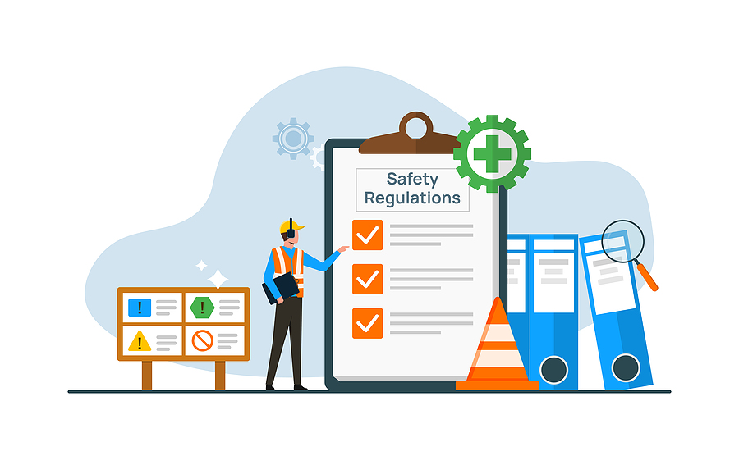

What is a Material Breach?

A material breach in health and safety refers to a serious violation of health and safety law.

It May Result In One Of The Following Actions:

- Notification of Contravention
- Improvement notice
- Prohibition notice
- Prosecution

Technical or trivial breaches where verbal advice may suffice are not considered material breaches. A material breach exists when you have broken a health and safety law and the inspector judges that it is serious enough for them to notify you in writing. The law and regulations require health and safety key actions and controls to be in place to manage the health safety and well-being of all school users.

Before deciding to notify you in writing, the inspector must apply the principles of the HSE’s Enforcement Policy Statement and the Enforcement Management Model to ensure their decision on the level of enforcement action is proportionate to the circumstances that they are aware of.

Typical Examples of Material Breaches Include:

- Failure to manage asbestos, for example, lacking in asbestos surveys, and/or not having asbestos management plans or asbestos training.
- An unprotected or inadequately protected fall from height, flat roofs without edge protection and staff/contractors gaining access/working on the flat roof
- Lack of servicing/maintenance re: statutory compliance requirements

The HSE Inspector’s written notification will make it clear which contraventions are material breaches where a fee is payable. Noting that if you have complied with the law you will not be paying the HSE fee.

It is critical that the school management are fully aware of the legal compliance requirements of the school.

Guidance Version Control
Name Of Document | Version | Last Review date
Material Breach | NASPM V1 | October 2024

Copyright © 2024 NASPM

All rights reserved.

No part of any NASPM document may be reproduced, distributed, or transmitted in any form or by any means, including photocopying, recording, or other electronic or mechanical methods, to any individual, school, or organisation outside of the school named in the school membership agreement.

Should membership terminate, no part of any NASPM document may be used, reproduced, distributed or transmitted by any individual, school, or organisation.

