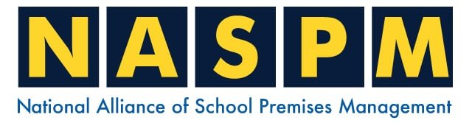
Home | Training | Membership | Contact

Happy Christmas

to our members,

looking forward to a

safe and healthy 2025

We hope you are enjoying your NASPM Newsletters,
in this December newsletter we cover the following:

- Fire Risk Assessment Common Findings
- National School Fire Working Group
- Legionella Management
- PUWER 1998
- Offences
- NASPM Training
- Your input into NASPM

Introduction
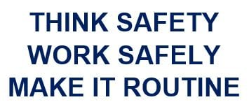

Dear Members, I hope all is well and you have had a safe December. A welcome to our new members and thank you for all the incredible input and communication we have received.
For those who were at the ISBL in Birmingham, it was good to catch up and thanks for coming to see us.

Undercover School Fire Risk Assessor



Let’s talk hardware

Not all door hardware is suitable for fire doors. Hinges, latches, and handles must meet fire-rating standards, as they’re tested to withstand high temperatures without warping or failing. Using non-fire-rated hardware will compromise the door’s fire resistance rating. This is a common non-compliant finding that is often missed in the monthly internal fire door inspections and even within some school FRAs.

Hinges

Looking at the hinges, the photo below shows the old piano hinges that run along the length of the door, these are used for security purposes, and they are not normally
fire-rated hinges. The school has been very productive and has a 5 year fire door improvement plan that includes the replacement of non-compliant fire doors.

Non-Compliant piano hinge The new fire door upgrade

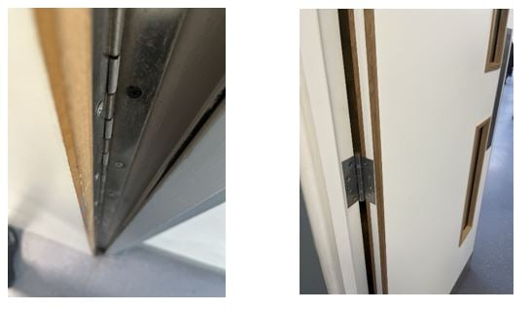

Middle chain hinge – Non-Compliant

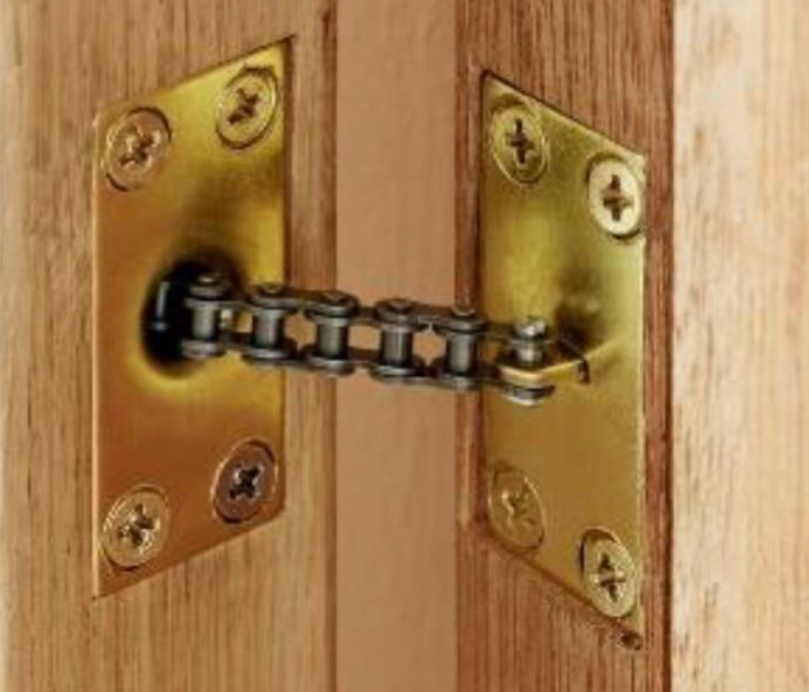

Latches

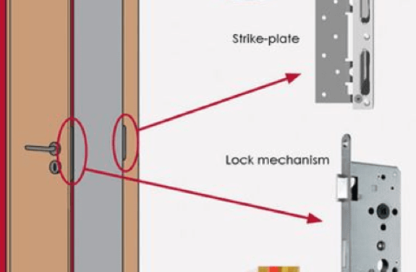
The question that often comes up around latches is do fire doors need latches?
Information on fire doors varies, because the scope of what you can and cannot do depends on the fire test evidence for that particular door.
The answer to this question is that you can have a fire door 'unlatched' and held closed by the self-closing device provided that the door has test evidence for that use. I always advise checking with the door supplier/manufacturer, if it’s a new fire door they should be able to supply certification and product data sheets with the information.
That said most fire door assemblies are fitted with single-axis hinges (butt hinges) and fitted with mortise latches rely upon the latch bolt to make an important contribution to the performance of the door in the event of a fire, the self-closer alone would not be sufficient.
The latch prevents the fire door from distorting in the initial stages of the fire. If you require a fire door without a latch then you would need a pivot hinge and the test details that come with the door should indicate this is a possibility.
The only self-closer I have seen that doesn't use a latch is a pivot hinge (floor hinge) which I have seen used on double doors in older schools within corridors.
It is common to miss damage to the latch, and strike plate, damage includes holes around the latch and damage to the latch and mechanism that may prevent the fire door from closing properly or fully.

Handles

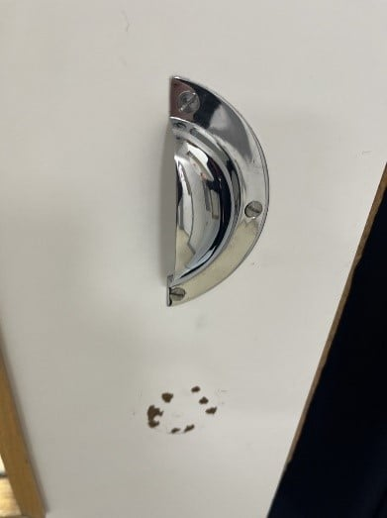
Fire door handles are not merely decorative elements; they serve a vital purpose in ensuring the proper operation of the fire door. In the event of a fire, these handles must be able to withstand high temperatures and remain functional, allowing occupants to easily open and close the door during an evacuation.
Non-compliant fire door handles can have severe consequences. If a handle fails during a fire, it can prevent occupants from escaping, leading to injury or even loss of life.
Furthermore, using non-compliant handles can result in significant fines and legal liabilities for School employers.
To ensure the safety of your school building and its occupants, it is essential to use fire door handles that meet the required standards and regulations. In the UK, fire door handles must comply with BS EN 1634-1.
When selecting fire door handles, look for products that have been tested and certified to meet these standards. It is also crucial to ensure that the fire door handles are compatible with the specific fire door and its hardware. The handle must be able to operate smoothly with the latch and lock mechanism, ensuring that the door can be easily opened and closed in an emergency.
Regular maintenance and inspection of fire door handles are essential to ensure their continued effectiveness. Over time, handles can become loose, worn, or damaged, compromising their ability to function properly during a fire.
Schools should establish a schedule for inspecting and maintaining fire door handles, along with the rest of the fire door assembly. This should include checking for any signs of damage, wear, or corrosion, and ensuring that the handle operates smoothly and securely.
Ensure that the fire door inspection template found in the NASPM resource hub is used.
Any damaged or non-compliant handles should be replaced as soon as possible with products that meet the required standards. It is also important to keep accurate records of all maintenance and inspection activities to demonstrate compliance with fire safety regulations.

Testing Standards and Certification

Fire doors undergo rigorous testing to determine the fire resistance rating, which indicates how long a door can hold back flames.
Understanding these ratings is essential for professionals in building design, construction, and management as the level of protection needed may vary depending on the building type, layout, and occupancy.
Let’s have a quick overview of the different timber fire door ratings and what they mean, testing standards they must meet, as well as guidance on selecting the appropriate fire door rating for various building types and purposes.

What do the fire door ratings mean?

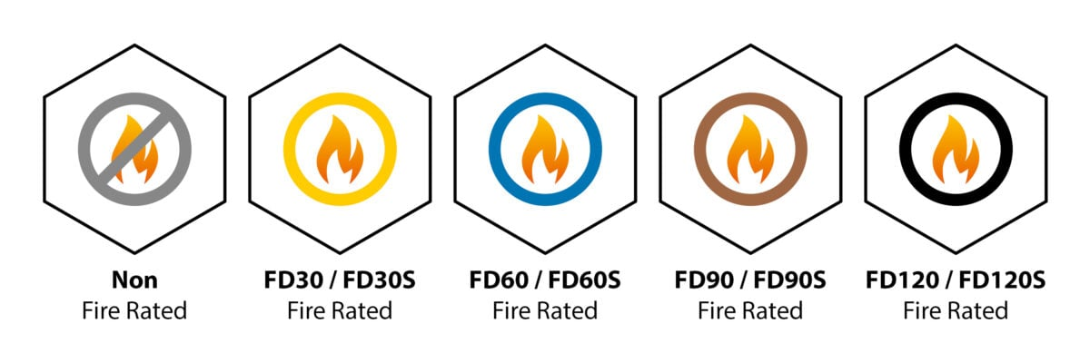

A fire door rating indicates the duration (in minutes) that a door can resist fire, typically denoted as "FD" followed by a number representing the tested time.
FD30
This indicates that a door can resist fire for a minimum of 30 minutes. These doors are typically installed in low-risk environments. Although in schools FD30 doors are deemed suitable as school evacuate normally under 4 minutes. Noting that in tests they actually last on average for 36 minutes!
FD60
These doors provide 60 minutes of fire protection and are designed for high-risk environments, such as schools and hospitals, where more time is required for evacuation, especially on the upper floors, you may often see 2 sets of FD30S doors around the stairwells, also common around the plant rooms and single travel situations.
FD90
FD90 doors are capable of withstanding fire for 90 minutes. Unlike FD30 and FD60 doors, they are less frequently used and are typically found in industrial environments or locations where flammable materials are stored. Not normally needed in school settings.
FD120
These doors provide an exceptionally high level of protection for up to two hours. They are not installed in commercial or residential properties, as they are used in extremely high-risk environments, such as power plants.
Smoke (S) Seals
A ‘S’ following the number e.g. FD30S, indicates that the door is a fire and smoke door, which requires the installation of fire and smoke intumescent strips to prevent the spread of smoke.

I often get told by school premises staff that ‘this fire door is non-compliant as it doesn’t have any smoke seals’ which is not true. Fire door specifications for any new or upgraded fire doors should detail whether it is a standard fire door (FD) or a smoke fire door (FDS).
Remember the fire safety order states that the responsible person should reduce the spread of a fire, this also means the spread of smoke so any upgrades to the FDS are always seen as a good thing.

Best looking fire door of 2024 goes to

Swanlea School Tower Hamlets

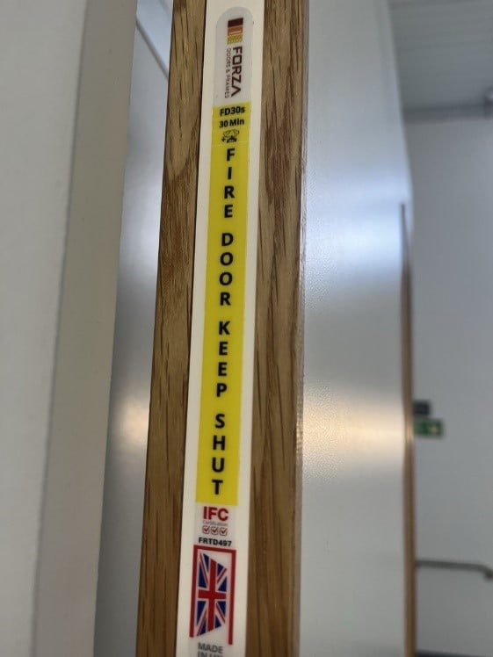

Shout out to Terry Stimson and the School Management for their work on the school fire door improvement plan with the extensive professional fire door upgrades and the continued planning of future fire door replacements.
Fire doors were specified and a process of seeking a competent fire door supplier and qualified installation company was completed with a review of fire door replacements based on risk and priority.

(Continued)

Fire Evacuation – Assistance to Escape

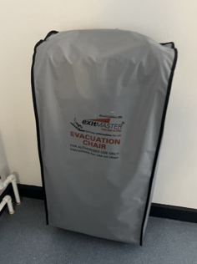
Any schools with upper floors that allow access to those staff/pupils/visitors who will need assistance to evacuate must have a PEEP (Personal Emergency Evacuation Plan) in place.
The PEEP template can be found in the resource hub within the fire section https://naspm.co.uk/fire/
Please remember it is not always an automatic decision that everyone who has a mobility disability will be put into an evac-chair to evacuate via the stairs.
The first question should be to anyone who may need assistance is can you walk down the stairs? Some will be able to bear their weight and walk slowly down the stairs, with staff supporting them as a guide. Or they may be able to use crutches to support them. The PEEP must be a specific individual assessment taking into consideration the ‘Person’ and the support required. If the pupil has complex medical needs the detail must be in the ‘planning’.
Planning the PEEP – Medical/Individual questions;
- Is the right equipment in place to ensure that their medical condition is not made worse – putting a pupil in an evac-chair that has a critical bone condition may not be deemed as suitable safe planning.
- Involving the medical profession, the doctor’s guidance on specific cases is normally found within the care plan. We need to follow the medical professional advice and information.
- Ensuring the school has the required competent staff to assist.
- Staff need to be deemed as ‘capable’ under the Fire Safety (Employees’ Capabilities) (England) Regulations 2010 which states ‘Every employer must, in entrusting tasks to employees, take into account their capabilities as regards health and safety, so far as those capabilities relate to fire.’ This means that if the school appoint staff to us evac-chairs the staff must be physically able to complete this task.
- Another example is, that if staff are appointed to lift and move/person handle people in the event of an emergency they must be physically able to do so.
If you have any questions about the school PEEPs contact us for a review.

National School Fire Working Group

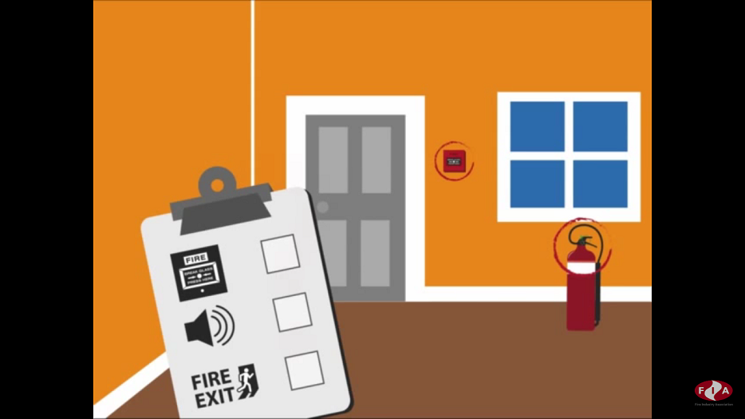

The Alliance are setting up a National school fire working group to focus on school fire safety. This is to focus on the improvement of fire safety in schools and will include governance such as fire policy, evacuation standards, fire training and driving the fire legislation through the schools in understanding the RRFSO.
1 hour monthly or quarterly virtual meetings are being reviewed for 2025.
Email admin@naspm.co.uk to register your interest in joining this group

(Continued)

Legionella Management

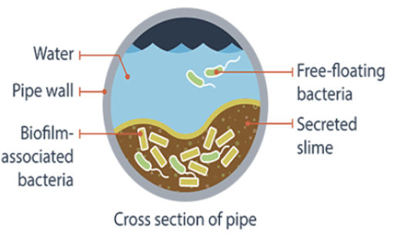

The recent prosecution in court was from the death of Graham Butterworth who died on 5 December 2017 after contracting Legionnaires’ disease while serving a prison sentence at HMP Lincoln.
A company has been fined after it failed to manage the risk of legionella bacteria in the hot and cold water systems at HMP Lincoln. Water samples from Mr Butterworth’s cell and nearby shower blocks tested positive for legionella days after the 71-year-old died.
HSE's investigation found that the facilities management company failed to:
- Act on a risk assessment carried out in 2016
- Put in place a written scheme for preventing and controlling legionella risks
- Ensure that appropriate water temperatures are maintained
- Monitor water temperatures in the water system

I know this is not a school-related incident, but we should use this as a timely example and reminder to schools that legionella can and does kill if not managed correctly. A reminder of how not managing legionella can lead to death.
Not the Christmas message you wanted to hear today! But when you stop and think about the school environment and how a school building can cause harm, illness and fatal incidents legionella remains a potentially significant hazard that could alongside asbestos and fire cause significant harm to lots of people.

Let’s break down the investigation findings and failings in this legionella management



Following any workplace death the Health and Safety Executive (HSE) will complete a full health and safety investigation. This investigation would have included the notification to the HSE that this was a confirmed Legionella pneumophila infection from the doctor.
If you ever have over 1000 CFU/l elevated levels of legionella bacteria immediate action is required, make sure your focus is immediate. This action would include isolating areas of water use such as showers and other sprayed outlets, arranging for cleaning of the system and maybe heat treatment whilst arranging for resampling.
Another area that is often missed is to check with the office to see if you have staff off with flu-like symptoms that may work in that area, if this is the case you may have to advise them to get tested. I was investigating a case years ago after being notified of having over 20,000 CFU/l in one outlet, a shower located on the second floor of the school. When asked if anyone used this shower, the premises manager told me the school SEN Manager did but was currently off sick with a chest infection, which was actually a legionella pneumophila infection! They were notified and the doctor changed their medication.
The investigation at HMP Lincoln, carried out by HSE inspector Aaron Rashad, found Amey Community Limited, which provided facilities management services at HMP Lincoln, failed to………………………………………….

Act on a risk assessment which was carried out in 2016, this was a year before the fatality. Why is this such a significant learning point? Put bluntly, if they had followed the recommendations within the water risk assessment Mr. Butterworth would not have died from legionella bacteria. It is also an extremely important point for all statutory building compliance documents/reports; to test and challenge these reports to ensure there are action plans in place for all recommendations and they are based on the timeframe and priority of risk.

Now please review your school legionella water risk assessment, have you completed all the actions from the recommendations and are these within the timeframe? For example, do you still have outstanding dead-legs to be removed or staff training outstanding?
Failed to put in place a written scheme for preventing and controlling legionella risks, failed to ensure that appropriate water temperatures were maintained and failed to monitor water temperatures in the water system in October and November 2017. This allowed legionella bacteria to multiply rapidly.
Note that the primary method used to control the risk from legionella is water temperature control – temperature management. If the temperatures are in the danger zone, the risk of legionella developing and growing within the closed-water system becomes high which was evident in this investigation.
I have investigated many legionella issues within schools that had high counts of legionella being found normally within areas of the school and in some extreme cases throughout the whole school. The main causation factors have nearly always been related to poor temperature management, meaning the cold was not cold enough and the hot was not hot enough.

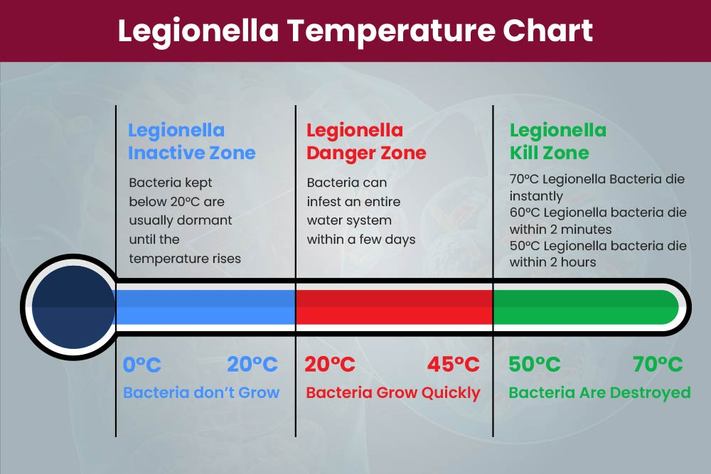

Hot water should be stored above 60°C, hot water distribution should be above 50°C and cold water storage and distribution should be below 20°C.
Water services should be operated at temperatures that prevent legionella growth:
- Hot water storage cylinders (calorifiers) should store water at 60°C or higher
- Hot water should be distributed at 50°C or higher (thermostatic mixer valves need to be fitted as close as possible to outlets, where a scald risk is identified)
- Cold water should be stored and distributed below 20°C
You must identify 'sentinel' outlets (furthest and closest to each tank or cylinder) for monthly checking of the distribution temperatures. You should also check the hot water storage cylinder temperatures every month and the cold water tank temperatures at least every 6 months.
Amey Community Limited, of Furnival Street, London, pleaded guilty to breaching Section 3(1) of the Health and Safety at Work etc. Act 1974. The company was fined £600,000 and ordered to pay £15,186.85 in costs at Lincoln Magistrates’ Court on 3 December 2024.
HSE inspector Stacey Gamwell said: “There is a legal duty to keep workers and inmates safe in prisons. The occupants of HMP Lincoln had been put at risk of legionella bacteria and developing Legionnaires’ disease because of Amey Community Limited’s failures.
All schools need to ensure they have identified any risk of legionella and have suitable and sufficient arrangements in place for managing the risk and control measures they have implemented.
Contact us for any legionella management concerns/questions and remember to book your NASPM legionella training.

PUWER 1998

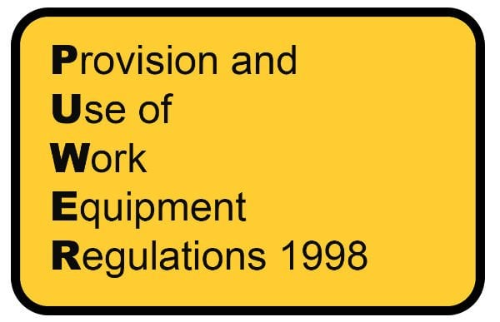

Overview of PUWER

In general terms, PUWER 1998 prescribes that work equipment must be:
- Suitable for purpose
- Safe for use, maintained in a safe condition and, where appropriate, inspected to ensure it remains safe
- Used only by staff who have received the necessary information, instruction, and training to allow to do so safely i.e. without risks to themselves and others; and
- Accompanied by any appropriate safety measures, e.g. protective devices, markings, and warnings
The regulations are divided into four main parts.
- Introduction – directed to issues of interpretation and application
- General – setting out the regulations that are of generic application to all work equipment
- Mobile work equipment – setting out supplementary requirements
- Power presses - setting out the supplementary requirements

Check out the PUWER risk assessment template located within the Resource Hub.

Offences



Please see below for a selection of the latest news and prosecution notices.
Update on investigation into Birmingham fairground incident
The Health and Safety Executive (HSE) continues to investigate an incident involving a fairground ride in Birmingham City Centre. Twelve people were injured as a result of the incident on the evening of 12 December 2024. Two people were taken to hospital and discharged shortly after with minor injuries.
20th December 2024 News Press release
School Academy Trust fined £300,000 after student death
A school academy trust has been fined £300,000 after a 19-year-old student died because of a ‘series of management failures. Owen Garnett, who was described by his family as having “an incredible sense of humour” and who had “everything to live for” died two days after choking on a paper towel at Welcombe.
18th December 2024 Press release Prosecution

Drinks giant fined after worker sustains serious burns
An international drinks manufacturer has been fined half a million pounds after an employee sustained burns to over 30% of his body. The mechanical engineer had been repairing a defective pump at Diageo’s Glenlossie Distillery Complex in Elgin on 24 March 2021 when he was burned by pot ale.
18th December 2024 News Press Prosecution

Company fined after worker “full of hopes and dreams” dies at wind farm construction site
An engineering company has been fined after a labourer died during the construction of a wind farm on the Shetland Islands. Liam MacDonald, from Tain, Ross-shire, lost his life on the morning of 5 June 2022 while removing dried concrete from a skip at the Viking site on Upper Kergord.
18th December 2024 Press release Prosecution

Council fined after employees exposed to risks from vibrating tools
A worker who repaired potholes was diagnosed with Hand Arm Vibration Syndrome (HAVS), an occupational disease, following repeated exposure to vibration tools. This week, his employer, Rotherham Metropolitan Borough Council has been fined following a prosecution by the Health and Safety Executive (HSE).
17th December 2024 Press releaseProsecution

Engineering company fined after ‘caring and loving’ man killed
A Blackburn-based engineering company has been fined £80,000 after a man described as ‘caring and loving’ by his family was killed after being crushed under a machine. Connor Borthwick, from Wigan, was working for Partwell Special Steels Limited at its site in Bruce Street when the incident happened on 25 November 2021.
16th December 2024 Press releaseProsecution

Statement on HSE proposals to restrict use of lead ammunition in Great Britain
Proposals follow a series of GB consultations and intend to reduce harm to the environment Regulator proposes alternatives to lead ammunition that would need to be used for some outdoor shooting Derogation is proposed for athletes who are preparing for the Olympic and Paralympic Games The Health and Safety Executive (HSE) in its role as the Agency for the UK […]
13th December 2024 Corporate

Company and director sentenced for putting workers at risk
A roofing firm has been fined while its director has been handed a suspended prison sentence after putting the lives of workers at risk during a roof renovation in Surrey. Weather Master Roofing Limited and company director Jack Avanzo, also known as Jack Avenzo, were sentenced at Brighton Magistrates’ Court on Monday following a prosecution […]
6th December 2024 NewsPress releaseProsecution

Plastic manufacturing company fined after death of young dad
A company that manufactures plastic products for the food industry has been fined £330,000 after a young dad was killed while doing his job. Nathan Hook, a father of one, was working for Suffolk-based Maynard and Harris Plastics when he was drawn into rotating machinery. As a result, the 34-year-old suffered fatal head injuries. The […]
5th December 2024 Prosecution
Councils’ asbestos management to be assessed during inspection campaign
Hundreds of inspections at council buildings will be carried out by the Health and Safety Executive (HSE) to check councils are managing the risk of asbestos properly. HSE inspectors will visit the head offices of dozens of councils across the country to ensure asbestos risks are being managed effectively to keep people safe. Each council […]
4th December 2024 Corporate Press

Company failed to manage legionella risk as prisoner dies
A company has been fined after it failed to manage the risk of legionella bacteria in the hot and cold water systems at HMP Lincoln. The Health and Safety Executive (HSE) investigation followed the death of an inmate. Amey Community Limited has now been fined £600,000 after pleading guilty to a health and safety offence. […]
3rd December 2024 NewsPress releaseProsecution

Company and contractor sentenced as failures led to evacuation in village
A company and a contractor have been fined following the evacuation of 30 homes in a Derbyshire village. Residents in Wessington were forced to leave their properties on 21 June 2022 after Elliott Kirk struck an underground gas main with a mechanical post knocker. Mr Kirk had been installing fencing around Belper Skip Hire Limited’s […]
2nd December 2024 NewsPress releaseProsecution

Plastics manufacturer fined as worker suffers multiple leg fractures
A plastics manufacturer in Kent has been fined £400,000 after an employee was seriously injured by a forklift truck. The man was struck by the vehicle while walking to collect materials at FloPlast Limited’s site at Eurolink Business Park on 4 July 2023. The driver of the forklift truck failed to see the worker, who […]
29th November 2024 Press releaseProsecution

(Continued)

Company fined £1.6m following the death of ‘happy-go-lucky’ 24-year-old
A company has been fined £1.6m after a 24-year-old man was crushed to death. Jack Phillips lost his life on 8 August 2019 while working for Brand Energy and Infrastructure Services UK Ltd at South Cliff Tower in Eastbourne. His parents say they are “no longer complete” following the loss of their “happy-go-lucky” son. Jack […]
27th November 2024 NewsPress releaseProsecution

Company fined after an explosion seriously injured two employees
A company which produces electricity from food waste by anaerobic digestion has been fined more than £300,000 after an explosion caused two employees to suffer life-changing injuries. The metal tank the two men were working on was projected high into the air before crashing to the ground nine seconds later. Footage of the blast […]
22nd November 2024 Press releaseProsecution

Two companies fined after man falls through roof of Salford skate park
Two companies have been fined more than £100,000 after a man fell 30 feet through a fragile skylight as he was working on a roof. Nicolas Vilela suffered multiple injuries in the incident at Graystone Action Sports Centre, on Brunel Avenue in Salford on 23 November 2022. Now 43, Mr Vilela had been fixing a […]
20th November 2024 Press release

HSE publishes annual work-related ill health and injury statistics for 2023/24
The Health and Safety Executive (HSE) has today (Wednesday 20 November) published its annual statistics on work-related ill health and workplace injuries. The statistics reveal that the number of workers reported to be suffering from work-related ill health during 2023/24 is 1.7 million – which is like 2022/23 (1.8 million workers). The rate of […]
20th November 2024 Corporate Press

(Continued)

Wood panelling firm fined £400,000 after injured worker loses leg
A wood panel manufacturer has been fined £400,000 after a worker suffered life-changing injuries at its factory in Chirk, near Wrexham. The incident happened at Kronospan Limited on 31 March 2021, when a pack of waste MDF sheets weighing around 350kg fell from a trailer and landed on the left leg of Mark Hughes from […]
19th November 2024 Press release

Ginsters owner fined £1.28m after employee crushed to death by lorry
The owner of Ginsters has been fined £1.28 million after an employee was killed by a lorry that was delivering supplies to the bakery where it makes its pasties. Paul Clarke was fatally crushed on 2 December 2021 after being struck by the vehicle as it reversed into a loading bay at The Cornwall Bakery, […]
13th November 2024 NewsPress releaseProsecution

Company fined after worker killed by telehandler
A construction company has been fined £160,000 after a man was killed by a telehandler at a house build site in Glasgow. Scott Bradley had been reversing the vehicle at the Stepford Road site when it slid down an embankment and overturned on 11 May 2022. The 44-year-old, employed by Merchant Homes Partnership Limited, had […]
12th November 2024 Press release

(Continued)

NASPM Training



We offer live virtual trainings for all areas of the school’s health and safety every month.
Training courses are certificated and provide the employer with CPD evidence of competence.
Training sessions include,
- Lockdown Awareness
- PUWER
- Fire Warden
- Legionella Awareness
- Asbestos Awareness
- Managing Contractors
- Electrical Management
- Fire Door Management
- COSHH
- Working at Height Risk Assessment
- Manual Handling Risk Assessment
- Risk Register for Premises
- Premises Auditing
- Premises Building Projects
- Playground Premises Management
- Senior Team Leaders Health and Safety
- EYFS Risk Management
- DSE Assessor
You can access all training via the NASPM website at www.naspm.co.uk/my-account/
Enter username and password
From the dashboard select BOOK TRAINING
Click on the name of the course
Add desired number of people
Click on get tickets
Click on Proceed to Checkout
Complete billing details and payment method
Please book as soon as possible to guarantee your place.

  Training Overview
  Book Training

Your Input Into NASPM
Do you have any requests regarding documents, templates, or an area of concern that you would like us to include in the document centre or website?
Do you want a tailored health and safety training programme?
Or do you want to leave feedback?
Email admin@naspm.co.uk

Get In touch

Happy Christmas
Stuart and the NASPM Team

National Alliance of School Premises Management  Old Town Hall, 29 Broadway, Stratford, London  United Kingdom |  | You received this email because you are a NASPM member.
   |  |  | 
  Unsubscribe

