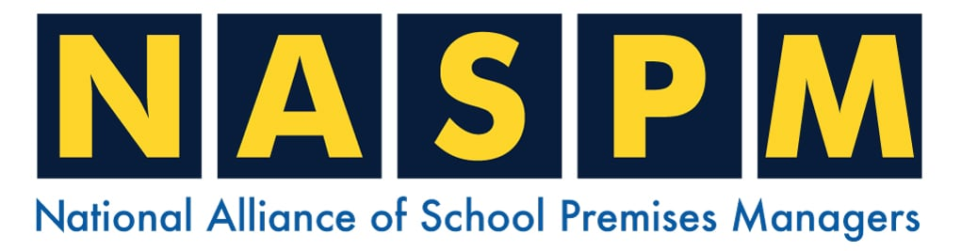
Home | Training | Membership | Contact

We hope you enjoy your November Newsletter.
In this newsletter, we cover the following:

- Fire Risk Assessment Common Findings
- Annual Statistics For 2023 To 2024 Released
- Offences
- NASPM Training
- Your input into NASPM

Introduction

Dear Members, I hope all is well and you have had a safe November.
A welcome to our new members, and thank you for all the incredible input and communication we have received. For those who were at the NEC in Birmingham, it was excellent to catch up. Thank you for coming to the speaking events.

Undercover School Fire Risk Assessor



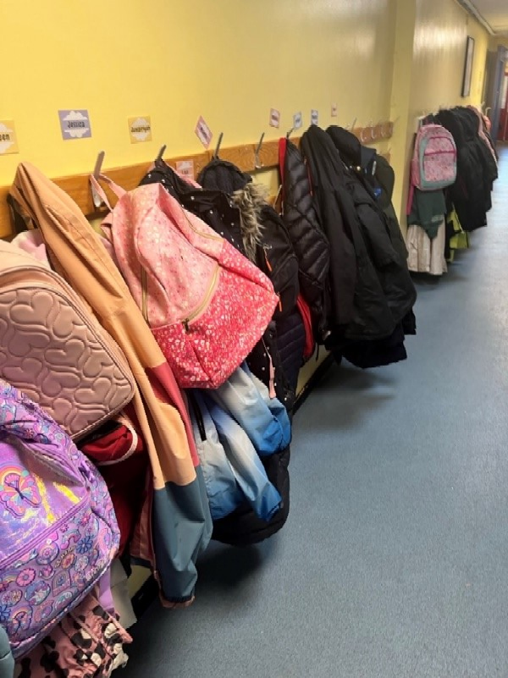
You know that I am the undercover ‘fire risk assessor’, I just wanted to create some cloak and dagger-themed school assessor! I also thought it would be of interest to start sharing the fire risk assessment findings and common themes with our members as I know most of these are very similar across the UK and it will be of benefit to share the recommendations alongside the non-conformities.
Let’s start with the dreaded ‘Coats in Corridors’ – over the many years of completing school fire risk assessments, this has improved, but not completely. The photo below is a very recent school fire risk assessment which is a 50 year old one level primary school building.
Several factors to consider must start with the consideration of the high fire loading within school corridors, starting with the basic standard questions -
Should they be there?
What is the risk to life safety?

The common response I get from schools and almost an instant dismissal is that there is nowhere for these coats and bags to go and it has been like this forever and ‘what else can we do?

Let’s take a look at the legal standards and what you must understand as the duty required under the RRFSO – Fire Safety Order, Article 4 (a) states that the responsible person must ‘reduce the risk of fire spreading’ Article 14 ‘to keep fire escapes clear’ and Article 10 ‘Principles of Prevention’ are some of the key legal duties covering this risk.

Standard Recommendations and Considerations

What it should not become is a final decision if there are no further actions that can be taken, it is what it is and we can’t do anything further. The considerations are as follows in order of the principles of prevention;

- Can the coats and bags (described in the standards (BB100) as ‘open cloakrooms’) be relocated to classrooms? This is sometimes a straight ‘no’ – but sometimes they can, this is solely around space and classroom setups.
- If they cannot be relocated, then they must be enclosed in a fire-rated compartment, which is normally a purpose-built fireboard wood or metal cabinet, noting that the cabinets must be closable.

Other factors should be identified within the school fire risk assessment such as the location of bags and coast re: ground, first, second and upper floors. It may be that at the ground floor level, all classrooms have their own direct fire exits from their classrooms compared to upper floors classrooms that have no option but to exit.

We encourage all of our members and the wider key staff to use the website via the member’s area to enable the full benefits of the Alliance membership. So, just a quick reminder of how to use the website, and how easy it is to do so.

To Be Or Not To Be? A Fire Door

Many schools do not have a fire strategy and therefore do not have identified fire doors. From a recent fire risk assessment, a fire door is an original 40 year old panelled door that offers little fire and smoke protection. The question was to consider if this door formed part of a protective means of escape and a review of the environment, it was a swift decision that it was needed to be a fire door.

You must take advice from the school’s fire risk assessor on the identification of fire doors in addition to the condition of the doors. Some schools will have a fire strategy for example of having just corridors, stairwells and higher-risk rooms having fire doors and this is fine as a defined agreed fire strategy. Other schools will have nearly all doors, classrooms, offices, stairwells and corridors as fire doors.

The minimum requirement at least as a fire assessor I would expect would be the corridors and stairwells, together with higher risk rooms such as plant, boiler, server, kitchens and staffrooms as fire doors.

What we don’t want to see or promote is the school deciding what the fire doors should be, but do encourage the premises team to be fully aware and discuss/challenge fire risk assessors on this information.

Some examples from me include schools having every fire door signed as a door, with the signage looking very old and the classroom doors also looking very old and very non-compliant, when asking the premises manager he stated that they stuck on the fire door labels on every door without knowing the compartmentation/fire strategy. It was clearly evident that the corridor doors and stairwell doors were actually fire doors and the classroom doors a standard door.

(Continued)

Panelled Door – Non-Compliant Fire Door

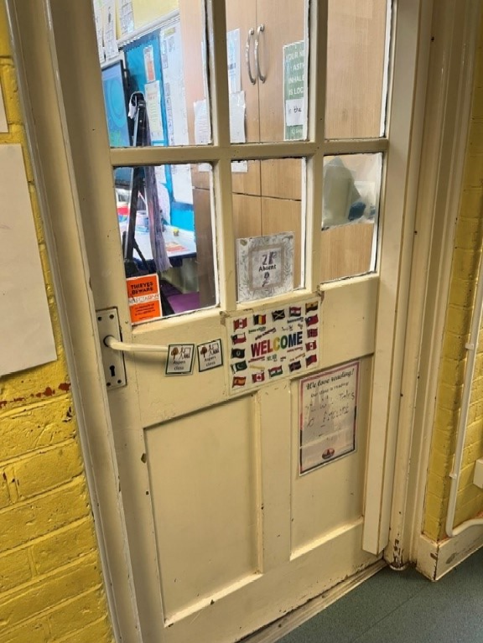

Fire Doors Opening In the Wrong Direction

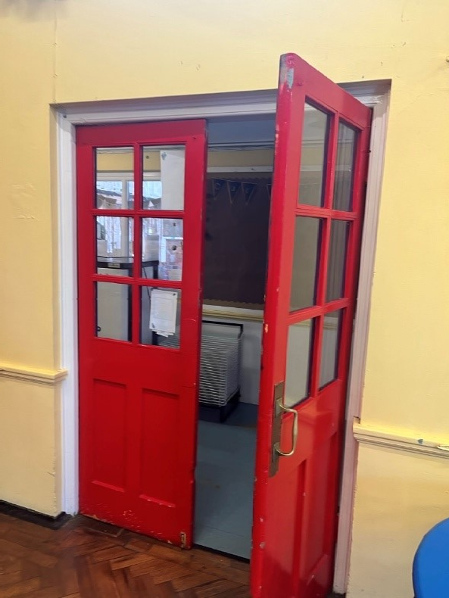
Fire door-themed issues of older buildings that have inward opening fire exit doors, often found in places of assembly, large halls. Fire doors that open against the direction of travel can cause a bottleneck situation in the event of fire evacuation and large numbers trying to escape.

The standard recommendation is to turn these around so that they open in the direction of travel. The exception is areas that may have low numbers of people using the escape. The general rule of thumb is anything over 30 is high enough to warrant the need for these to be turned around – always taking advice from the school fire risk assessor.

Are Fire Doors Fit For Purpose?

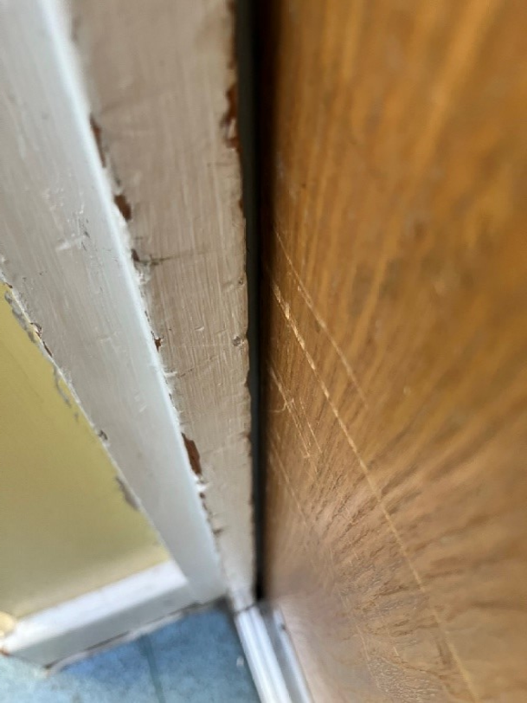
I am not a promoter of fire door surveys. A fire door survey will cost the school thousands of pounds to tell you exactly what you know, you have old non-compliant fire doors.
What I much prefer is for the school to use their competent fire risk assessor to assist and identify specific fire door concerns and issues and for schools to develop ‘fire door improvement plans’ as this is much better for the school budget and a more sensible and defined approach.
I think sometimes fire risk assessors will give the school a very broad statement such as ‘general themed issue of fire door non-compliance, arrange for fire door survey’ and I think this is not very helpful. I may use the ‘general themed finding’ but back this up with specific findings based on the priority of risk.
For example, the kitchen door and plant room doors needed to be replaced as an urgent recommendation, together with some stairwell fire doors as the current condition could cause a potential life safety concern such as affecting the means of escape.
A reminder to you that we have our monthly fire door inspection form that you should be using to record your fire door inspections. In addition to this, we offer fire door training.

Looking at the condition of fire doors

- Does the fire door fully close and is fully flush, a nice fitting fire door. Often fire doors are out of position either due to the closer, a damaged hinge, or a dropped door, all of which cause an issue as an ill-fitting door will not hold back fire or smoke.
- Are there excessive gaps around the door? I must stress this includes gaps around the frame, door-to-frame gaps and gaps or holes around the surround.
- Is there general damage to glass, beading, locks or closers all general findings
I often find a school has written in the fire door log that there are no concerns or defects with the fire doors but the fire risk assessment clearly identifies many fire doors with damage and non-conformities.

Fire Door Set Not Closing Fully – A Common Finding

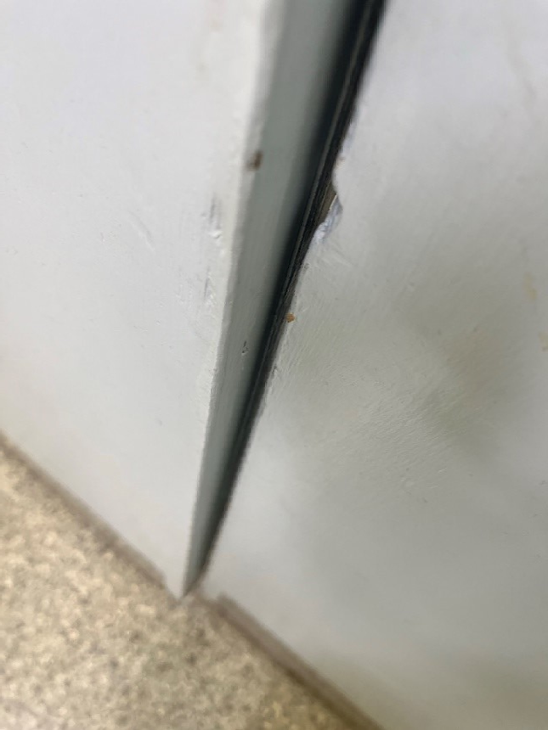

Fire Doors Being Wedged Open – This Will Not Hold Back Fire Or Smoke!

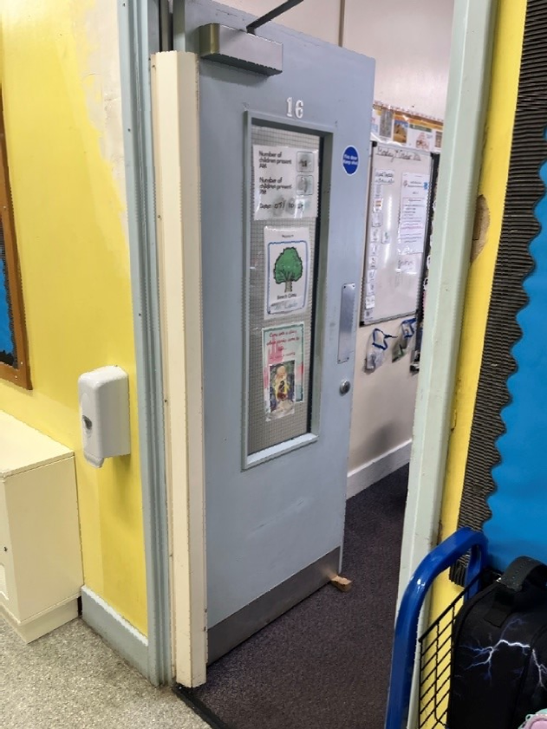

Gaps around Fire Door Frames

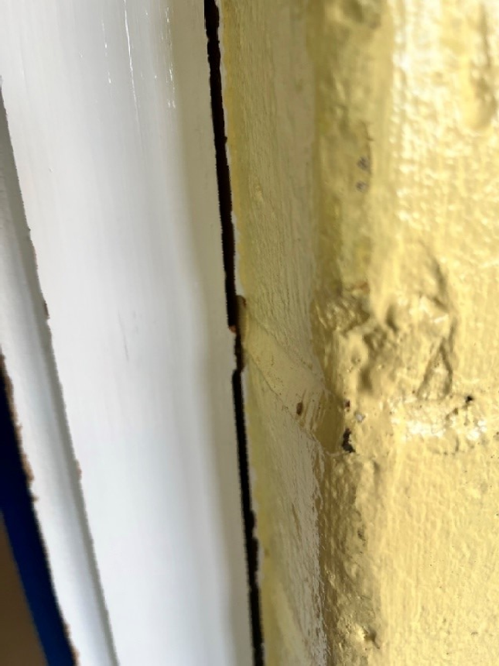
A common issue with damage around the fire door and frames is gaps and ill-fitting damage.

This damage is normally due to banging and general use, local damage.

Note that it is not always possible to seal these gaps as the damage may be extensive. A repair may be required to bring the frame closer to the wall.

Plant Rooms

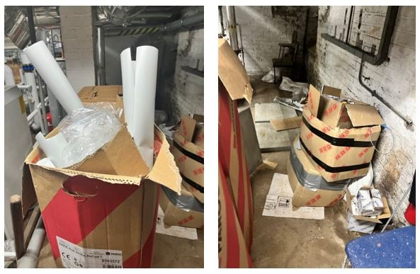

Another very common theme is the school boiler rooms/plant rooms being used as storage. There is no allowance for using these rooms like this. A fire brigade safety inspection would consider this a non-conformity and would have the same recommendation.

This includes electrical intake rooms, gas intake rooms, boiler rooms and plant rooms. I understand the demands and restrictions regarding lack of storage within schools and this is often a themed concern with new schools, but the use of plant rooms is not an option.

Door Hinges

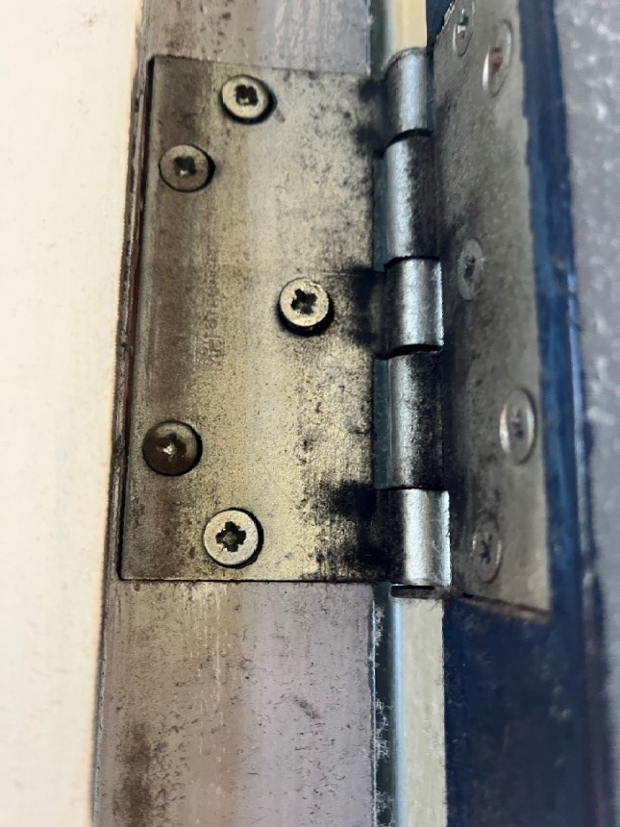
The general issue with fire doors is sometimes the age of the doors and the non-compliant hinges. This may include hinges that do not have the CE marking or hinges that do have the CE marking but have general damage, leaking, and in poor condition.

I often recommend schools to work on older fire doors that are still deemed fit for purpose, to upgrade their hinges and at the same time replace damaged worn intumescent seals and strips/cold smoke brushes. So it is not always just about replacing fire doors.

(Continued)

Fire Shutters – School Kitchens

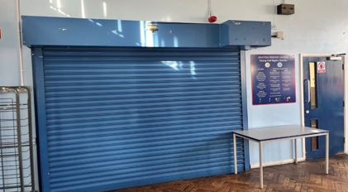

The focus on the kitchen is key as nearly half of all school fires originate from the kitchen. Around 90% of the schools I have assessed have shutters, the remaining 10% have solid walls and fire doors and have a servery set up rather than coming through or past the kitchen servery.

Out of the 90% of schools with shutters, approximately half of these are not actually fire shutters. A fire shutter is linked to the fire alarm system and would close upon fire alarm activation. Often these are not linked correctly to the fire alarm system, as the cause and effect setup should only be set up to close if the local fire detection system activates around the kitchen area because the whole point is that the shutter should close if the fire is in the kitchen, thus preventing the spread of fire to those in the area. However, it doesn’t matter if the shutter is linked to operate upon any fire detection alarm.

The themed issue with the shutters is the ‘drop zone’ not being clear of storage, often cutlery trays and objects are in the way of the shutter dropping down to close. Note that the fire shutters are fire shutters and not smoke, meaning the fire shutter will hold back a fire normally for over 2 hours as these are metal shutters. The fire alarm system coverage and activation will normally mean that schools will evacuate within 4 minutes and the fire brigade is normally on site within 9 minutes. The gas shut-off system means that the cooking process is also immediately stopped upon the fire alarm activating.

Cooking and Fire Safety Management

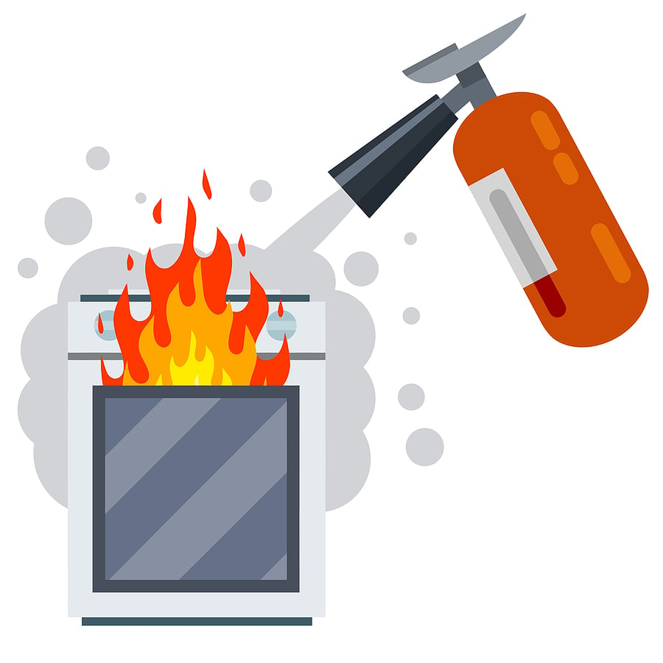

Keeping the themed focus on school kitchens the following must be known, completed and be able to show evidence, as these will be requested and reviewed during fire risk assessments and any fire brigade audit:

- Cooker hood cleaning, schedules and cleaning evidence. This is based on a risk assessment which includes how much cooking is taking place throughout the year. For example, I would expect at least 2 deep cleans a year and sometimes quarterly. If you look at the condition of the cooker hood, this is very simple to assess just by looking at the filters above the cooking area.

- TR19 – ensure this is completed and you have the evidence on site. I recommend that the kitchen area has a compliance folder that includes this and the cooker hood cleaning.
- PPMs – this includes evidence of planned preventative maintenance of the cooking and kitchen equipment including cookers, fridges, gas appliances etc.

Often the catering service is contracted out to a catering company. The school should ensure that you have evidence from the contractor that includes the above information and also the below information:
- Fire training evidence
- COSHH risk assessments
- Catering cooking activity risk assessments

Displays in Corridors


This is an interesting themed issue and concern. Note that schools are not hospitals and do not have to be a sterile environment, with the balance that schools will want to display and present their wonderful pupil works and seasonal displays.

The schools should take note of their fire risk assessment around the recommendations to manage their corridors and display management.

I offer the following information from an active fire risk assessor:

- Are the Corridors a Protected Corridor?
A protected corridor is a corridor that is surrounded by fire doors, every classroom, room and corridor is a fire door this pretty much informs you that this is a protected fire route.
An unprotected route is a corridor that has only corridors with fire doors.
- Protected Routes
Displays should covered and enclosed and there should not be any open paper displays in the corridors
- Unprotected Routes
Displays should still be recommended to be enclosed following the principles of prevention that run through the whole of the Fire Safety Order Regulations, but if you have open paper displays in this area they should not be more than 3m in length and you should have a gap of 1.5m

Displays in Stairwells

This is where I become very strict! There shouldn’t be any 3D displays or open paper displays within the stairwells. These stairwells are life-saving areas that enable large numbers of pupils and staff to escape buildings at height to a place of ultimate safety i.e. outside and shouldn’t have any storage or displays – i.e. fire loading.

Annual Statistics For 2023 To 2024 Released



HSE has published the latest statistics on work-related health and safety in Great Britain.

The annual work-related health and safety figures for 2023 to 2024 include:
- 1.7 million working people suffering from a work-related illness, of which:
  - 776,000 workers are suffering from work-related stress, depression or anxiety
  - 543,000 workers are suffering from a work-related musculoskeletal disorder
- 138 workers killed in work-related accidents
- 33.7 million working days lost due to work-related illness and workplace injury
- £21.6 billion estimated cost of injuries and ill health from current working conditions (2022 to 2023)
HSE's statistics webpages have full information on this year's figures, including different types of work-related ill health and different industry sectors. You can also view our annual infographic-style summary statistics booklet.

For more details, and quotes from HSE's Chief Executive Sarah Albon, read the press release: HSE publishes annual work-related ill health and injury statistics for 2023 to 2024

Offences



Please see below for a selection of the latest news and prosecution notices, this month we have a school-related prosecution regarding finger amputation.

Construction company issued fine after worker is paralysed in fall
A £40,000 fine was issued after a worker fell through the ceiling at a house renovation, leaving him paralysed.

School trust fined after pupil injured
They were fined £6,000 after a pupil's finger was injured in an unsafe door hinge. A school trust in Surrey has been fined after part of a pupil’s finger was amputated. The five-year-old boy, a Year 1 pupil at Danetree Primary School in Epsom, had been leaving the toilet on 15 June 2022 when his right hand slipped and went into the hinge side of a door.

There was no door guard installed and he trapped his right hand in the door.
This led to the tip of his middle finger becoming detached as his right hand was stuck in the door.

This is a common issue within schools. Mainly Primary schools and mainly in the early years. Schools should complete our finger trap risk assessment document within the resource hub.

Company fined as worker fractures skull
The £80,000 fine was issued following an incident in which a worker was struck by a telehandler bucket on site.

Metal recycling firm fined £650,000 after routine HSE inspection
The fine was issued for failing to implement effective control measures to protect workers.

Residents put at risk of legionella as company fined £900,000
The housing association was fined following an outbreak of legionella at its sheltered housing accommodation.

(Continued)

NASPM Training



We offer live virtual training for all areas of the school’s health and safety every month.
Training courses are certificated and provide the employer with CPD evidence of competence.
Training sessions include,
- Lockdown Awareness
- PUWER
- Fire Warden
- Legionella Awareness
- Asbestos Awareness
- Managing Contractors
- Electrical Management
- Fire Door Management
- COSHH
- Working at Height Risk Assessment
- Manual Handling Risk Assessment
- Risk Register for Premises
- Premises Auditing
- Premises Building Projects
- Playground Premises Management
- Senior Team Leaders Health and Safety
- EYFS Risk Management
You can access all training via the NASPM website at
www.naspm.co.uk/my-account/
Enter username and password
From the dashboard select BOOK TRAINING
Click on the name of the course
Add the desired number of people
Click on Get tickets
Click on Proceed to Checkout
Complete billing details and payment method
Please book as soon as possible to guarantee your place.

Your Input into NASPM
Do you have any requests regarding documents, templates, or an area of concern that you would like us to include in the document centre or website?
Do you want a tailored health and safety training programme?
Or do you want to leave feedback?
Email admin@naspm.co.uk

Stuart and the NASPM Team

National Alliance of School Premises Management  Old Town Hall, 29 Broadway, Stratford, London  United Kingdom |  | You received this email because you are a NASPM member.
   |  |  | 
  Unsubscribe

