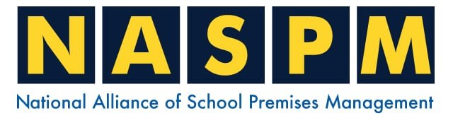
Home | Training | Membership | Contact

We hope you are enjoy your NASPM September/October 2024 newsletter. In this newsletter we cover the following:

- New Website
- Health Safety and Compliance Areas - Mind Map
- Key Document Review
- The Hub – Premises Management Toolkit
- Membership Login
- Safety Signs and Signals Regulations
- Manual Handling Regulations
- Spot Light – New for November
- Offences
- Schools and Academies Show
- NASPM Training
- Your input into NASPM

Introduction

Dear Members, I hope all is well and you have had a good, safe and productive term. We have put September and October Newsletters together as there was so much work with the new website and changes being developed during this period.

1 New Website

We are delighted to see the fruit of our labour in launching of the new website, and we owe this to your input. It is really something when we have so much engagement with our members and recognise that the Alliance must be a member driven-development process that includes a cycle of ongoing improvement.

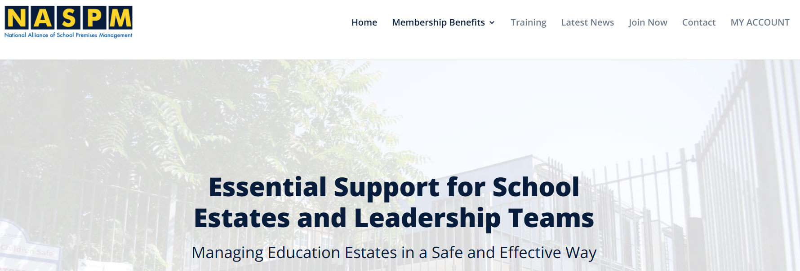

We encourage all our members and the wider key staff to use the website via the member’s area to enable the full benefits of the Alliance membership. So, just a quick reminder of how to use the website, and how easy it is to do so.

- Make sure you have www.naspm.co.uk set as your favourites within your internet search/favourites

- Look at the top bar – select ‘members area’ or ‘my account’ in the tab bar
- The login page appears, enter your login details

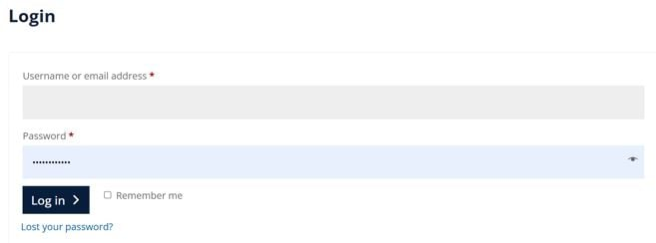

4. You will now be in the member’s area and look like this:

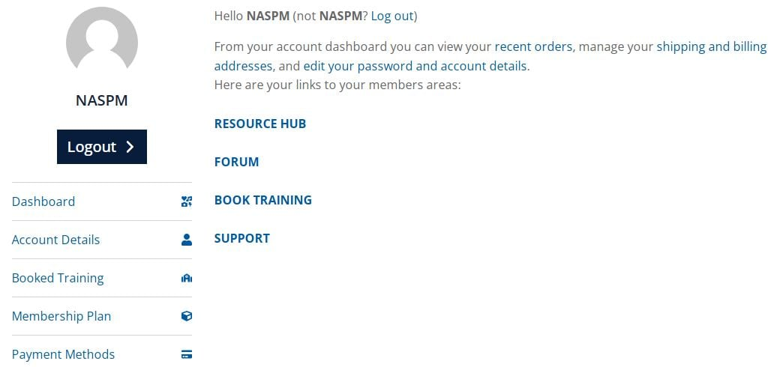

5. Resource Hub is everything you need to assist you in the competent management of estates and health and safety. Take some time reviewing the resource hub, the key improvements include the introduction of toolkits. These include simple guides and information including key documents to help you. Other new areas include having all the checklists in one location and separating them into periodic headings. Please note that we are still generating documents and some folders will look a little sparse compared to others. We have also now numbered every document, this will make it easier for everyone to find and reference the documents, and we will be using this number reference during our training.



6. Action – Please let us know if there are any specific documents you need to be added to the resource hub, also let us have your thoughts on the new resource hub/website via admin@naspm.co.uk

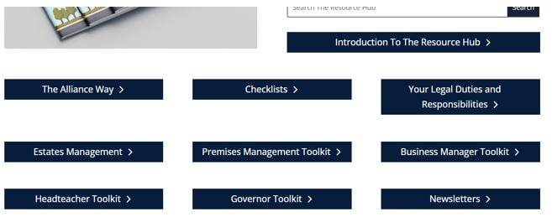

7. Remember when you are in the member’s area, you only have to use the back arrow to get back to the main member’s area page.

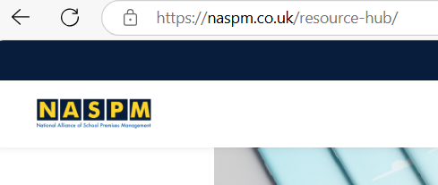

8. Training – select ‘book training’ and then enter the number and then press ‘get tickets’ – this will automatically process and guide you through the purchase

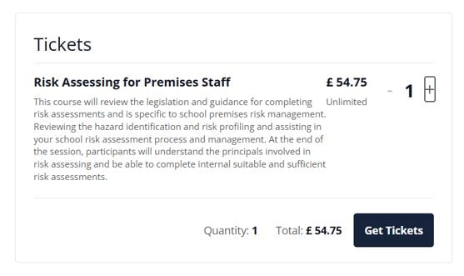

9. The ‘Forum’ – why not make use of this, as our members continue to grow this community should be used to network, link up and ask questions – easy to use, click on Forum and click on ‘ask question’ or search for past information. Remember this is not the direct line to our experts, if you need this you will need to click on ‘support’ and fill in for any professional expert guidance.

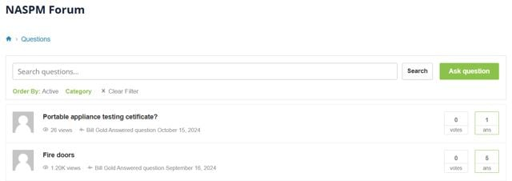

2 Health Safety and Compliance Areas - Mind Map

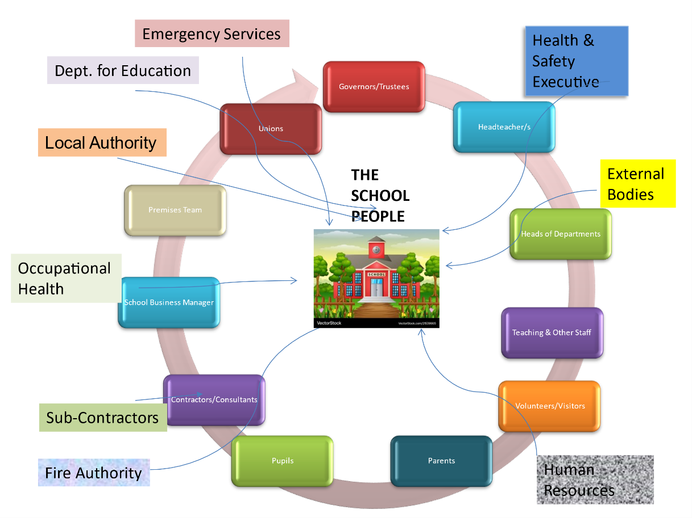

As an overview of all things health safety and compliance, we have designed the above mind map to show how integrated and complex the school environment and compliance requirements can be. Check out the toolkits for additional information and guidance.

3 Key Document Review

Our key new document to raise awareness for our members is document number 51 Security Premises Audit’. This is a very unique and school-specific security audit that all schools will be able to complete and generate an overall assurance level of compliance with an action plan for improvements. I have been a school security auditor since 2004 and worked for large local authorities in completing school audits, with the general themed findings as follows:
- Most schools do not complete school security audits
- The security audits I have assessed have been general security and not school-specific/industry-related audits

- Most schools do not have risk assessments for security
- General weaknesses around the ‘tailgating’ and how far unwanted visitors can gain access around the school
- Opening gates that go directly into play areas
- Poor reception security, lacking physical protection for reception staff

Action – Document 51 Security Premises Audit – let me know how this went, happy to review any completed audits and also take any comments on this document and the process – support@naspm.co.uk

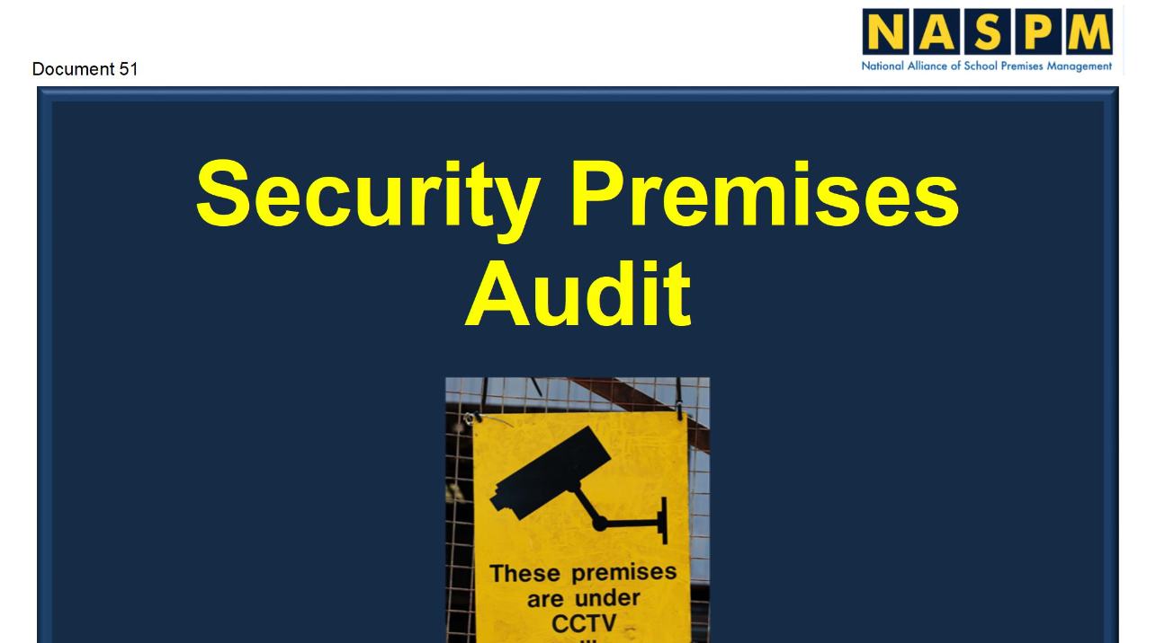

4 The Hub – Premises Management Toolkit



Wow! How I wished I had this at my School in 2002. You will note that we have aligned the SBM, Head, and Governor to the same toolkit headings, as we want to ensure we get the key duty holders and staff on the same profile awareness as our premises staff to really raise the bar in competence and awareness.

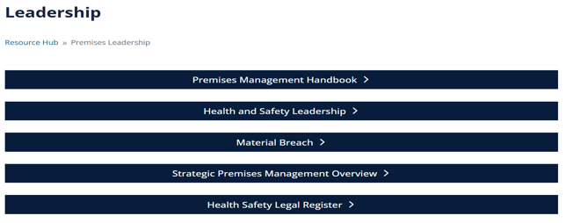

We welcome all feedback from our members – admin@naspm.co.uk

5 Membership Login

It is really important to ensure that all of our members can log into the system and have full access to all of our supporting documents and guidance. On some member visits, it was clear that the premises staff didn’t have access and not using the Alliance as they should. We have expanded the key staff areas with specific toolkits, so please let them know and let us know if you need logins for SBM, Headteachers, and School Governor admin@naspm.co.uk

6 Safety Signs and Signals Regulations



Often this regulation isn’t fully adhered to sometimes identify as a concern or an action during your fire risk assessment or health and safety audits. You should be aware of the HSE's guidance publication sets out what you should do to comply with the Health and Safety (Safety Signs and Signals) Regulations 1996.
You can buy a hard copy or download a free copy: Safety Signs and Signals. The Health and Safety Regulations 1996. Guidance on Regulations (L64)

7 Manual Handling Regulations

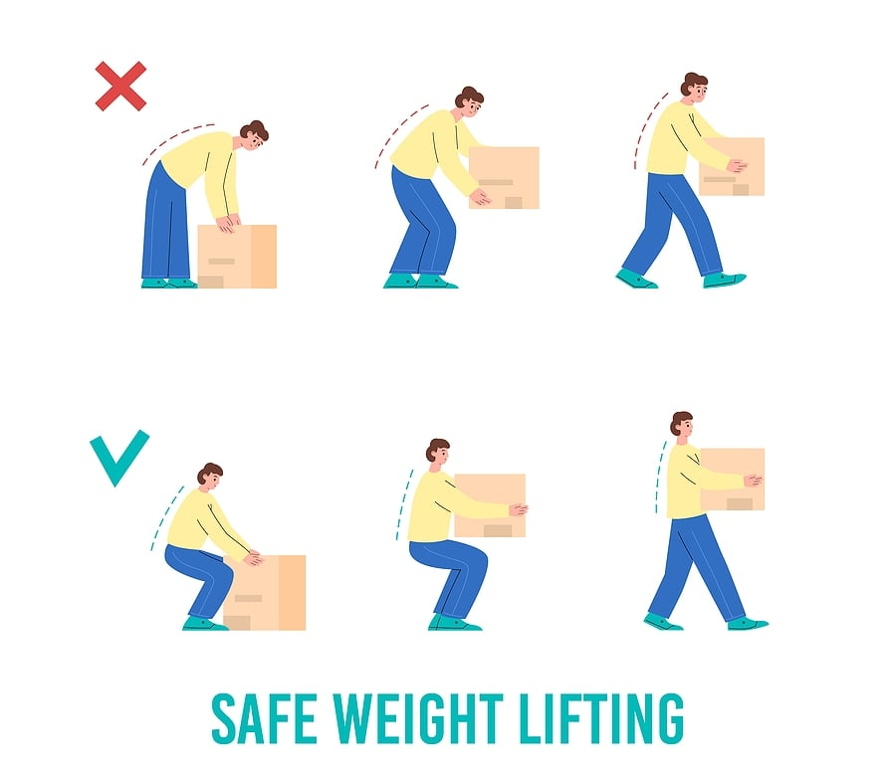

Manual Handling at Work: Guidance on the Law
As an employer, you must protect your workers from the risks of manual handling injuries in the workplace.
You can find help with preventing these sorts of risks in your workplace on the HSE manual handling web pages.
They have a range of useful information and guidance for employers, including sections on assessing manual handling and training for workers.
There are also links to a variety of useful resources. These include the HSE free-to-download publications:
- Manual handling at work: A brief guide

- Manual handling: Guidance on Regulations

(Continued)

8 Spotlight – New for November



Following membership feedback that the Alliance needs to be more ‘in the faces’ of our members, we are introducing a new weekly ‘Spotlight’ newsletter in addition to the monthly ones. This will be a shorter but specific subject in the ‘Spotlight’ each week. The purpose of this is to raise subject awareness, member competence and timely reminders and to align to any supporting helpful documents in the resource hub or training offering. If there are any specific areas you want to add to the weekly ‘Spotlight’ then please let us know – support@naspm.co.uk

Offences



Please see below for a selection of the latest news and prosecution notices, fortunately, none of these are school-related. Still very concerning to note the fatal incidents and significant life-changing injuries that in every case could have been prevented.
Routine inspection lands metal recycling firm with £650,000 fine
22nd October 2024
Residents put at risk of deadly disease as company fined £900k
22nd October 2024
Contractor fined after worker left paralysed by falling tree
15th October 2024
Cheshire farm owner fined after roofer dies in fall
11th October 2024
Company fined following crane collapse
11th October 2024
Cosmetics firm fined after HSE inspection found serious failings
10th October 2024
World Mental Health Day: “Employers risk losing valued employees if stress is not managed”
10th October 2024
Crown Censure issued following the death of a soldier
4th October 2024
Leading sandwich bread baker fined after worker loses finger
3rd October 2024
Chemicals firm fined following explosion
24th September 2024
Manufacturing company fined as worker suffers six bone fractures
18th September 2024
Company fined after ‘loving’ Grandad dies from fall
18th September 2024
Construction firm fined as worker loses life and another injured
17th September 2024
HSE to prosecute Snowdome Limited
13th September 2024
National Grid fined £3.2million after pylon worker suffers serious burns
5th September 2024
Routine HSE inspection results in £150,000 fine for food manufacturer
4th September 2024
Tyre firm fined after worker dragged into machine
4th September 2024
Fine for rogue landlord who put tenants lives at risk
2nd September 2024

10 Schools and Academies Show



NASPM will be exhibiting and Stuart will be speaking at this show. We will be on stand A72, if you are attending please come and visit us
Skyrocket your 2025 estates strategy at the #SAAShow.
Join thousands of school estate managers at the Schools & Academies Show on 20th November at NEC Birmingham, for 50+ hours of CPD-accredited content and over 200 education suppliers with incredible solutions.
Gain key insights on driving efficiency, saving costs and enhancing your school or MAT's estate strategy for improved pupil outcomes. Please follow the link to register for free today https://hubs.la/Q02Vs08k0

NASPM Training



We offer live virtual trainings for all areas of the school’s health and safety every month.
Training courses are certificated and provide the employer with CPD evidence of competence.
Training sessions include,
- Asbestos
- Legionella Awareness
- COSHH
- Working at Height Risk Assessment
- Manual Handling Risk Assessment
- Managing Contractors
- Headteacher Health and Safety Training
- PUWER Assessment
- Accident Investigation SBM
- Legionella Management for SBM
- SBM Refresher Health and Safety Compliance
- Health and Safety for Premises Staff
- Health and Safety Management – School Governor Training
- SLT – Senior Leaders Health and Safety Awareness
- Risk Assessing for Premises Staff
- School Fire Safety Management – School Governor Training
- School Business Managers Health and Safety
- Your Defence Starts Today – Accident Management – School Governor Training
- Your Defence Starts Today – Accident Management – Headteacher
- Health and Safety for EYFS Statutory
You can access all training via the NASPM website at
www.naspm.co.uk/my-account/
Enter username and password
From the dashboard select BOOK TRAINING
Click on the name of the course
Add desired number of people
Click on get tickets
Click on Proceed to Checkout
Complete billing details and payment method
Please book as soon as possible to guarantee your place.

Your Input Into NASPM
Do you have any requests regarding documents, templates, or an area of concern that you would like us to include in the document centre or website?
Do you want a tailored health and safety training programme?
Or do you want to leave feedback?
Email admin@naspm.co.uk

Stuart and the NASPM Team

National Alliance of School Premises Management  Old Town Hall, 29 Broadway, Stratford, London  United Kingdom |  | You received this email because you are a NASPM member.
   |  |  | 
  Unsubscribe

