

Happy Easter from the NASPM team!



Asbestos Awareness Week

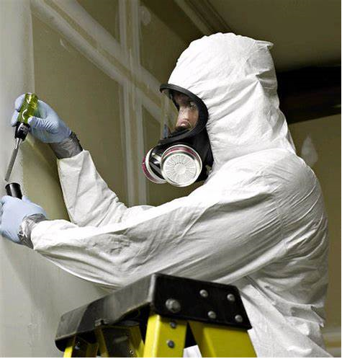
NASPM is highlighting the HSE asbestos campaigns ahead of Global Asbestos Awareness Week

1st April to 7th April

Asbestos remains in a high percentage of schools in England and it can become dangerous when disturbed or damaged.

HSE are currently running 2 asbestos campaigns which include awareness for tradespeople.

Asbestos Checklist for Schools
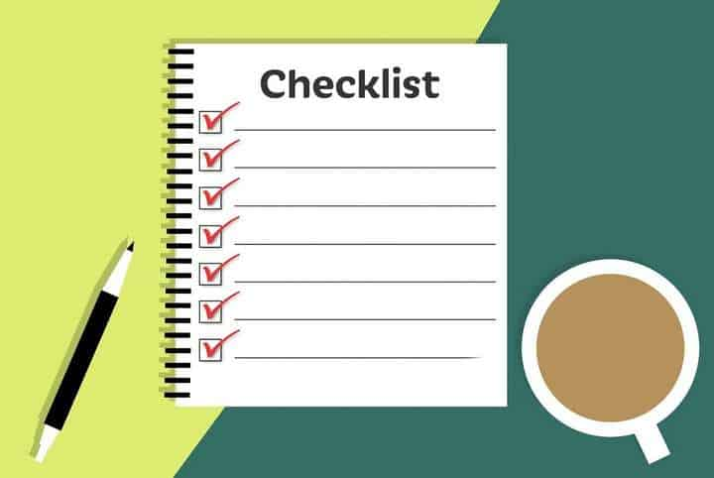
HSE has an asbestos checklist for schools This will help schools review their asbestos management arrangements. It asks key questions so schools can check if suitable precautions are in place, and to record any further action that is needed.

How compliant is your school with the management of asbestos?

For schools that were built before the year 2000 a simple review of the following will enable you to have some assurance of the legal requirements
- Does the school include other staff when arranging for asbestos training such as Headteachers and others that may have responsibility for managing the school estate?
- Do you have an up-to-date Asbestos Management Plan that reflects the location and condition of asbestos and ongoing monitoring program?
- Do you have evidence of contractors signing the asbestos management plan/register if working near the asbestos?
- Do you manage the ‘presumed asbestos’? Treating it like asbestos until proven otherwise?
- Do you understand the limitations of an Asbestos Management Survey and the need for additional surveys when planning to gain access to and work in the areas that were not surveyed?
- Do you have an annual re-inspection programme for identified asbestos?
- Do you complete refurbishment surveys before completing intrusive works within the estate?
- Do you warn others of the location/hazard of asbestos such as fire and rescue services? This can be located within a plan located in the firebox at the entrance of the school
- Do you review your asbestos companies to ensure competence, such as UKAS membership?
- How often do you complete asbestos awareness training?

Make sure you book onto our interactive Asbestos Awareness training, you can include other school staff to attend. This is completed by Stuart McGregor who is deemed a competent Asbestos Professional AFAAM.

Guidance on the Breakdown of the

Fire Alarm System

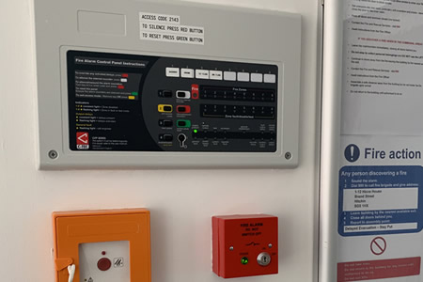
It is so important to have that monitoring role of the fire alarm system and to give it the respect that it deserves as it is potentially life-saving equipment.

As a lifelong fire risk assessor I couldn’t count the number of times when reviewing the fire panel during a school fire risk assessment to find ‘fault’ in the system and being told the system is still fine and working but without the full assurance that is working. Often the knowledge is lacking of the impact and lack of risk assessing what the fault may present as a life risk.

Critical Incident? Action required? Yes building/lifesaving equipment failure should be considered and form part of the school’s critical incident plan.

Significant risk? Action required? Yes. The Management Regulations 1999 requires employers to complete risk assessments for all significant risks and also when there are significant changes.

Examples of specific panel fault findings included:
- Whole sections of sounder loops not operating
- Smoke vents not operating
- Automatic detection not operating
- Large sections of detection not operating

I have been involved with follow-up enforcement works that included the breach against the RRFSO 2005 Article 17 for the legal requirement of Maintenance:

Maintenance

17.—(1) Where necessary in order to safeguard the safety of relevant persons the responsible person must ensure that the premises and any facilities, equipment and devices provided in respect of the premises under this Order or, subject to paragraph (6), under any other enactment, including any enactment repealed or revoked by this Order, are subject to a suitable system of maintenance and are maintained in an efficient state, in efficient working order and are good repair.
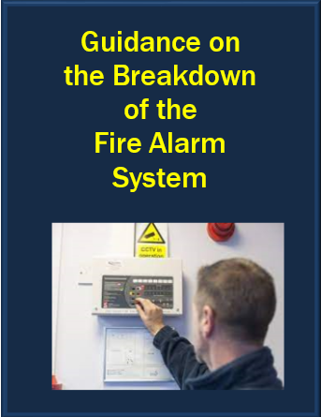
We have the template policy and risk assessment within our document centre for schools to use and amend following the breakdown of the fire alarm system. This includes guidance and reference to:

The Hazards
- The outbreak of fire will remain undetected due to the failure of automatic fire detection equipment.
- Staff/visitors unable to actuate fire alarm system to give warning in the event of a fire.

The consequences of the hazard
(i.e. What is the potential harm)
- Potential for staff, pupils and visitors sustaining fatal or serious injury as a result of an undetected outbreak of fire.
- Potential for fire development due to the inability to activate the fire alarm system and as a result staff, pupils and visitors being placed at risk (fatal or serious injury).

The controls
(the school should review and amend where necessary)
- School to enact the written procedure for this event.
- Additional floor fire wardens (either staff or temporary premises staff) are to be engaged to undertake fire-watching duties, including floor patrols. The fire wardens appointed must not be engaged in any other duties apart from fire-watching.
- Fire wardens are to raise warnings with whistles in the event of a fire being discovered whilst patrolling.
- Teaching staff to be issued with whistles, so that they can augment the fire warden’s air horns in the event of a fire.
- In the event of a warning (bells and whistles) staff, pupils and visitors will evacuate the building using the designated escape routes and staircases
- On the evacuation of the building report to the designated fire assembly point at the rear of the main playground.
- Fire wardens Administration will notify the Fire Brigade of the fire or assign the nearest available person with a working mobile to do this.
- The school will restrict any high-risk works, such as contractors working with gas/flame/hot works

Incident Golden Hour


We continue with our Critical Incident Plan review and development for our schools.

Following a recent training session and follow-up input with school premises teams, we are creating a template based on an ‘impact tree wider analysis’ of impact.

Creating a library of all potential premises-related critical incidents and creating layers of headings for review. One of the responses is always the key initial response, often referred to as the ‘Incident Golden Hour’

Actions needed for the

‘Incident Golden Hour’


Make safe and contain an incident scene

- Isolate services, contain spillages etc.
- Contact emergency services

Emergency Response

- Instigate a localised emergency response plan
- Carry out first aid if required and if safe to do so (competent trained person)
- In the event of a casualty requiring a hospital visit, a designated person must accompany the casualty where possible.
- Key contacts notified
- Contact utility service providers if required

Take control of the incident scene

- Secure the scene, no interference, little is moved
- Limit access to authorised persons and clear others away from the area
- Assess the risk as a dynamic risk assessment with control measures needed
Obtain critical information
- Make sketches
- Take photographs
- Take witness statements even if there are initial witness statements where possible
- Take details of any plant/equipment/taking photographs

Preserve key items of evidence on-site
- Secure the area, secure evidence
- Make a list of key related documents that will be needed, inspection and maintenance records, risk assessments

Contractor Site Safety Induction

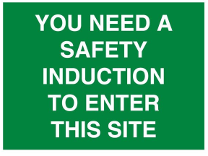
Do you have one?

Do you need one? Yes

Having additional layers of risk communication is only seen as a good thing as it provides additional controls and sharing of health and safety information. Schools do not need to have the same sort of induction you find on construction sites.

What should be considered within your contractor induction form?

School Safety Induction for Contractors – Content

A welcome note with reference to having this induction signed by the contractor, with the following areas as examples:
- Public shared spaces
- Staff and pupils
- Plant rooms
- Roof areas
- Access/Egress routes
- Security
- Asbestos
- Confined spaces
- General site rules and welfare
- Emergency information including fire safety
- RAMs
- PPE
We are working on this contractor induction template for you to make and amend to your site, it will be a short document to ensure it can practically be used for your contractor management.

It could be that your contractors complete the same work activities every time they come so they could be inducted once, or it could be that their work activities have changed and the risks are different with changes to their risk and method statements.

CDM – Project works Summer Holidays

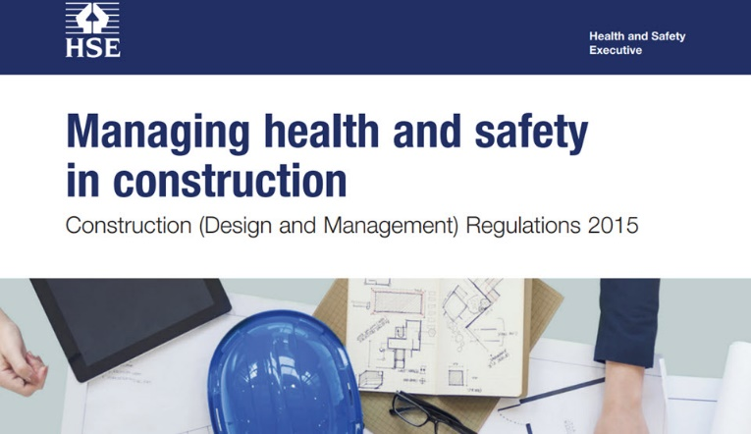
As we approach the Easter holidays, the first question is where did Christmas go?

The busyness of school environments and on particular your roles of premises management makes planning a vital control measure and mechanism for managing building works/projects health and safety.

Reflecting on last summer I identified several schools having building projects from small types of refurbishments to large multi-contractor works and the themed finding was that the schools were breaching the Construction Design Management Regulations 2015 as they were not aware of the duties of the CDM regulations in the need to appoint specific duty holders such as Principle Designer, Principle Contractor and their duties as client.

We are running a free workshop in May on this subject in preparation for summer break and the potentially busy period of building works. We are also designing a new CDM Client Competent training programme which will be a 3-hour training course via Zoom.

I believe this legislation remains the most misunderstood legislation and has the potential highest risk of material breach. A material breach is a breach in following legislation. This is mainly due to a lack of understanding, lack of competence and knowledge of the CDM regulations.

There is also a themed finding that many contractors, your school contractors are not aware of the requirements of this regulation. It doesn’t help with having the title of ‘Construction’ within the first word of this regulation as it makes people think about construction and construction sites, this is misleading as the regulation refers ‘to any works on the fabric of the building’.

Common breaches and failings of the CDM regulations include:
- Engaging with contractors to complete works without the knowledge of CDM regulations/requirements
- Lack of providing pre-construction site information
- Lack of Construction Phase Plan’s (CPP)
- Not appointing key duty holders
- Monitoring of projects

Although many larger projects are managed better with the assistance of competent personnel, the assurance and management of this needs to be confirmed. In an instance of significant harm/injury/death, the enforcing authority will follow and test the requirements of the CDM regulations.

We are in the process of key CDM documents being added to the new ‘Resource Hub’ with its own folder and reviewing the need to have a Member working group of CDM management in schools.

Any members interested in CDM management in the school working group please email

support@napsm.co.uk

Changes to the Document Centre

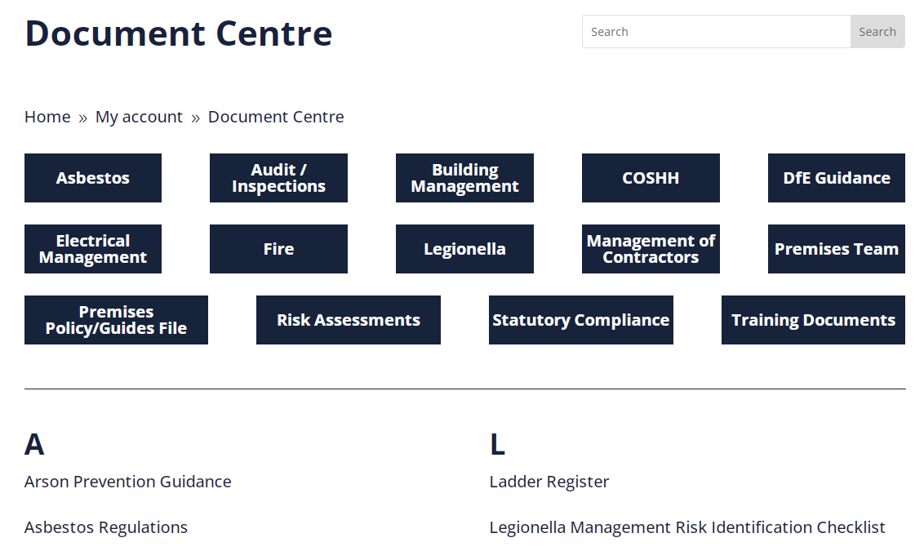
Following the input of members the document centre is changing and becoming the ‘Resource Hub’ which will include new folders and headings that will make it easier for you, the end user to navigate your way around the vital toolkit in assisting you to manage your school estate.

We value your input into the development of the new ‘resource hub’, please email us at admin@naspm.co.uk for any recommendations to improve the document centre/resource hub.

Current changes include an overview document of the resource hub and how to use the hub, with key documents and templates explained, based on priority and legal compliance and best practice.

A new improved risk assessment folder that includes more risk assessments with the aim to be the standard UK go-to for suitable and sufficient risk assessments for school estates. The aim is to work with our members and produce any risk assessments/documents that are necessary.

FREE Webinar
Fire Enforcement Preparedness
25th April 10am - 11am


A review of the fire enforcement code and the responsible person duties of the RRFSO. What the RRFSO articles are and how these are reviewed before/during and after a fire and rescue school audit, with case studies of enforcements and what ‘good looks like’ which includes an overview of fire risk assessment and stage 2 action plans.

To book tickets go to www.naspm.co.uk/my-account/
Enter username and password
From the dashboard select BOOK TRAINING
Click on the name of the course
Add the desired number of people
Click on Get tickets
Click on Proceed to Checkout
Complete billing details and payment method

Offences

A round-up of what enforcements are happening around the UK, fortunately not school related but it shows you the health and safety failures and prosecutions.

Please note the dates of accidents and the recent dates to get to court, this is normally anything from 2 to 6 years with an average of 4 years. If this was a school incident imagine the investigations, stress and anxiety whilst awaiting a court date.

Remember, the common theme for each of these significant accidents is that the HSE and prosecution counsel review in detail the ‘risk assessment’ for the activity taking place and this process includes a review of how ‘suitable and sufficient’ the risk assessment was and was the accident ‘foreseeable’

Pizza maker fined £800,000 after 2 workers caught in machinery

15 March 2024 - The fine was issued following 2 separate incidents involving workers being caught and severely injured in machinery at a factory.

Construction firm fined after worker dies from fall

15 March 2024 - A worker fell nearly 2 metres through an opening in a scaffold, suffering several broken ribs and serious internal injuries.

£400,000 fine for chemical company after worker seriously injured

8 March 2024 - The fine was issued after a worker fell into a sump due to inadequate grating and sustained severe burn injuries and permanent scarring to his leg.

Metal recycling company fined £200,000 after worker loses arm

6 March 2024 - A worker's right arm was severed after becoming entangled and trapped in a catalytic converter sampling machine.

Company and director sentenced after worker crushed to death

6 March 2024 -The worker was unpacking slabs using an overhead crane when 2 slabs weighing 250kg each fell and crushed the worker against a forklift truck.

Manufacturing company fined after worker fatally crushed

5 March 2024 - A £120,000 fine has been issued following the worker suffering fatal injuries after becoming trapped between 2 heavy steel beams.
Company fined after delivery driver suffers brain injury

1 March 2024 - The worker was stowing equipment in a trailer when a reversing forklift struck the attached vehicle. This led to the trailer shunting into the worker causing him to fall over and hit his head on the tarmac floor below.

Health & Safety Training with NASPM

We offer live virtual trainings for all areas of the school’s health and safety every month.

Training sessions include,
- Lockdown Awareness
- PUWER
- Fire Warden
- Legionella Awareness
- Asbestos Awareness
- Managing Contractors
- Electrical Management
- Fire Door Management
- COSHH
- Working at Height Risk Assessment
- Manual Handling Risk Assessment
- Risk Register for Premises
- Premises Auditing
- Premises Building Projects
- Playground Premises Management
- Senior Team Leaders Health and Safety
- EYFS Risk Management
- DSE Assessor

Training courses are certificated and provide the employer with CPD evidence of competence.

You can access all training via the NASPM website at
www.naspm.co.uk/my-account/
Enter username and password
From the dashboard select BOOK TRAINING
Click on the name of the course
Add desired number of people
Click on get tickets
Click on Proceed to Checkout
Complete billing details and payment method

Please book as soon as possible to guarantee your place.

Your input into NASPM
Do you have any requests regarding documents, templates, or an area of concern that you would like us to include in the document centre or website?

Do you want a tailored health and safety training programme?

Or do you want to leave feedback?

Email admin@naspm.co.uk

 |  | 

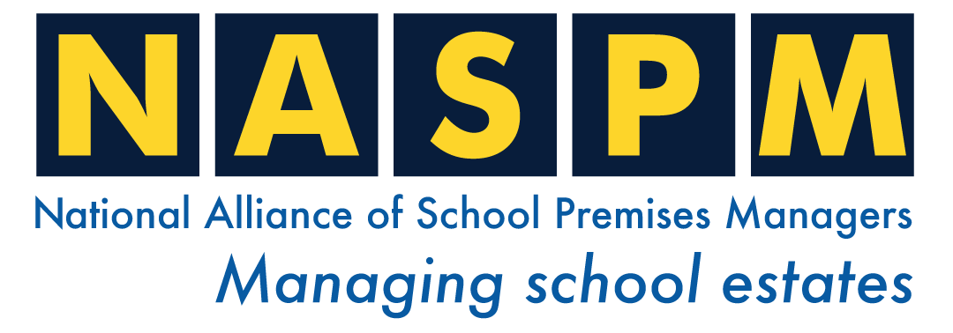
Copyright (C) 2023 NASPM. All rights reserved.

Our mailing address is:
NASPM The Old Town Hall 29 Broadway London, London E15 4BQ United Kingdom

