

We hope you enjoy your NASPM June 2024 newsletter.
In this newsletter we cover the following:

- Safety Culture – The NASPM Way
- Your Defence Starts Today…. Preventing slips, trips and falls
- Working at Height – Checklist
- NASPM Documents in the Spotlight
- Schools and Academies Show – NASPM have become the official partners
- Offences
- FREE Webinar – CDM 2015 Compliance – Are you ready for the summer holiday contractor’s work?
- FREE Webinar – Legionella Management
- FREE Training – Schools Out for Summer! Summer school training
- FREE Training – New Headteacher Health and Safety Training
- NASPM Training
- Your Input into NASPM

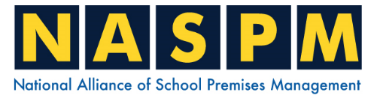

Safety Culture 'The NASPM Way'

The feedback we are receiving from our members is wonderful as the focus has been on how well the schools have been able to implement and improve areas at school following our training sessions and the use of our templates and guidance documents.

One example of this feedback was from a member following our safety alert of the carbon monoxide school incident, they contacted us and told us that they identified 5 areas within their school that needed additional carbon monoxide detection.

From my experience over the years, I have learnt that people are the key to safe working environments. You are our focus in the Alliance, competent staff, as you can have the best software and great buildings, but without the competent person, things will go wrong.

Safety Culture is an interesting topic and one that I believe every Premises Manager/Estates leader/Staff can raise the profile of the importance of working safely across the school environment. You have the whole school within your remit and interest as you manage the entire building health safety fire and security. You engage and assist in the day-to-day management of the school and you also engage with senior management, staff, visitors, contractors and pupils.

Your attitude to safety will be like a lighthouse put on a hill, meaning, it will be very obvious to others that you mean business when it comes to health and safety and what you expect on your site. The premises staff that really shine are those who treat the school site as belonging to them and will often hear them saying on my site this is what I expect and how we manage the safety.

You will see unsafe issues and conditions, including unsafe acts being completed by staff and contractors, and it is how you REACT that really matters as this reaction could prevent accidents and severe injuries. If you do not react this shows the lack of culture and importance to health and safety could be seen to be lacking.

REACT – Raise a concern with the unsafe act, Engage with the person, Act you need to take action to stop and prevent an accident, Control – have you controlled the unsafe act, Time – take time to reflect on and follow up with any actions from the unsafe act. REACT

Always be the professional premises staff, drive the safety culture to the highest level and be proud to do so. You will always have some challenging staff, I know I did when I was a premises manager, often this was certain staff, and the usual small percentage of staff that didn’t feel that safety was part of their responsibilities. The staff that you may have advised over and over on certain health safety security/building concerns such as not leaving security doors open, wedging fire doors open, blocking fire escapes, working on tables or chairs, or not reporting damage to buildings, you know the ones! Often at some point have ended up having an accident or causing an accident.

We want to have our own slogans for the Alliance to promote the importance of safety culture and would love to have any ideas, or feedback from you. I think the easiest and best safety culture that we have all heard of is the railway slogan, see it, say it, sort it! We know that this encourages both staff and members of the public to report unsafe acts or unsafe environments. We can’t copy this and the following are some ideas for our own NASPM safety culture slogans:

- Think Safety – Work Safely
- Make it Routine
- Make Safety Routine
- Take 10
- Safety – The NASPM Way

‘Think Safety – Work Safely’ is the simplicity of safe working, thinking about safety and then working safely will always give you some thinking time when dealing with all school estates work activities. When you recognise that over 95% of accidents are caused by people, mainly people not taking due diligence at work, the message to Think Safety and Work Safely is potentially a lifesaver slogan.

‘Make it routine’ is the message NASPM encourages our members to take on all work within the school, with the key message being to make health and safety routine, it automatically becomes a full part of the day-to-day work.

‘Take 10’ – is the well-known stress-coping exercise of counting to 10 before any reaction.


Action

Email admin@naspm.co.uk for any input into the new Alliance health and safety slogans if you have any, or if you prefer any of the above slogans as we will add to our marketing, and it is good to have our member’s input as always.

Make sure you title your email ‘slogans’

Share any good news stories on the safety culture improvements since being a member of the Alliance that other members may want to hear about



Your Defence Starts Today….

Preventing slips, trips and falls

The most common cause of accidents around the world, and although mainly resulting in minor injuries sometimes these types of accidents result in life-changing injuries.
As a lead accident investigator, the most common civil claims are related to someone slipping, tripping and falling at the workplace and an injury occurring. Remember in last month’s newsletter we focused on ‘Your defence starts today’

This included the review of general building activities that may have a higher risk of slips and trips such as cleaning. I wanted to hang around in this topic, the area of slips and trips as I do believe that many schools remain at risk of staff/pupils falling over. Today, this week, look at the dining hall area to see how well this area is being managed regarding cutlery/knives and forks, spillages liquids and food spillages on the floor – as this area of control is a common weaker area and one that often results in either staff, contract catering staff, or pupils falling and hurting themselves.



Action
Dining hall slip trip management

- Is there a risk assessment in place for management of slips, trips and falls in the dining hall? Does it include trip hazards such as cutlery and food items as well as from spillages?
- Does the risk assessment detail who is responsible for cleaning and managing spillages
- Is there a mixture of responsibilities from the school staff and the catering staff?
- When you spot-check this week, if you are finding knives, forks, food debris and spillages on the floor of the dining hall, are the risk assessment controls working? The answer would be no!
Safety Shoes
What is the school policy on shoes? Often this is lacking within the school slip, trip fall risk assessment and not addressed at all in any policy or procedure. Some schools may have this detailed within the school handbook and include a description of what is not considered sensible shoes such as open-toe shoes. If for example a member of staff slipped on a spillage and was wearing high heels and the school didn’t have a risk assessment or reference on the need for sensible shoes the school would find it difficult to defend this case.


Action

Safety Shoes

- Do kitchen staff wear safety shoes?
- Are premises staff issued with safety shoes?
- Do you have a risk assessment for slips, trips and falls?

- Does the risk assessment specifically cover key risk areas and times/activities such as dining hall/lunch?
- Do you have any reference to staff needing to wear sensible shoes, re non-slip, with a list of those shoes that are not allowed?

Working at Height

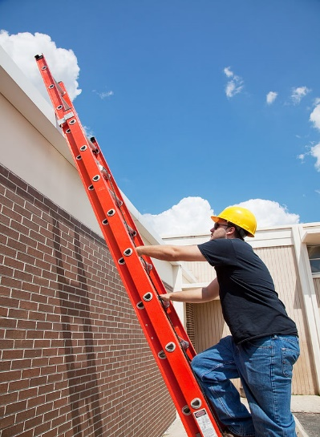
Checklist
Falls from height are the most common cause of fatalities accounting for nearly one-third of fatal injuries to workers. The Work at Height Regulations 2005 require you to prevent death or injury caused by a fall from height.

The Regulations have no minimum height requirement for work at height. They include all work activities where there is a need to control the risk of falling a distance liable to cause personal injury.

Work at height needs planning and organising and those working at height need to be competent. The risks from work at height need to be risk assessed and appropriate work equipment used, inspected and maintained.

Common Work at Height Situations
Working at height occurs in many areas of the school, especially in the premises and estates management activities. Common situations include cleaning gutters or maintenance work using leaning ladders, changing lightbulbs working from step ladders or mobile elevated work platforms, contractors working on scaffolding or repairing roof damage or staff working on mezzanine levels.
The regulations also require you to consider the risk of falling objects onto persons below. E.g. tools falling from your ladders or platforms

THINK SAFETY - WORK SAFELY
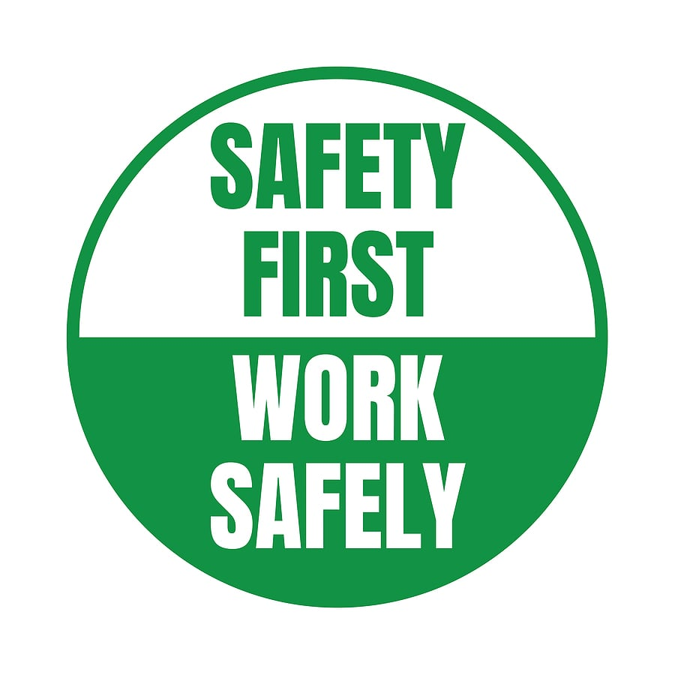
Reminder, what the regulations state
Assessing the Risk of Falls
Step 1: Avoid work at height where it is reasonably practicable to do so.
Step 2: Where work at height cannot be easily avoided, prevent falls through workplace design or equipment.
Step 3: Minimise the distance and consequences of a fall using equipment, where the risk cannot be eliminated.
Reducing the Risk of Falls
- Work from ground level as far as possible.
- Ensure staff and contractors have safe access and egress to/from work at height.
- Ensure work-at-height equipment is suitable for the job, maintained and checked regularly.
- Work equipment requires inspection in position before use and at suitable intervals if exposed to conditions causing possible deterioration. Use the NASPM ladder inspection template every 6 months
- Ensure you/staff do not overload or overreach when working at height.
- Consider fragile surfaces - no one should stand on or near a fragile surface.
- Warning signage is required at possible entry points onto a fragile surface.
- Provide protection from falling objects.
- Storage cabinets with the potential to topple or fall should be secured and shelving/racking should also be secure and sound.
- Consider emergency evacuation and rescue procedures for persons working at height. This could be contractors up on the roof.
- ‘Danger’ areas should be demarcated preventing unauthorised access into areas in which people are working at height or where objects may fall from height.
- Workplace design - perimeter railings should be provided to mezzanine floors and handrails on staircases. Gates to open stairs such as into the boiler/plant rooms

(Continued)

NASPM Documents in the Spotlight
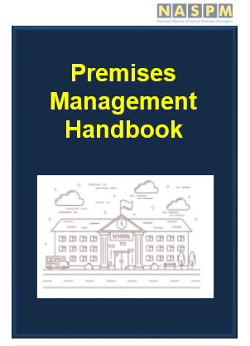
Please make sure you have access to the document centre/resource hub, if you need login details contact admin@naspm.co.uk

This month the focus document is the Premises Manager Hand Book – ‘The Standard’

This is a great resource for all premises staff and has been developed over the years as a reference book for staff to have a quick guide with easy layout sections.

The introduction is followed by references and checklists:
1.1 Key tasks
1.2 Summary of tasks and checks
1.3 Premises Checklist

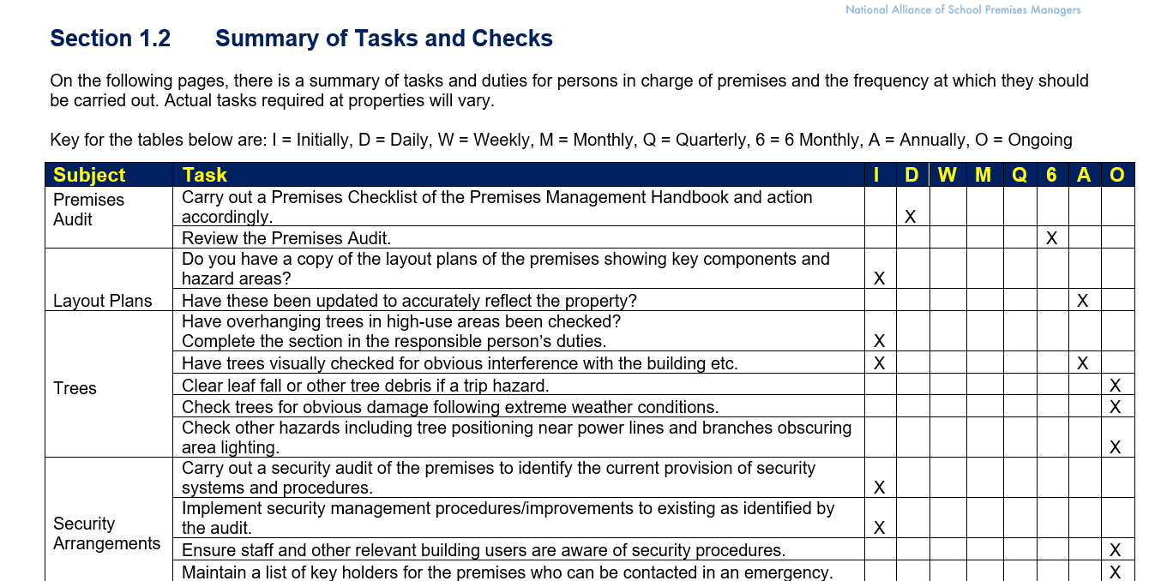
Look at section 1.2 on page 6 which has a great table that details the ‘summary of tasks and checks’ in an easy-to-use table. This includes all building statutory compliance requirements, in a table format that includes the frequency. All of this key information is in one area for ease of reference

Schools and Academies Show


NASPM has become an official partner
We are delighted to announce that we are an official partner with the Schools and Academies Show.
You may be aware that our Operations Director Stuart was a key speaker at the Excel in London this year, Birmingham last year and is planning some of the Estates Shows for Birmingham later this year.

We have been asked to provide information and guidance to the SAAS newsletters and blogs and look forward to launching our partnership to ensure we can get the most out of our members by being a voice across the country.

It is also a time to come together and celebrate the Alliance and a time we can meet many of our members.

If you have any ideas/topics that you want us to consider, please let us know.

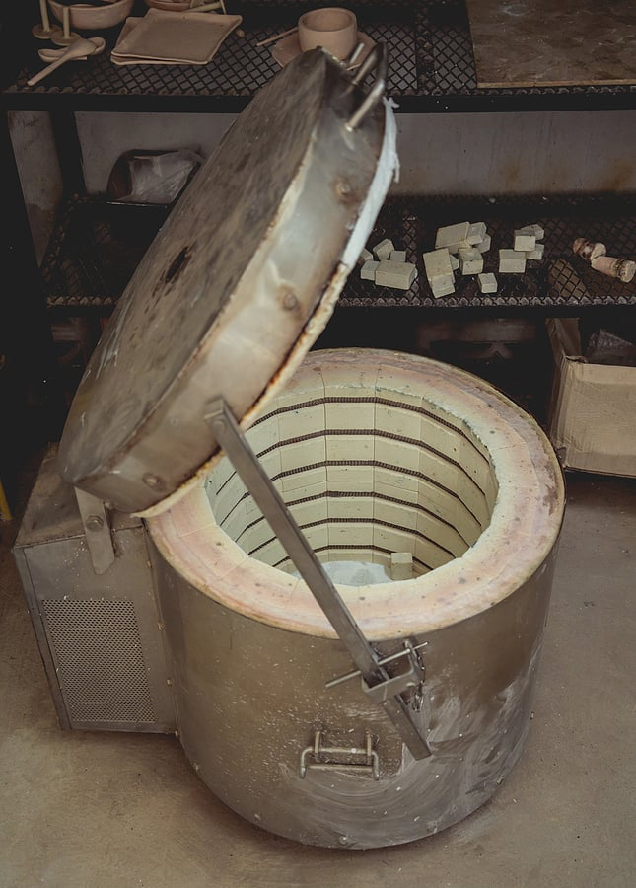
Safe Use of Kilns
All Kilns need to have maintenance and a safe system of work. I am aware of several incidents involving Kilns that have been used overnight and have activated the fire alarm system due to incorrect use and poor management.
Follow the HSE link for further information
Kilns.pdf


Offences
Please see below for a selection of the latest news and prosecution notices, fortunately, none of these are school related. Still very concerning to note the fatal incidents and significant life-changing injuries that in every case could have been prevented.
Telephone engineer incident led to a significant fine.

Alun Owen, a 32-year-old engineer from Bethesda, was working to repair a telephone line in October 2020 when he slipped and fell into the River Aber in Abergwyngregyn. He sadly died due to the incident.

Several Openreach Limited engineers were trying to fix the telephone line, which ran across the river, for two months. When the incident happened, there was flooding in the area so the river was higher and faster than usual. Mr Owen had to enter the river on 6 October 2020 to reach an island in the river. From there he would try and throw a new telephone cable to the other side by taping it to a hammer and then throwing the hammer. Unfortunately, when crossing the remaining section of the river, he slipped into a deeper part and the river subsequently swept him away.

A joint investigation took place between the Health and Safety Executive (HSE) and North Wales Police. The investigation found that there was no safe system of work in place for work near or on water. In addition, none of the engineers received any training, information or instruction on safe working near water.

As a result, Openreach Limited pleaded guilty to breaching the Health and Safety at Work etc. Act 1974 and was fined £1.34 million. In addition, it was ordered to pay costs of £15,858.35.

HSE inspector Christina Roberts said "This was a tragic incident that resulted in the death of a much-loved young man. Mr Owen’s family, friends and colleagues have always remained in our thoughts.

“His death would have been preventable had an effective system for working on or near water been in place. Mr Owen should not have been put in an unsafe working situation. Companies should learn the lessons from this incident if they have staff who may work on or near water and be aware that HSE will not hesitate to take appropriate enforcement action against those that fall below the required standards.”

In addition, North Wales Police Detective Chief Inspector Andy Gibson said “North Wales Police worked closely with HSE and whilst it was a protracted and lengthy investigation, it was critical that any failings were identified and acted upon.”

Car wash firm fined over safety failings.

Best Car Wash Ltd in Tavistock has been fined £40,000 and ordered to pay costs of £3,164 for failing to adequately protect workers and the public.

Multiple visits were carried out by the Health and Safety Executive (HSE) to the car wash between July 2021 and November 2022. The investigation discovered electrical hazards due to the fact employees were washing cars outdoors, using electrical equipment such as pressure washers and vacuum cleaners, but systems were not in place to prevent danger to employees and members of the public.

Five enforcement notices were subsequently issued, but follow-up visits confirmed they had not been complied with. This meant electrical safety risks to vulnerable workers persisted for longer than they should have. It wasn't until April 2023 that a competent person was brought in to inspect, test and repair the installation.

Best Car Wash Ltd was eventually found guilty of breaching both the Health and Safety At Work etc. Act 1974 and the Electricity at Work Regulations SI 1989/635. HSE Principal Inspector Helena Allum said "We can and will prosecute if companies fail to comply with enforcement notices. Those in control of work have a responsibility to ensure safe methods of working. The dangers associated with electricity in a work environment are well known and a wealth of advice and guidance is freely available from HSE.”



Legionella Management

Wednesday 3rd July 2024 at 11am - 12pm

FREE for members, £75 for non-members.

An overview of legislation including the L8 and control matrix needed to manage legionella in the school. Designed to highlight the risks of exposure to legionella bacteria, this Legionella Awareness Training Course looks at what to look out for and how to protect your school from harmful Legionnaires' disease
Anyone working within a School Premises Management Team will benefit from this training.

Contact admin@naspm.co.uk to book.

CDM 2015 Compliance
Are you ready for the summer holiday contractor's work?
Friday 5th July 2024 at 10am - 12.30pm
FREE for members, £75 for non-members.

We have created an additional free CDM-2015 webinar following feedback from members. We are aware that this is somewhat new to many members and a longer overview session has been developed to give additional assistance and guidance on the school CDM requirements.

This covers Legal Compliance, duty holder roles, client duties, Principal Designer, Principal Contractor and Construction Phase Plans. Join our Director of Operations Stuart McGregor who is a Principal Designer to review the CDM 2015 requirements in our free webinar and to review how schools can ensure compliance.

Contact admin@naspm.co.uk to book.


New Headteacher Health and Safety Training

Monday 15th July 2024 at 11am – 12pm
FREE to members, non-members £75
Duty holder, responsible person, lead accountable person – what does this mean for you as a new Head teacher? What do I need to know?
NASPM have developed a one hour well-structured whistle stop tour of all relevant legislation and risk management to give new Head teachers a sound foundation of all things health and safety.
Also very suitable for existing Head teachers as a refresher and update.
Contact admin@naspm.co.uk to book

Schools out for Summer!
Summer School Training


Health and Safety Summer School
Friday 2nd August at 9.30am – 2.30pm
Schools out for summer! Except of course for school premises and school business managers! Why not take the opportunity to brush up on school legislation, DfE standards, risk management and an overview of Good Estates Management.

In the comfort of your own surroundings, jump on and listen to our Director of Operations Stuart McGregor CMIOSH MIIRSM AFOH AFAAM RSP RRP MIIAI covering the following subjects supported with years of relevant information and case studies. In addition we will provide key control measures and links to our extensive resource hub. Get prepared for September!

- Overview of legislation

- School Risk Profile and Risk Assessment
- The Essentials - Managing School Estates, including fire, security, lock down and critical incident management
- DFE GEM’s – implementation and review
- Estates Management System

Cost – FREE for members, non-members £150 per person.


NASPM Training

We offer live virtual trainings for all areas of the school’s health and safety every month.
Training courses are certificated and provide the employer with CPD evidence of competence.

Training sessions include,
- Lockdown Awareness
- PUWER
- Fire Warden
- Legionella Awareness
- Asbestos Awareness
- Managing Contractors
- Electrical Management
- Fire Door Management
- COSHH
- Working at Height Risk Assessment
- Manual Handling Risk Assessment
- Risk Register for Premises
- Premises Auditing
- Premises Building Projects
- Playground Premises Management
- Senior Team Leaders Health and Safety
- EYFS Risk Management
- DSE Assessor

You can access all training via the NASPM website at www.naspm.co.uk/my-account/

Enter username and password
From the dashboard select BOOK TRAINING
Click on the name of the course
Add desired number of people
Click on get tickets
Click on Proceed to Checkout
Complete billing details and payment method

Please book as soon as possible to guarantee your place.

Your input into NASPM
We are reviewing our Website.
We are refreshing the website to make it easier to navigate and so that it's more user-friendly and will include a review of each tab/title area. So please let us know if you have any comments, opinions or ideas on the website.
Do you want a tailored health and safety training programme?
Or do you want to leave feedback?
Email: admin@naspm.co.uk

Get In touch

Stuart and the NASPM Team

National Alliance of School Premises Managers
Old Town Hall, 29 Broadway, Stratford, London
United Kingdom
 |  | 

