
Home | Training | Membership | Contact

We hope you are enjoy your Summer 2024 NASPM newsletter.
In this newsletter we cover the following:

- Safety Culture The NASPM way – the results are in!
- The Name is Changing
- Website Changes
- Resource Hub – ‘The Hub’
- End of Summer Holidays
- Membership Login
- Roles of School Estates Staff
- Project Management
- Offences
- Training

Safety Culture –

‘The NASPM Way’

Thank you for your responses to the potential health and safety culture slogans. The resounding votes starting with the most are:
- Safety – The NASPM Way
- Think Safety – Work Safely
- Safety – Make it Routine
- REACT
We will be using these in our marketing materials.
Just a reminder of what REACT stands for and why we want to focus on this in the day-to-day works -
Raise a concern with the unsafe act,
Engage with the person,
Act you need to take action to stop and prevent an accident,
Control – have you controlled the unsafe act,
Time – take time to reflect on and follow up with any actions from the unsafe act.
REACT
The walk past rule is often referred to when managing health and safety and estates, ‘The standard you walk past is the standard you expect’ similar to unsafe acts/unsafe conditions/unsafe environments – with the Alliance’s new slogan to REACT
I remember going to large construction sites during the ‘building schools for future’ government project and meeting this very lively excitable loud character of a site manager. He took me through the general induction process and we completed a joint safety inspection of the construction build.
The way this site manager managed the site was so refreshing for me to see as he was dealing with mainly unsafe acts from some of the construction workers. It was very visible that he was leading from the top and created such a strong culture and expectation of a safe place and safe workers.
A mile up the road at another school construction site it was the complete opposite, although it was the same contractor company, with all the same health and safety documentation, the key differences were the 2 leading site managers - people. One was so proactive and safety-led, being visible and active, identifying real-time hazards and implementing immediate corrective actions, the other was in the office with no impact on the site safety standards and the difference on the walk round inspection was vast.
We want to express the power of a positive health and safety culture and empower our members to drive this through our schools. Raising the profile of your role, which is extremely important, as you manage the school estates, compliance and related health and safety legal requirements and standards.
We welcome any news from our members around this subject, this could be a short news story on a concern and how you managed or corrected the safety culture.

The Name is Changing

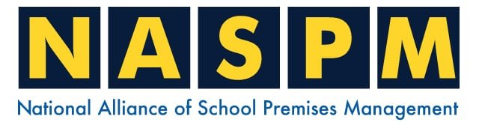

Over the last 8 months, some members have raised a themed concern with the ‘Premises Managers’ name within NASPM not being inclusive of all the other school estates staff titles. For example members with job titles such as Facilities Managers, Site Managers, Caretakers, Site Agents, Estates Managers, Operations Managers, Estates Directors and more.
The name change is simply ‘Premises Managers’ to ‘Premises Management’, so will still keep the NASPM acronym. Again, this shows how much we listen and evolve with our members, as we say, NASPM is for our members.
It also allows the Alliance to bring in the wider school community in the main focus and aims to raise the profile of your important role together with the related legal duties and responsibilities of managing school estates. From my experience with managing in schools and managing school estates, it requires a multi-layer involvement that includes school business managers, operational managers, Headteachers, School Governors, Trust board and Local Authority to ensure that the school compliance and estates management has the correct governance and joined up strategic development.

Let me explain further, the general national pattern within schools is that the high percentage of compliance sits with the premises/estates management, with these staff being competent and aware of the legal requirements and knowledge of estates management and related health and safety duties. The same people, you, on the whole, do not have the power or authority to sign off budgets or make significant decisions without the backing and agreement of the school business manager, Headteacher or school governors/trust leads. These additional key staff, often do not have the same competence, experience, training and understanding specifically on estates management and may have a negative impact on your requests for work, and inadvertently affect school compliance and H&S.

The Alliance is including these key target staff within the changes to The Hub that will align with the aims of raising the profile across the school, although the key focus of the Alliance remains very much on the premises staff, seeing this joined-up process only a benefit to the school and premises teams.

Website Update



From September we will be updating the website. This includes the new resource hub, or simply ‘The Hub’
The website has needed of a refresh, and we are excited to share the changes with you in September.

The Hub

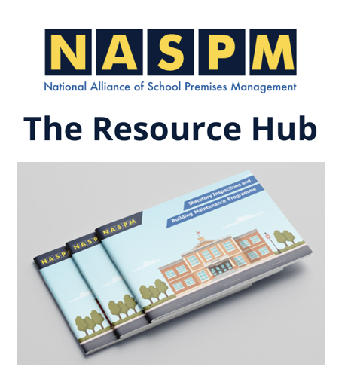

Following member feedback and as part of the Alliance development process we are moving away from the document centre and creating the resource hub, known as ‘The Hub’.
Changes include bringing all the building checklists together and having an introduction on how to use the Hub and introductions to key folders and key documents. The development of NASPM strategy documents and a change of some of the folder names. We will also have a folder to keep all the newsletters in, to allow members to look back and have a central communication database of key information.
Some of the new folders have a longer-term active update and development programme that we keep growing together with our members. This includes folders such as risk assessments, COSHH, policies and procedures as these all form part of the ongoing development. We are also introducing tool kits and codes of practice. The wider key target staff and school management will also have specific guidance folders within the Hub.
We welcome all feedback from our members.

End of Summer Holidays



Well, the summer holidays are nearly over and congratulations on all your hard work on our schools. I know from my school premises manager days these six weeks are often a huge demand both physically and mentally on you and as the weeks go by this last week tends to be the most stressful as you are also dealing with staff turning up and still trying to finish and manage all the contractor works.

Some points of interest and potential actions/reminders for return to school:
- Legionella management – hopefully you continued to complete the flushing during the holidays and increased during this last week. Depending on the school-specific legionella risks, it is always a good idea and relevant control measure to include a sampling of the water at this time and during the start of September to give another layer of assurance that the water is clean with no significant findings of legionella bacteria
- Fire safety – any significant changes to the building will need to have a competent review of the fire risk assessment. Such as refurbishments, changes to the current building structure and changes to travel distance as some examples. Some schools will still have contractor works continuing throughout September due to works not being finished on time and having live contractor works this must be considered as a higher-risk activity that needs careful risk management and controls in place. Often the continuation of contractor works means the loss of some normal fire exits, and extending fire exit travel distance, this will require the input of a professional fire risk assessor to ensure that the safety of staff, students and contractors is considered with appropriate control measures in place
- CDM – Construction Design Management Regulations – again this has been a huge concern for me visiting schools and identifying material breaches in this legislation, with schools that should have had project management in place and key duty holder roles identified often still lacking. We will be extending the CDM awareness training and specific CDM Hub documentation. Just reflect over the summer holidays on how the contractors were appointed, managed and monitored, hopefully, nothing went wrong, but if there was a significant accident/incident how would your evidence look like in proving you followed all health and safety legal requirements including CDM 2015 regulations?
- Contractor Performance Management – you should review all contractor works. Often something happens but is not followed up with, so there are no corrective actions. If for example, you had concerns with a contractor during the holiday works that included unsafe acts but didn’t follow up with the person or the contractor management contact
- New staff – inset days are around the corner, new staff will be coming into the school and will need to ensure that they have the appropriate induction. This includes health and safety, fire, security and site rules. How well do you induct the new staff?
- New pupils – hundreds of new pupils will be starting in your school – the importance of fire drills are critical and should form part of the fire safety evacuation strategy for new pupils/staff
- New equipment/changes of equipment – some schools will have new play equipment installed and changes of equipment, introduction of new equipment, all of which will need risk assessment review/updates

Membership Login

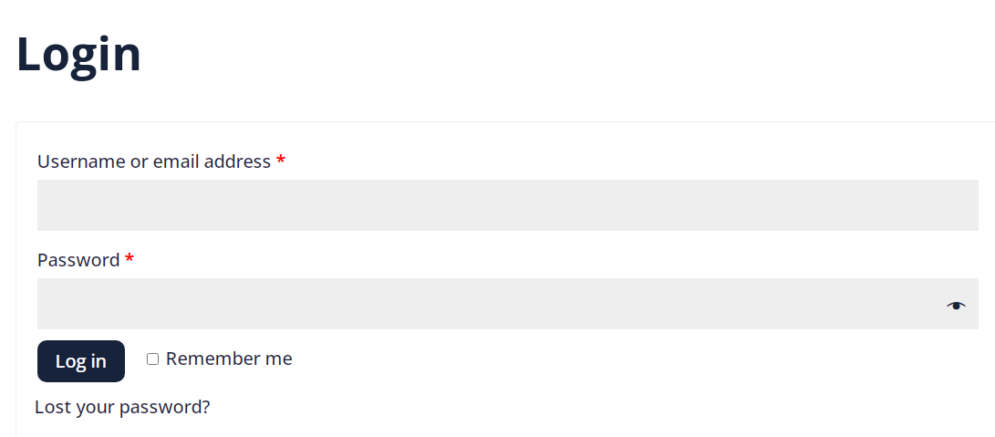

It is really important to ensure that all of our members can log into the system and have full access to all of our supporting documents and guidance. On some member visits, it was clear that the premises staff didn’t have access and not using the Alliance as they should.

We have sent reminders and provided additional log-ins for key staff. Please note that this is for member schools only and not trust-wide for academies, we do encourage academies to sign all schools up to the Alliance to ensure a consistent uniformed approach. Key central team staff such as operational managers, directors and estates managers that manage the whole trust can have membership log-ins aligned to one of the signed-up school memberships for MATs.

Roles of School Estates Staff
Effective and efficient provision of Estates Management



Estates staff roles can be considered at the three levels within the school setting:

1 Strategic Level - Defining the overall Estates Strategy
Policy making, setting guidelines for compliance, assets, building management, processes and services
- Active input and response at the school management level
- Initiating risk analysis and providing the direction to adapt to changes in the school
- Initiating and monitoring performance on the school estates management
- Managing the impact of estates management, including a safe environment and occupants
- Maintaining relationships with internal key staff/management and external stakeholders, contractors, industry leaders, enforcement authorities, local authorities

(Continued)

2 Tactical Level - Implementing and monitoring guidelines to follow strategies
- Developing budget plans with key school staff/business managers
- Translating business objectives into operational level – implementation at operational level
- Defining and interpreting KPIs (performance, quality, risk and value)
- Monitoring compliance with laws and regulations, related standards
- Managing projects, processes and agreements
- Managing the FM team
- Optimising the use of resources
- Interpreting, adapting and reporting changes
- Communicating with internal and external service providers on a tactical level
3 Operational Level - Delivering services
- Monitoring and checking service delivery processes
- Monitoring service providers/school contractors
- Receiving requests for service – management requests
- Collecting data for performance evaluations, feedback and demands from end-users
- Reporting to Headteachers, SLT
Communicating with internal or external service providers on an operational level

(Continued)

Project Management



I really do believe that all of you are Project Managers. You may not know this, or be fully aware that your duties include project management.
This becomes relevant towards the start of the summer holidays although this should start around February half term in preparing some of the bigger works for summer.
This is a reoccurring finding, something that happens every year in many schools and sometimes the same school over and over again and that is the lack of managing school holiday projects. I know the bigger construction works normally have an appointed project manager, but not always, and the themed concern is many contractor works are lacking in project management including the legal areas such as CDM 2015 and other related legislation.
We have added this to the Hub and are reviewing the development of school-specific project management training and competent person development.

(Continued)

Offences



Please see below for a selection of the latest news and prosecution notices, fortunately, none of these are school-related. Still very concerning to note the fatal incidents and significant life-changing injuries that in every case could have been prevented.
Fine issued after walkers struck by tree
12 August 2024
A body that manages a major forest has been fined after a rotting tree fell, injuring nearby walkers.
Health Board prosecuted after death of patient
8 August 2024
The board has been fined over £60,000 after the patient's body was found on the bathroom floor.
Company fined £1m as worker suffers serious injuries
2 August 2024
The fine was issued to the logistics company after the worker fell over 10 metres.

Companies fined after worker crushed by machine
1 August 2024
Two companies have been fined after a worker was crushed by a machine that fell from a telehandler.
Company fined £160,000 after worker loses legs
30 July 2024
The fine was issued after a worker's legs were crushed by a pallet of slate tiles that fell from a forklift.
Write engaging and informative content that will help your readers understand your message.

NASPM Training


We offer live virtual trainings for all areas of the school’s health and safety every month.
Training courses are certificated and provide the employer with CPD evidence of competence.
Training sessions include,

- Accident Investigation SBM
- Asbestos Awareness
- CDM Management
- COSHH
- Headteacher Health and Safety Training
- Health and Safety for EYFS Statutory
- Health and Safety Management – School Governor Training
- Legionella Awareness
- Legionella Management for SBM
- Managing Contractors
- Manual Handling Risk Assessment
- PUWER Assessment
- Responsible Person Duties – RRFSO 2005 Legal Requirements for Headteacher Fire Safety Management
- Risk Assessing for Premises Staff
- SBM Refresher Health and Safety Compliance
- School Business Managers Health and Safety
- School Compliance and Assurance Management – School Governor Training
- School Fire Safety Management – School Governor Training
- SLT – Senior Leaders Health and Safety Awareness
- Understanding the CDM 2015 requirements and Duty Holder Roles – School Governor Training
- Working at Height Risk Assessment
- Your Defence Starts Today – Accident Management – Headteacher
- Your Defence Starts Today – Accident Management – School Governor Training

You can access all training via the NASPM website at
www.naspm.co.uk/my-account/
Enter username and password
From the dashboard select BOOK TRAINING
Click on the name of the course
Add desired number of people
Click on get tickets
Click on Proceed to Checkout
Complete billing details and payment method
Please book as soon as possible to guarantee your place.

Your Input into NASPM
Do you have any requests regarding documents, templates, or an area of concern that you would like us to include in the document centre or website?
Do you want a tailored health and safety training programme?
Or do you want to leave feedback?
Email admin@naspm.co.uk

Get In touch

Stuart and the NASPM Team

National Alliance of School Premises Management  Old Town Hall, 29 Broadway, Stratford, London  United Kingdom |  | You received this email because you are a NASPM member.
   |  |  | 
  Unsubscribe

