G

Premises

Management

Handbook



Premises Management Handbook Contents

Section 1 Introduction
1.1 Key tasks
1.2 Summary of tasks and checks
1.3 Premises Checklist

Section 2 Health and Safety Arrangements
2.1 Premises Risk Assessments
2.2 Health and Safety Inspections
2.3 First Aid
2.4 Pedestrian and Vehicle Segregation
2.5 Bomb Threats and Suspicious Packages
2.6 Tree Hazards

Section 3 Access and Use of Premises
3.1 Security Arrangements
3.2 Control of Visiting Contractors
3.3 Event Safety

Section 4 Fire Safety
4.1 Fire Safety
4.2 Fire Detection and Alarm System
4.3 Fire Fighting Equipment
4.4 Means of Escape
4.5 Fire Safety Arrangements
4.6 Fire Safety Information Training

Section 5 Maintenance Arrangements
5.1 Requesting Maintenance Work
5.2 Safety during Construction Work
5.3 Cleaning Arrangements
5.4 Window Maintenance

Section 6 Plant and Equipment
6.1 Boilers
6.2 Kitchen Canopy Extract Systems
6.3 Local Exhaust Ventilation
6.4 Fall Arrest Anchors
6.5 Fuel and Oil Storage
6.6 Gas Safety
6.7 Lifts
6.8 Playground and Gymnasium Equipment

(Continued)
Premises Management Handbook Contents Continued

Section 7 Electricity
7.1 Fixed Electrical Installations
7.2 Portable Electrical Appliances

Section 8 Water Hygiene
8.1 Control of Legionella

Section 9 Asbestos
9.1 Asbestos Information
9.2 Asbestos Management
9.3 Asbestos Emergency Procedures



Premises Manager Handbook

1. Introduction and Background

The statutory framework for any school includes the legal compliance duties to ensure that the school is legally compliant. This also includes the setting of identified key staff and specifically those responsible for managing the estates.

Premises staff including premises managers have extensive requirements as detailed within their job descriptions to manage the school estate which also includes many premises duties including these examples:

- Building Statutory Compliance
- Selection and management of contractors
- Risk assessment for premises management
- Fire safety
- Condition management
- Security
- Traffic management
- Contractor management including cleaning, catering and local school contractor management
- Building and area inspection
- Electrical and Mechanical management
- Management of site deliveries
- Emergency management

This Premises Management Handbook has been produced by NASPM to assist the Premises Manager and Premises Staff in those duties and tasks associated with this role. The handbook has been developed to cover the most common range of property compliance tasks that will apply to the majority of school premises, however, due to the often unique nature of individual premises and facilities this handbook cannot be considered exhaustive.

Role of the Responsible Person

School management should ensure that the key premises staff are aware of their compliance duties and also have a ‘check the checker’ role which may include a senior member of staff involved in checking the roles and responsibilities are being managed and monitored.

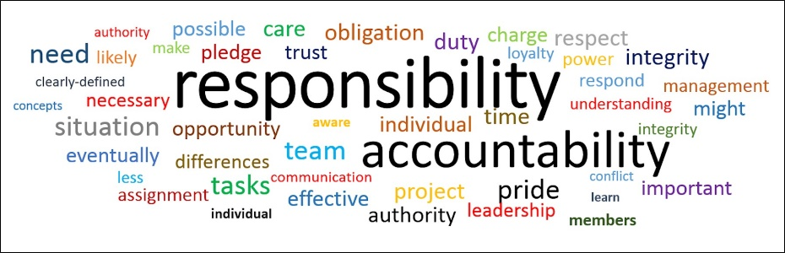

Section 1.1 Key Tasks



- Emergency arrangements (including bomb threats and suspicious packages)
- Pedestrian and vehicle movement
- First aid requirements and risk assessment
- Health and Safety tours, inspections
- Risk assessments
- Security Management
- Contractor management
- Event Management
- Temporary closure of premises
- Permanent closure of premises
- Requesting essential maintenance
- Safety during work within the premises
- Property/service-funded improvements
- Housekeeping
- Asbestos management and control
- Control of legionella
- Electrical safety
- Safety of plant, facilities and equipment
- Fire risk management
- Window Management
- Management of water
- Working at height equipment check

